ATIC Accessibility
To support the accessible community in making informed travel decisions for their individual needs

This report prepared for:
Business name: | Voyager Estate
Address: | 41 Stevens Road
Town: | Margaret River
Contact for enquiries: | Adam Elton
Contact Number: | 08 9757 6354
Contact Email: | experiences@voyagerestate.com.au
Website: | www.voyagerestate.com.au
Date: | 2026-06-21 20:58

ATIC Accessibility
The following pages provides travellers with information on the businesses facilities and amenities which aims to support the traveller to make an informed decision on whether the business is suitable for their individual needs.
OVERVIEW 4
Business Overview 4
Bookings 4
Emergency Management 4
Communications 5
Other Information 5
Guide Dog and Service Animals 5
GENERAL 6
Pre-arrival, arrival and reception 6
Car Park and Access amenities 6
Entry 7
Internal Spaces 7
Public areas 7
Displays, exhibits, commentary and live performances 7
External Paths 8
Steps 8
Ramps 8
Public Toilets/Adult change facilities 9
TOUR OPERATORS 10
Route Planning 10
Guides 10
COMMON AREAS 11
Parks and gardens 11
FOOD AND DRINK 12
Dining Spaces 12
EVENTS 13
Events 13
Report Disclaimer 15

OVERVIEW

Business Overview

The business has the following products/services available
- Tour/Transport
- Food and Drink
- Event

Our business caters for the following disability types:
- Blind or low vision
- Deaf or low hearing
- Limited mobility
- Wheelchairs or mobility scooters
- Food allergies or intolerances
- Cognitive or people on the Autism Spectrum


Bookings

The business offers the following methods for bookings and enquiries:
- Phone
- Email
- Webportal

Emergency Management
- Exit signs are clear and easy to see
- Exit access is free and clear at all times
We ensure exit access is free and clear at all times by:
They are sign posted and treated accordingly
- Exits and access to exists are greater than 900mm
- Exits to the emergency evacuation point does not include stairways
The business identifies guests who need additional assistance should an emergency occur by:
Our staff are instructed to direct all individuals to the muster point, also being the last people to leave and thus identifying anyone who appears to needing assistance.
The procedure for assisting guests who need assisted rescue is:
To alert the Emergency Evacuation Warden who will coordinate their assistance using internal resources or contact Emergency Services
- Guests with disabilities are noted in the guest log book for emergency and evacuation purposes

Communications
- An accessibility guide is available on the website

https://www.voyagerestate.com.au/visit-us

Other Information
- For bookings made onsite, the ticket booth/counter/box office is accessible for people using a wheelchair
- The business accepts the companion card

Guide Dog and Service Animals
- The business provides a secure area with shade and water for service animals
- The business provides a toilet area for service animals
- Bowls, bedding, etc. are provided for service animals
The business provides the following services for services animals:
Water bowls and toilet area provided on request. Beds not specifically provided.

GENERAL

Pre-arrival, arrival and reception
The business has the following in place to support guests during pre-arrival, arrival and reception
- Booking information and websites are compatible with screen readers
- There is a reception/public entryway.
- Seating available at reception
- Lighting in the reception area is even and glare free
- Large print information sheets and registration forms

While we have a tasting counter, we encouraged seated tastings able to accommodate a wheelchair. Printed wine notes are placed on every table, with large format available on request. Our wine experiences are hosted so our team can explain the wines and manage further requests.
- Information and maps are available in written form
- In addition, the following further information can assist guests:
The Cellar Door has lounges for guests to wait, in the unlikely situation that their reserved table in the Wine Room or Restaurant is not ready.&nbsp;
- In addition, the following further information can assist guests:
Please let the Voyager team know of your requirements in the booking process or on arrival.

Car Park and Access amenities
The business has the following Car Park and Access amenities
- A drop off zone
- Designated disabled parking bays
- Level or ramped access from the car park to the entrance
- The accessible entrance is clearly signed from the parking bay
- In addition, the following further information can assist guests:
Personalised instructions can be provided with advance notice or phone call on arrival.&nbsp;

Entry
The business has the following amenities/systems in place for entry
- A drop off point close to the entrance
- A path of access to the building is clear of obstruction
- Glass doors are fitted with a visual sighting strip
- Door handles are of a contrasting colour to the door
- The entry door is a minimum of 850mm wide
- There a clear space of at least 1500mm x 1500mm in front of all doors.
- In addition, the following further information can assist guests:
We have a drop-off zone and entrance for guests with limited mobility. Please contact us for instructions or hosted arrival.&nbsp;

Internal Spaces
- Clear and unobstructed routes through and between buildings
- Interior walls are matte or low sheen
- Floors, walls, counters and furniture are of contrasting colours
- Tableware/glassware contrast with the table surface or table cloth
- Floor surfaces are hard or short pile carpet
- Seating is available for guests unable to stand for long periods
- All corridors greater than 900mm

Public areas
The public areas have the following amenities in place
- Even lighting
- Seating

Displays, exhibits, commentary and live performances
For displays, exhibits, commentary and live performances the following amenities are in place
- Seating
- Wheelchair accessible spaces/seating

External Paths
External paths of travel
- Surfaces are concrete, asphalt, smooth paving or hard packed fine gravel (max aggregate size 13mm)
- Pathways are wider than 900mm
- In addition, the following further information can assist guests:
All areas are accessible by wheel chair, although cobblestone paths and grass may require some assistance. All areas accessible by stairs have alternate routes with no stairs. Seating is provided intermittently for those whom require a rest station.

Steps
Steps
- There are steps.
- Handrails fitted to all open sets of steps
- Handrails extend 300mm beyond the top and bottom step
- Where steps are present are there three steps or less
- In addition, the following further information can assist guests:
All areas accessible by stairs have alternate routes with no stairs. &nbsp;

Ramps
Ramps have the following amenities are in place
- There are ramps.
- All fixed ramps are 1:14 or less
- Long ramps (more than 10m) are 1:20 or less
- Temporary ramps are available
- Temporary ramps are in place for the duration of the guests stay
- Ramps have a raised edge of at least 100mm
- In addition, the following further information can assist guests:
Permanent ramps are in place to provide access to visitor building and grounds. Some require taking an alternate route. Personalised instructions or host can be provided with advance notice. Temporary ramps also available on request.&nbsp;

Public Toilets/Adult change facilities
Public Toilets/Adult change facilities have the following amenities are in place
- There is an accessible toilet for public use
- The door is at least 850mm wide
- There is a minimum of 850mm beside the toilet
- Handrails are fitted
- The toilet seat is 460mm above the floor
- The toilet seat of a contrasting colour to the floor
- The toilet seat is460mm above the floor

TOUR OPERATORS

Route Planning
- Route Planning
- The tour route includes stops with accessible toilet facilities
- In addition, the following further information can assist guests:
With advance notice, we are happy to alter our tour experience to accommodate with no/low mobility in terms of stops and duration.&nbsp;
- Lunch stop venues are accessible
- Sightseeing and photo opportunity stops are step free
- Walking Tours
- Operated on a step free route
- Multi-paced to account for slower walkers
- Hearing aid compatible

Guides

Guides have been trained in the following
- Use of clear/simple English
- Correct pronunciation for lip readers
- In addition, the following further information can assist guests:
All guest tours are personalised and therefore can be adjusted to individual requirements, being it mobility, visual, hearing or other. Advance notice is required in order to provide the best experience.&nbsp;

COMMON AREAS

Parks and gardens
- The following parks and gardens amenities are available
- Accessible toilets
- Seats are provided at regular intervals
- Handrails and stairs are built as per state/territory building code.
- A handrail is available and at 865-965mm in height.
  - Parks and Gardens Stair entry and exit Image(s)
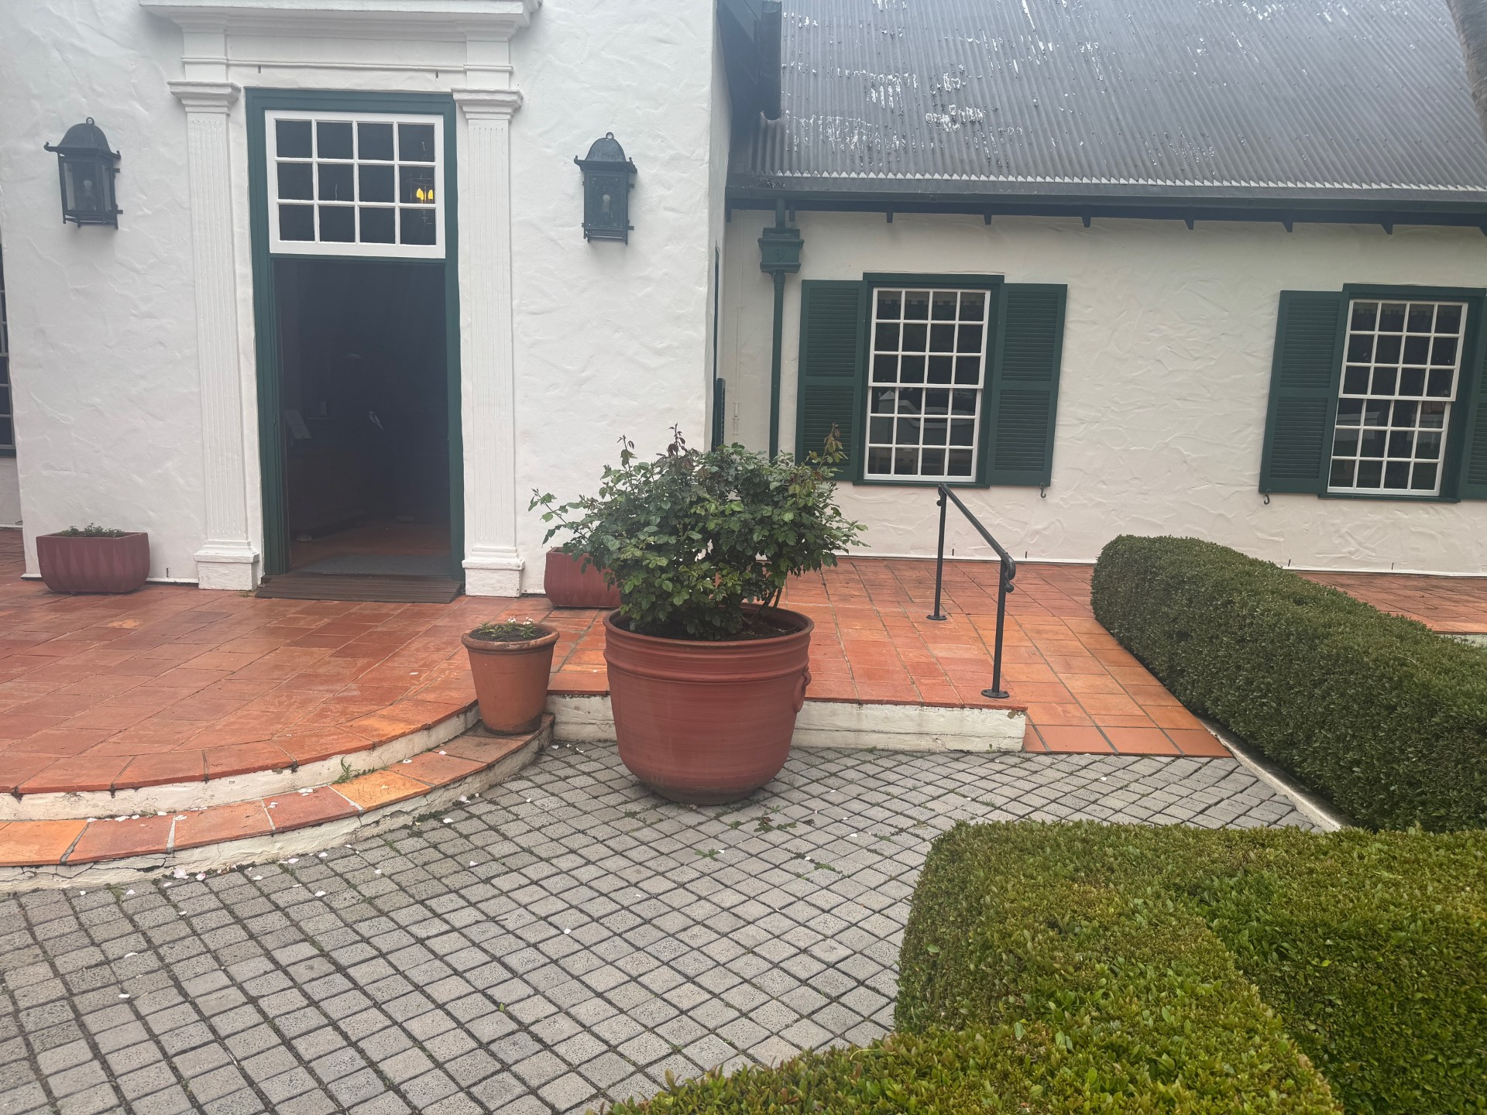
Front building entrance exit stairs and ramp

FOOD AND DRINK

Dining Spaces
The dining spaces have the following facilities/amenities in place
- The entrance has level access
- The doorway is at least 850mm wide
- There is level access through the dining area
- Chairs are moveable to allow for wheelchairs to be seated at the tables
- All glass doors and full height windows have contrast markings
- There are areas of full lighting
- There is an accessible toilet

Our business caters for the following dietary requirements
- Gluten free (celiac)
- Lactose free (dairy free)
- Nut free
- Vegetarian
- In addition, the following further information can assist guests:
The Voyager Estate kitchen operates to state and local regulatory standards for food hygiene and contamination. Allergies that are identified to us in advance are noted in booking notes, service board and accommodated with the upmost care by our chefs.&nbsp;
- There is a sample menu available online
Sample menu is available here -
https://www.voyagerestate.com.au/restaurant
- In addition, the following further information can assist guests:
Voyager Estate offers table service for ordering and payment. Tables can be used in the place of service bar for guests in a wheel chair or who need to remain seated.&nbsp;

EVENTS

Events
Events have the following facilities/amenities in place
- There is step free access throughout the venue
- Reception, registration desks or ticket offices have a lower counter section
- Accessible toilets are available at the venue
- Wheelchair designated seating is provided
- We cater for a range of seating and viewing options
- We cater for varying group sizes
- There is good circulation space with the number of people expected to allow people with a disability to move around freely
- Food and water is available for guide and service animals
- The event is outdoors
- Seating is at regular intervals
- Side shows, activities etc. are accessible
- Accessible car parking is available
- There are designated drop-off points

Report Disclaimer
Please note that this business report, provided as a result of the use of the diagnostic assessment, is for information purposes only.
Australian Tourism Industry Council (ATIC) cannot guarantee the accuracy of respondent’s answers, or that they are fully representative of your business. Therefore, ATIC does not warrant or guarantee any particular outcome in respect of your businesses self-assessment.
This report is intended as guidance only for your business and should not be relied on for future marketing considerations. ATIC recommends that you seek your own independent advice as well as the results from the diagnostic.
Links to external web sites are inserted for convenience and do not constitute endorsement of material at those sites, or any associated organisation, product or service.
ATIC does not:
- Assume any legal liability for the accuracy, completeness, or usefulness of any information from this report or any links provided; or
- Accept responsibility for any loss associated directly or indirectly from the use of this report.

