ATIC Accessibility
To support the accessible community in making informed travel decisions for their individual needs

This report prepared for:
Business name: | Outback Spirit Tours
Address: | 93 Bennu Circuit
Town: | Albury
Contact for enquiries: | Nicky Doughty
Contact Number: | 0458237089
Contact Email: | info@outbackspirit.net.au
Website: | www.outbackspirittours.com.au
Date: | 2026-10-23 19:35

ATIC Accessibility
The following pages provides travellers with information on the businesses facilities and amenities which aims to support the traveller to make an informed decision on whether the business is suitable for their individual needs.
OVERVIEW 4
Business Overview 4
Bookings 4
Emergency Management 4
GENERAL 6
External Paths 6
Steps 6
Ramps 6
TOUR OPERATORS 7
Tour/Transport Services 7
Route Planning 7
Guides 7
ACCOMMODATION 10
Room Amenities 10
Bathrooms 10
ATTRACTIONS 11
COMMON AREAS 12
Swimming pools, spas and waterparks 12
Parks and gardens 12
FOOD AND DRINK 13
Dining Spaces 13
ADVENTURE ACTIVITIES 14
Report Disclaimer 16

OVERVIEW

Business Overview

The business has the following products/services available
- Tour/Transport
- Accommodation
- Attraction
- Food and Drink
- Adventure

Our business caters for the following disability types:
- Food allergies or intolerances

Bookings

The business offers the following methods for bookings and enquiries:
- Phone
- Email
- Webportal

Emergency Management
- Emergency and evacuation procedures are explained on arrival
- Exit signs are clear and easy to see
- Exit access is free and clear at all times
We ensure exit access is free and clear at all times by:
n/a
- Exit doors are able to be opened by all occupants
- The evacuation point is clearly marked by a sign
- In addition, the following further information can assist guests:
n/a
- In addition, the following further information can assist guests:
n/a
The business provides the following services for services animals:
n/a

GENERAL
- In addition, the following further information can assist guests:
n/a

External Paths
External paths of travel
- Pathways are wider than 900mm
- There 3 successive steps or less on any path or at any doorway

Steps
Steps
- There are steps.

Ramps
Ramps have the following amenities are in place
- There are ramps.
- Hand rails are fitted

TOUR OPERATORS

Tour/Transport Services
The tour/transport services have the following facilities/amenities in place
- Buses/Coaches
- 0 vehicles have wheelchair lifts or ramps
- 0 vehicles have low floors with ramped entry
The maximum wheelchair capacity available in the fleet is:
0

Route Planning
- Route Planning
- The door is n/a wide
- Sightseeing and photo opportunity stops are step free
- Overnight Stops
The total number of wheelchair passengers that can be catered for at overnight stops are:
0
- Walking Tours

Guides

Guides have been trained in the following
- Use of clear/simple English
  - Image(s)
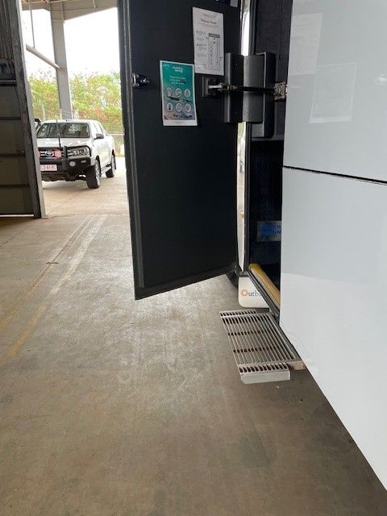
Coach Entry
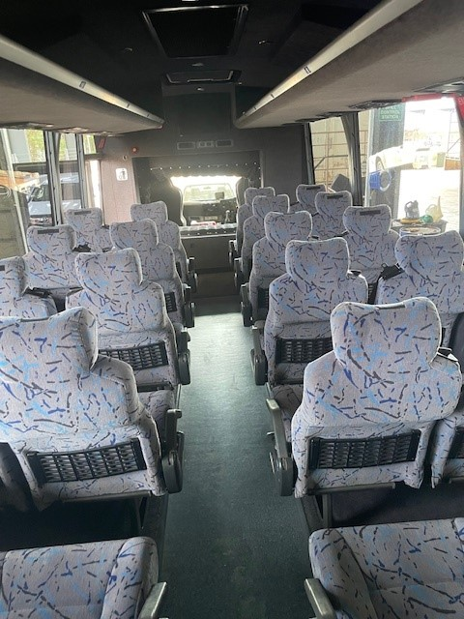
Coach Seats
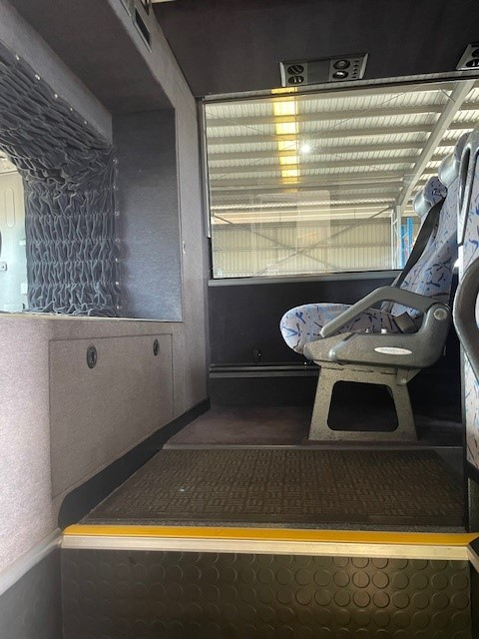
Coach Stairs
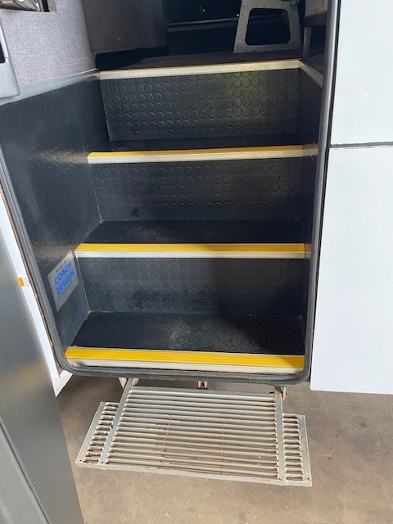
Coach Steps
- In addition, the following further information can assist guests:
We travel all over outback WA, from Kununurra to Esperance, the areas are very isolated and have minimal to no accessibility allowance for guests.

ACCOMMODATION

Room Amenities
- There is a clear opening at least 850mm wide
- There at least one chair with rigid arms

Bathrooms
The bathrooms have the following facilities/amenities in place
- The door is at least 850mm wide
- The width beside the toilet is n/a.
- There is n/a mm of clear space in front of the toilet
- The actual height of the toilet seat is n/a.

ATTRACTIONS

COMMON AREAS

Swimming pools, spas and waterparks
- The following swimming pools, spas and waterparks amenities are available

Parks and gardens
- The following parks and gardens amenities are available
- Handrails and stairs are built as per state/territory building code.
- Slip resistance surfaces are used.
- A handrail is available and at 865-965mm in height.
- The handrail is continuously graspable along entire length at least one side.

FOOD AND DRINK

Dining Spaces
The dining spaces have the following facilities/amenities in place
- The smallest doorway is n/a wide
- There is level access through the dining area
- Chairs are moveable to allow for wheelchairs to be seated at the tables
- All glass doors and full height windows have contrast markings

Our business caters for the following dietary requirements
- Sugar free (diabetic)
- Gluten free (celiac)
- Lactose free (dairy free)
- Low fat and fibre with no gastric content
- Low potassium
- Low sodium
- Nut free
- Additive free
- Organic
- Vegetarian
- Vegan
- Kosher
- Halal
- In addition, the following further information can assist guests:
All our Chefs are qualified and follow all required food handle laws and requirements.

ADVENTURE ACTIVITIES

Report Disclaimer
Please note that this business report, provided as a result of the use of the diagnostic assessment, is for information purposes only.
Australian Tourism Industry Council (ATIC) cannot guarantee the accuracy of respondent’s answers, or that they are fully representative of your business. Therefore, ATIC does not warrant or guarantee any particular outcome in respect of your businesses self-assessment.
This report is intended as guidance only for your business and should not be relied on for future marketing considerations. ATIC recommends that you seek your own independent advice as well as the results from the diagnostic.
Links to external web sites are inserted for convenience and do not constitute endorsement of material at those sites, or any associated organisation, product or service.
ATIC does not:
- Assume any legal liability for the accuracy, completeness, or usefulness of any information from this report or any links provided; or
- Accept responsibility for any loss associated directly or indirectly from the use of this report.

