ATIC Accessibility
To support the accessible community in making informed travel decisions for their individual needs

This report prepared for:
Business name: | Jet Ski Tours Perth
Address: | Rockingham Beach
Town: | Rockingham
Contact for enquiries: | Ronald Mayo
Contact Number: | 0450 538 754
Contact Email: | Info@jetskitoursperth.com.au
Website: | www.jetskitoursperth.com.au
Date: | 2026-09-17 19:07

ATIC Accessibility
The following pages provides travellers with information on the businesses facilities and amenities which aims to support the traveller to make an informed decision on whether the business is suitable for their individual needs.
OVERVIEW 4
Business Overview 4
Bookings 4
Emergency Management 4
Communications 4
Guide Dog and Service Animals 5
GENERAL 6
Pre-arrival, arrival and reception 6
Cognitive Impairment Support 6
Car Park and Access amenities 6
External Paths 7
Steps 7
Public Toilets/Adult change facilities 7
TOUR OPERATORS 8
Tour/Transport Services 8
Guides 8
ATTRACTIONS 10
Attractions Basics 10
COMMON AREAS 11
ADVENTURE ACTIVITIES 12
Adventure activities 12
Report Disclaimer 16

OVERVIEW

Business Overview

The business has the following products/services available
- Tour/Transport
- Attraction
- Adventure

Our business caters for the following disability types:
- Cognitive or people on the Autism Spectrum

Bookings

The business offers the following methods for bookings and enquiries:
- Webportal
- Our website supports Screen Readers
- Our forms have high contract boxes and submit boxes
- Staff have undergone disability awareness and training

Emergency Management
- The business has an emergency management and evacuation plan for guests with a disability
- Emergency and evacuation procedures are explained on arrival

Communications
- Our website meets WCAG 2.0 accessibility standards

Guide Dog and Service Animals
The business provides the following services for services animals:
NA

GENERAL

Pre-arrival, arrival and reception
The business has the following in place to support guests during pre-arrival, arrival and reception
- Booking information and websites are compatible with screen readers
- There is a reception/public entryway.

We operate right at the beach, with all bookings done online.
- Information and maps are available in written form
- A familiarisation tour
- In addition, the following further information can assist guests:
Flexible scheduling: Guests can choose times that suit their energy levels, and we can recommend quieter periods with shorter waits.
Assistance on request: Our team can provide early boarding, quicker processing, or other support to reduce physical demands.
Clear communication: We keep guests informed of any wait times or delays so they can plan rest periods as needed.
- In addition, the following further information can assist guests:
Guests with fatigue can request priority boarding or quieter time slots.
Staff can provide one-on-one support for boarding, transfers.
Shorter or assisted tours are offered for those unable to participate in longer activities.
Please let us know any medical or accessibility needs when booking so we can tailor your experience.

Cognitive Impairment Support
- Documents are available in plain English for people with cognitive impairment (This may include instructions, guides, menus and general information)

Car Park and Access amenities
The business has the following Car Park and Access amenities
- Designated disabled parking bays
- Level or ramped access from the car park to the entrance
- In addition, the following further information can assist guests:
We operate from a public beach with public car parks around.

External Paths
External paths of travel
- Pathways are wider than 900mm
- There 3 successive steps or less on any path or at any doorway

Steps
Steps
- There are steps.
- Handrails fitted to all open sets of steps
- In addition, the following further information can assist guests:
From The car park to where we are, there are about 5 steps to go to the walkway.

Public Toilets/Adult change facilities
Public Toilets/Adult change facilities have the following amenities are in place
- There is an accessible toilet for public use
- The door is at least 850mm wide
- There is a minimum of 850mm beside the toilet
- Handrails are fitted
- The toilet seat is 460mm above the floor
- The toilet seat of a contrasting colour to the floor
- The toilet seat is460mm above the floor
- In addition, the following further information can assist guests:
The facilities closest to us are public facilities / change rooms.

TOUR OPERATORS

Tour/Transport Services
The tour/transport services have the following facilities/amenities in place
- Buses/Coaches
- NA vehicles have wheelchair lifts or ramps
- NA vehicles have low floors with ramped entry
The maximum wheelchair capacity available in the fleet is:
NA
- In addition, the following further information can assist guests:
We do tours on Jet skis and our tour routes include stops but passengers do not disembark.

Guides
- Use of clear/simple English
- Correct pronunciation for lip readers
- Marine
- Accessibility is tide dependent
  - Image(s)
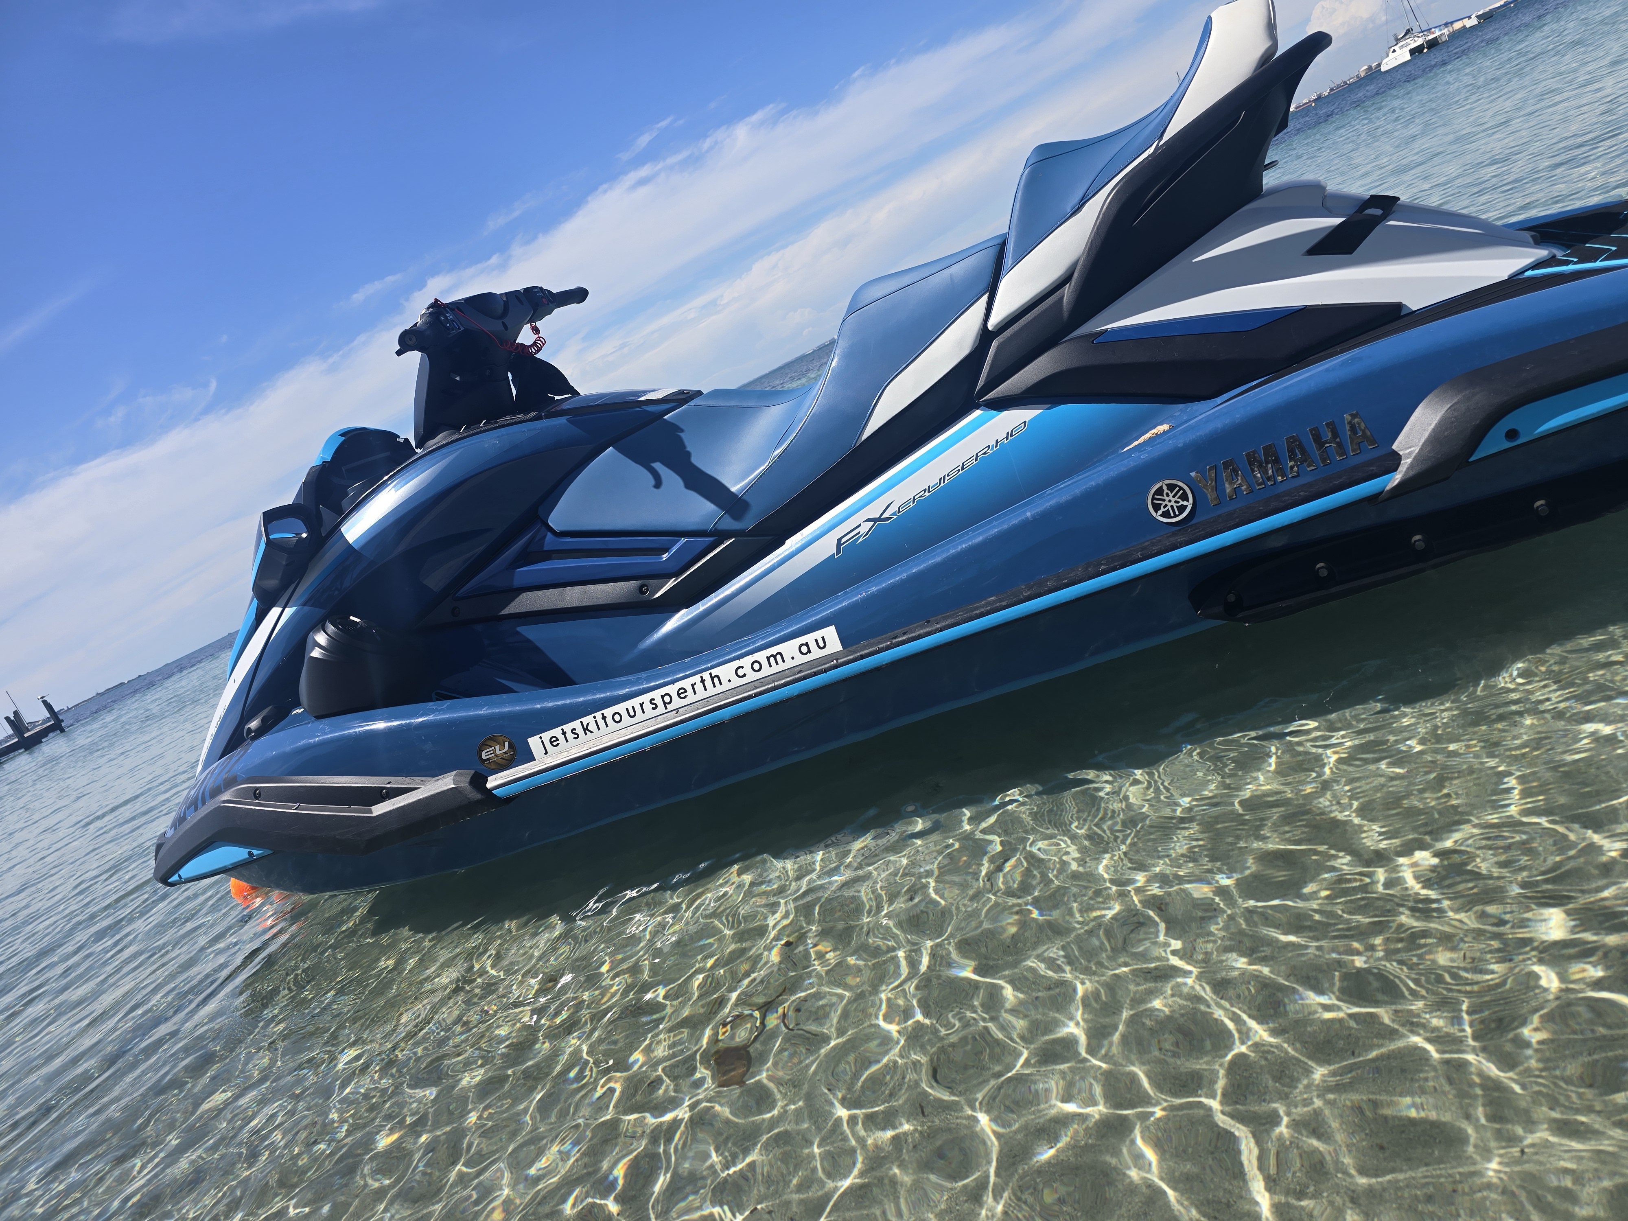
20251105_142630
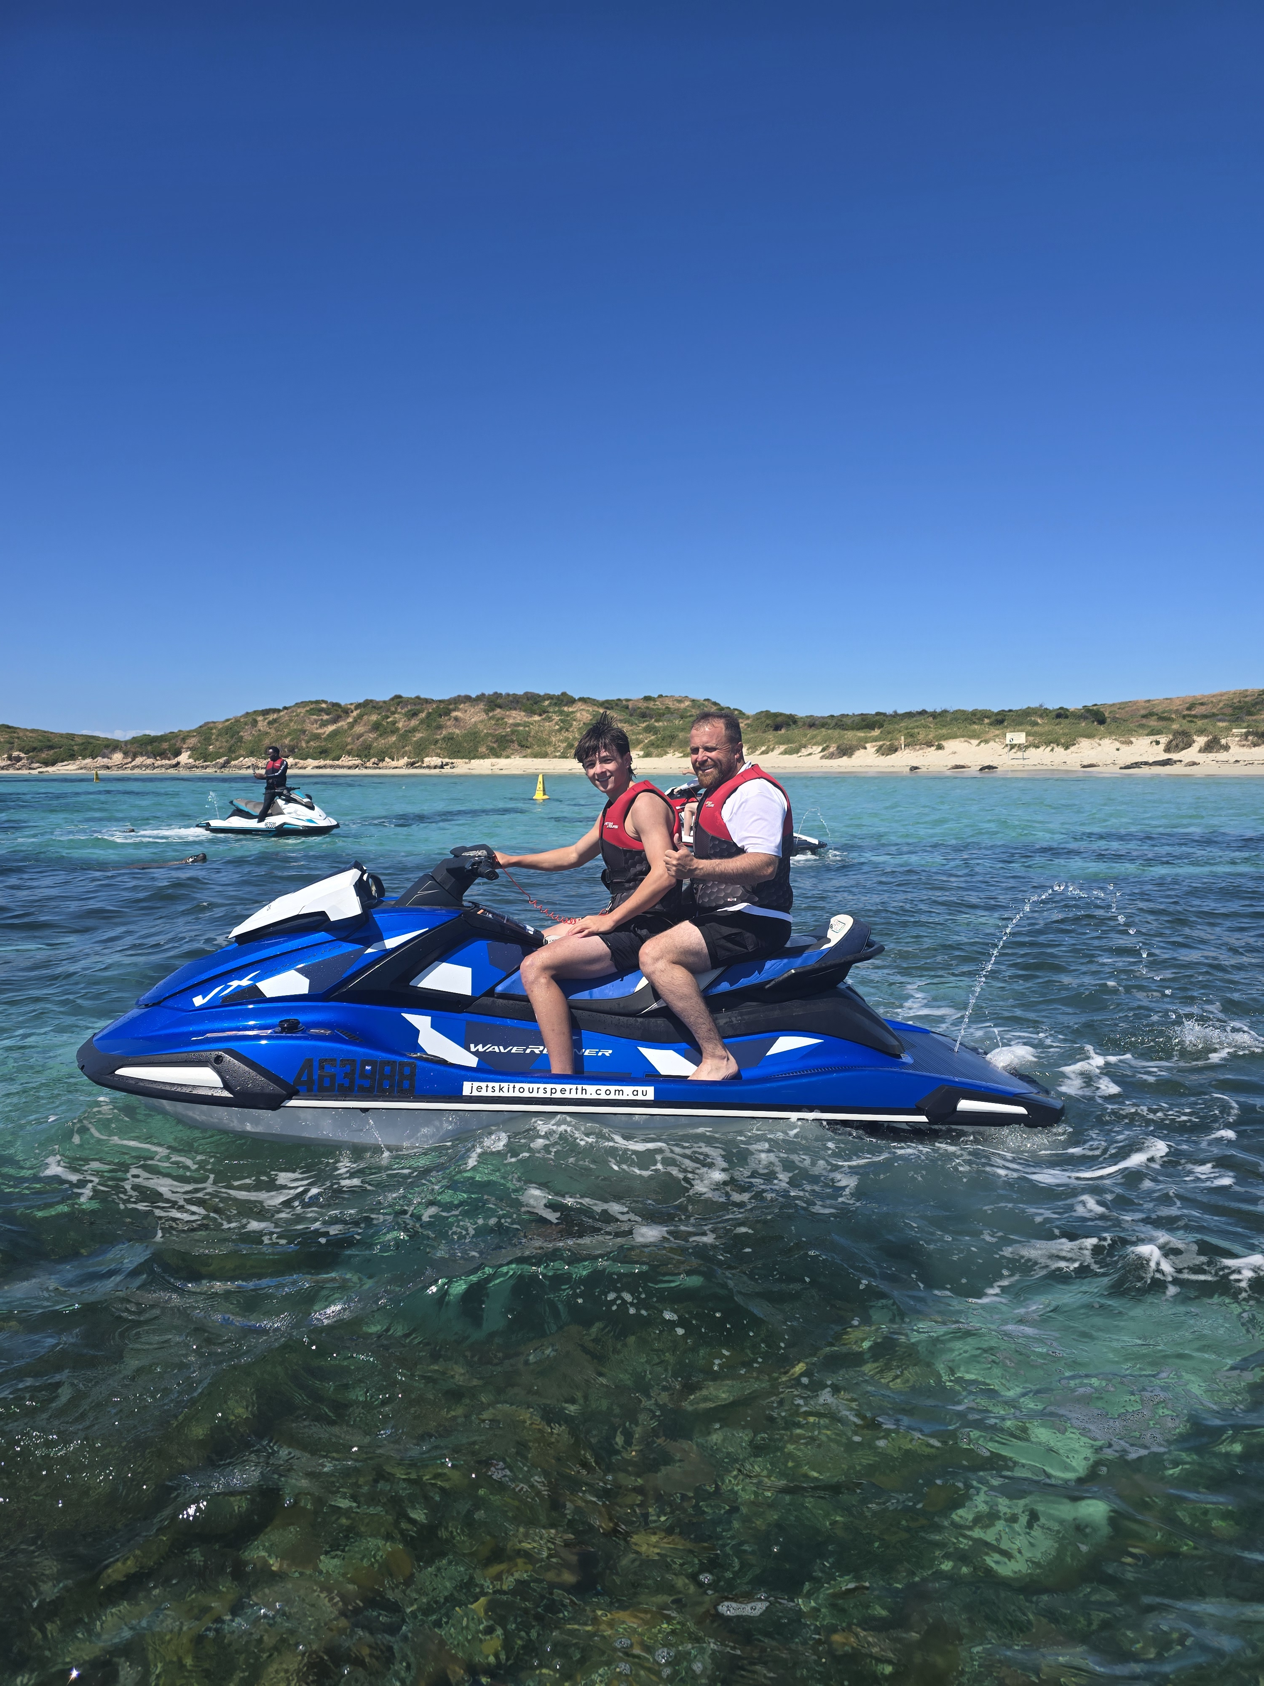
20251115_094054
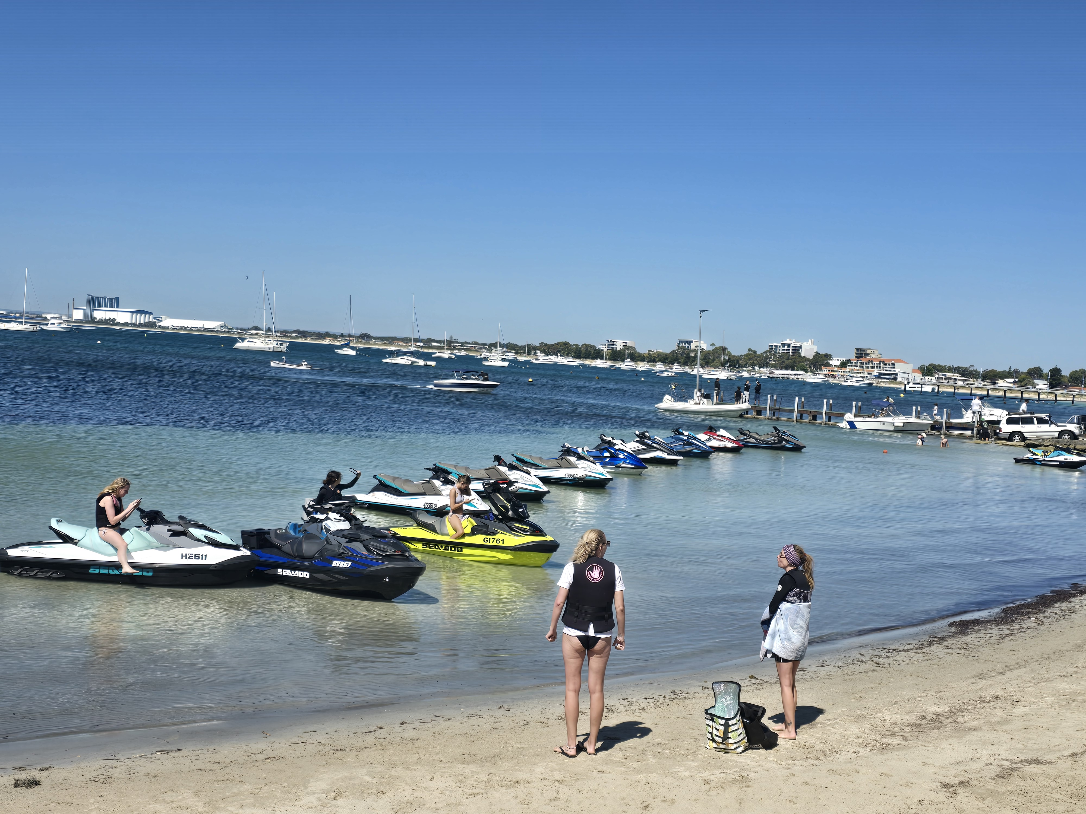
20251116_143709
LKP00074
- In addition, the following further information can assist guests:
Our tours do not stop at any external attractions, accommodation providers, food &amp; beverage venues, or retail spaces operated by other businesses. Our jet ski experiences run continuously on the water, and we do not disembark at any third-party locations during the tour. Therefore, there are no external businesses to list.

ATTRACTIONS

Attractions Basics
- A park map is available here:

https://www.jetskitoursperth.com.au/

COMMON AREAS

ADVENTURE ACTIVITIES

Adventure activities
The adventure activities have the following facilities/amenities in place
- Our adventure activities cater for people with a disability
- In addition, the following further information can assist guests:
Yes, we cater to people with disabilities and are committed to making our experiences as inclusive and enjoyable as possible. We recognize that every guest has unique needs, and we strive to provide support, accessibility, and adaptations to ensure everyone can participate comfortably.
Activities Available to People with Disabilities:
Adaptive Tours:
Our tours are designed to accommodate various mobility levels. Guests using wheelchairs or mobility aids can access most areas safely.
Assisted Jet Ski Experiences:
For those with limited mobility, we offer guided jet ski tours with and trained staff to assist with boarding and disembarking.
Safety briefings and personal flotation devices are adjusted to suit individual needs.
Inclusive Wildlife and Nature Viewing:
Guests with hearing or vision impairments can receive additional assistance or verbal descriptions from our guides.
Customizable Support:
Staff are trained to recognize accessibility needs and can assist with early boarding, reduced walking routes, or additional physical support if needed
Guests can request one-on-one attention to ensure safety and comfort during activities.
Quiet and Relaxed Options:
We understand that some guests may need shorter, less crowded experiences. We can schedule tours during quieter periods and offer flexible pacing.
Additional Considerations:
We encourage guests to let us know their specific needs when booking so we can tailor the experience appropriately.
- In addition, the following further information can assist guests:
Personal Flotation Devices (PFDs): Specially sized life jackets and PFDs are available for all body types and abilities, including designs that are easier to put on or remove.
Trained Staff Assistance
While not equipment per se, our trained staff act as a critical “living tool” for accessibility: helping with boarding, transfers, and personal support throughout the activity.
- In addition, the following further information can assist guests:
Accessibility for Guests with Disabilities
Yes, we welcome guests with disabilities and strive to make our activities safe and enjoyable.
Guided Tours: Assisted boarding, quiet/slow-paced options, and verbal/visual guidance.
Supportive Staff: Trained team available to help with transfers, equipment, and safety.

Limitations:
High-speed or extreme water activities may not be suitable.
Areas with deep water, strong currents, or uneven surfaces may be restricted.
Activities requiring full independent movement or quick reactions may not be possible.

Alternative Options:
Slower-paced tours, assisted participation, and accessible observation points are available. Guests are encouraged to share their needs when booking.
  - Adventure Activity Image(s)
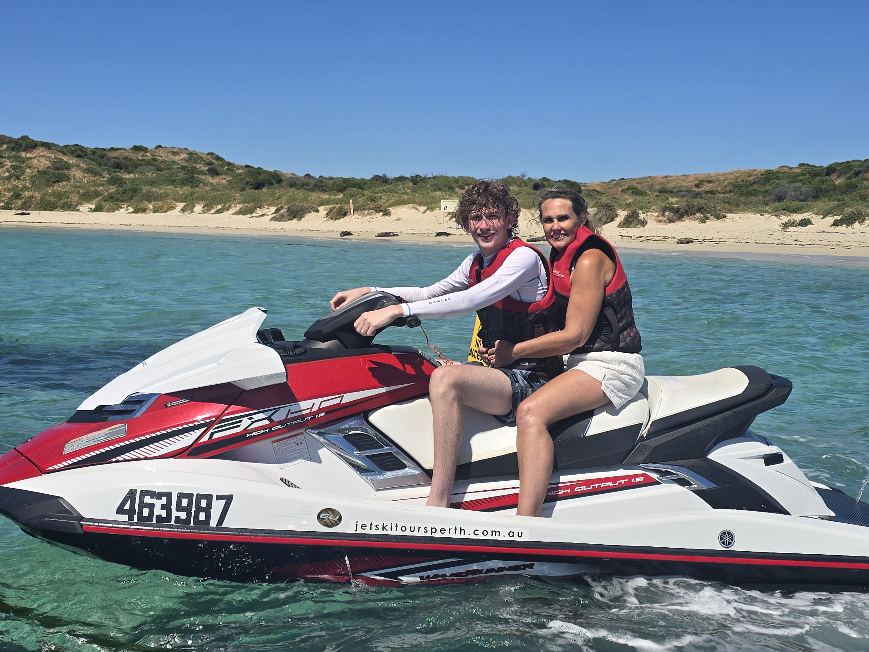
20251115_094219
LKP00074
- In addition, the following further information can assist guests:
Booking &amp; Requests: Please let us know of any accessibility requirements or special needs when booking so we can tailor the experience.
Safety First: All guests must wear safety equipment provided, including life jackets.
Assistance On Request: Our staff are trained to provide one-on-one support, including help with boarding, transfers, or equipment.
Flexible Timing: Guests who prefer quieter or slower-paced experiences can choose early or less busy time slots.
Health Considerations: Guests with certain medical conditions should consult with their healthcare provider before participating.
Communication Support: Verbal instructions, and staff guidance are available for guests with sensory or cognitive impairments.
Weather &amp; Conditions: Some activities may be limited in adverse weather for safety reasons.

Report Disclaimer
Please note that this business report, provided as a result of the use of the diagnostic assessment, is for information purposes only.
Australian Tourism Industry Council (ATIC) cannot guarantee the accuracy of respondent’s answers, or that they are fully representative of your business. Therefore, ATIC does not warrant or guarantee any particular outcome in respect of your businesses self-assessment.
This report is intended as guidance only for your business and should not be relied on for future marketing considerations. ATIC recommends that you seek your own independent advice as well as the results from the diagnostic.
Links to external web sites are inserted for convenience and do not constitute endorsement of material at those sites, or any associated organisation, product or service.
ATIC does not:
- Assume any legal liability for the accuracy, completeness, or usefulness of any information from this report or any links provided; or
- Accept responsibility for any loss associated directly or indirectly from the use of this report.

