ATIC Accessibility
To support the accessible community in making informed travel decisions for their individual needs

This report prepared for:
Business name: | Margaret River Surf School
Address: | 2 Villers
Town: | Cowaramup
Contact for enquiries: | Jarrad Davies
Contact Number: | 0401616200
Contact Email: | info@margaretriversurfschool.com
Website: | https://margaretriversurfschool.com/
Date: | 2026-10-23 13:01

ATIC Accessibility
The following pages provides travellers with information on the businesses facilities and amenities which aims to support the traveller to make an informed decision on whether the business is suitable for their individual needs.
OVERVIEW 4
Business Overview 4
Bookings 4
Emergency Management 4
Other Information 5
Guide Dog and Service Animals 5
GENERAL 6
Pre-arrival, arrival and reception 6
Cognitive Impairment Support 6
Car Park and Access amenities 6
External Paths 6
Steps 7
Ramps 7
Public Toilets/Adult change facilities 7
TOUR OPERATORS 8
Tour/Transport Services 8
Route Planning 8
Guides 8
ATTRACTIONS 10
COMMON AREAS 12
Report Disclaimer 14

OVERVIEW

Business Overview

The business has the following products/services available
- Tour/Transport
- Attraction

Our business caters for the following disability types:
- Deaf or low hearing
- Limited mobility
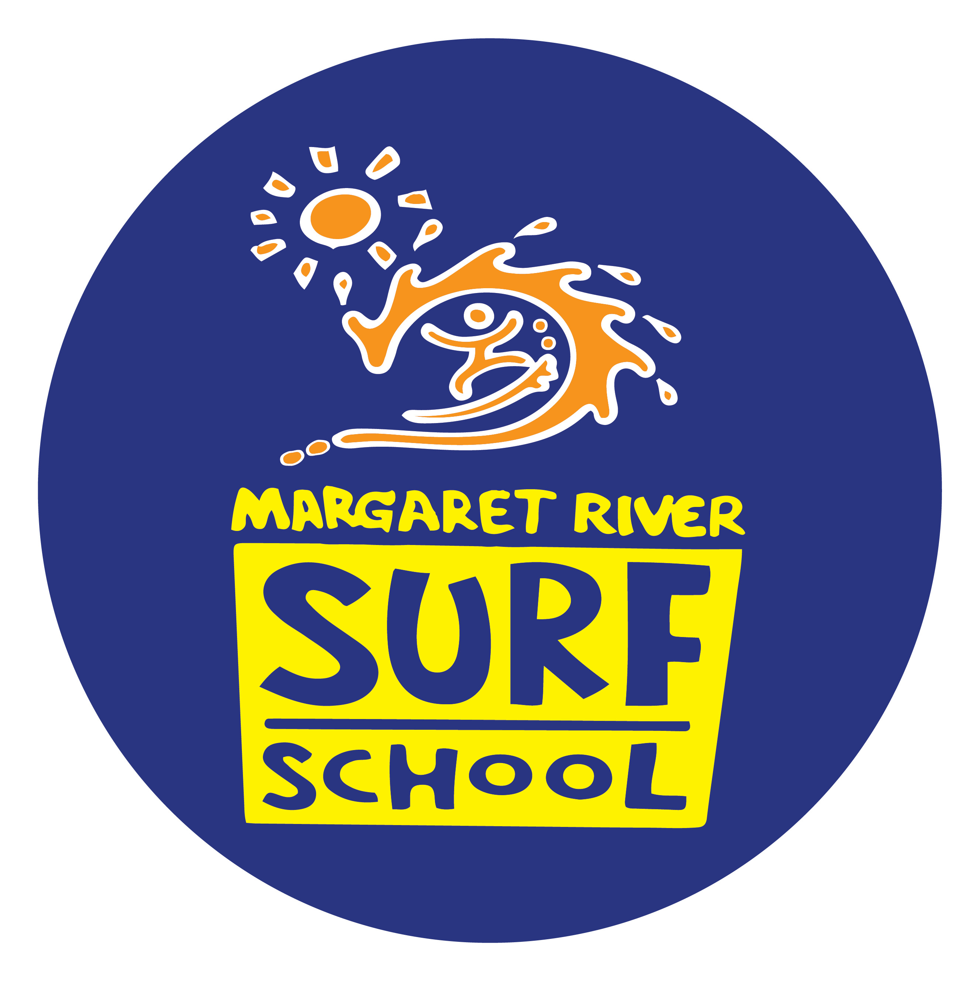

Bookings

The business offers the following methods for bookings and enquiries:
- Phone
- Email
- Webportal
- Our forms have high contract boxes and submit boxes

Emergency Management

No as we are at a beach
- Guests with disabilities are noted in the guest log book for emergency and evacuation purposes

Other Information
- For bookings made onsite, the ticket booth/counter/box office is accessible for people using a wheelchair

Guide Dog and Service Animals
The business provides the following services for services animals:
Not specified

GENERAL

Pre-arrival, arrival and reception
The business has the following in place to support guests during pre-arrival, arrival and reception
- Information and maps are available in written form
- In addition, the following further information can assist guests:
There are not long wait time. Poeple withdisability can go first too.

Cognitive Impairment Support
- Quiet periods or early opening times for people on the Autism Spectrum
- A space for parents and children on the Autism Spectrum

Car Park and Access amenities
The business has the following Car Park and Access amenities
- Designated disabled parking bays
- Level or ramped access from the car park to the entrance
- The accessible entrance is clearly signed from the parking bay
- Kerb ramps are in place where a pavement or walkway needs to be crossed

External Paths
External paths of travel
- Pathways are wider than 900mm

It is a beach

It is a beach

Steps
Steps
- There are steps.
- The underside of all staircases are enclosed or protected to a height of at least 2 metres
- Where steps are present are there three steps or less
- In addition, the following further information can assist guests:
There is 4 steps or a ramp to get to the sand path

Ramps
Ramps have the following amenities are in place
- There are ramps.
- All fixed ramps are 1:14 or less
- Hand rails are fitted
- In addition, the following further information can assist guests:
There is a ramp to get to the sand path

Public Toilets/Adult change facilities
Public Toilets/Adult change facilities have the following amenities are in place
- There is an accessible toilet for public use
- The door is at least 850mm wide
- There is a minimum of 850mm beside the toilet
- Handrails are fitted
- The toilet seat is 460mm above the floor
- The toilet seat of a contrasting colour to the floor
- The toilet seat is460mm above the floor
- In addition, the following further information can assist guests:
Totels are run but parks and wildlife

TOUR OPERATORS

Tour/Transport Services
The tour/transport services have the following facilities/amenities in place
- Buses/Coaches
- 0 vehicles have wheelchair lifts or ramps
- 0 vehicles have low floors with ramped entry
The maximum wheelchair capacity available in the fleet is:
0

Route Planning
- Route Planning
- The tour route includes stops with accessible toilet facilities
- In addition, the following further information can assist guests:
This is 14 seat van for surf camps
- Lunch stop venues are accessible

Guides
- Use of clear/simple English
- Correct pronunciation for lip readers
  - Image(s)
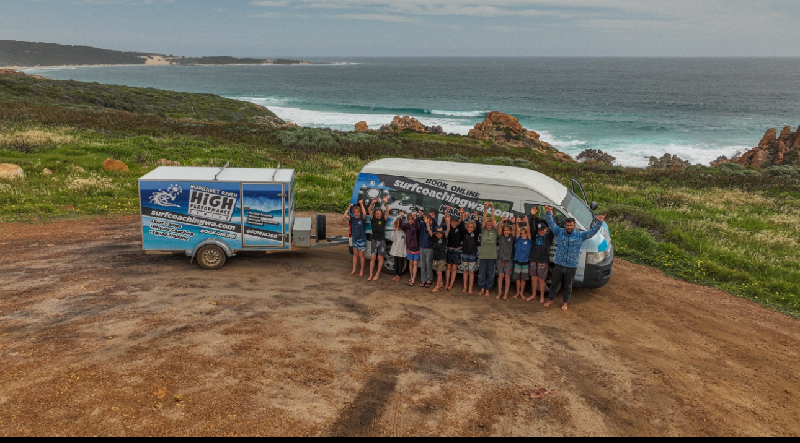
IMG_0842
- In addition, the following further information can assist guests:
We can stop at any food place in the south west.
- In addition, the following further information can assist guests:
the bus is for surfer that can surf it only for my high performace coaching. This not for learn to surf part bof the busness

ATTRACTIONS
  - Image(s)
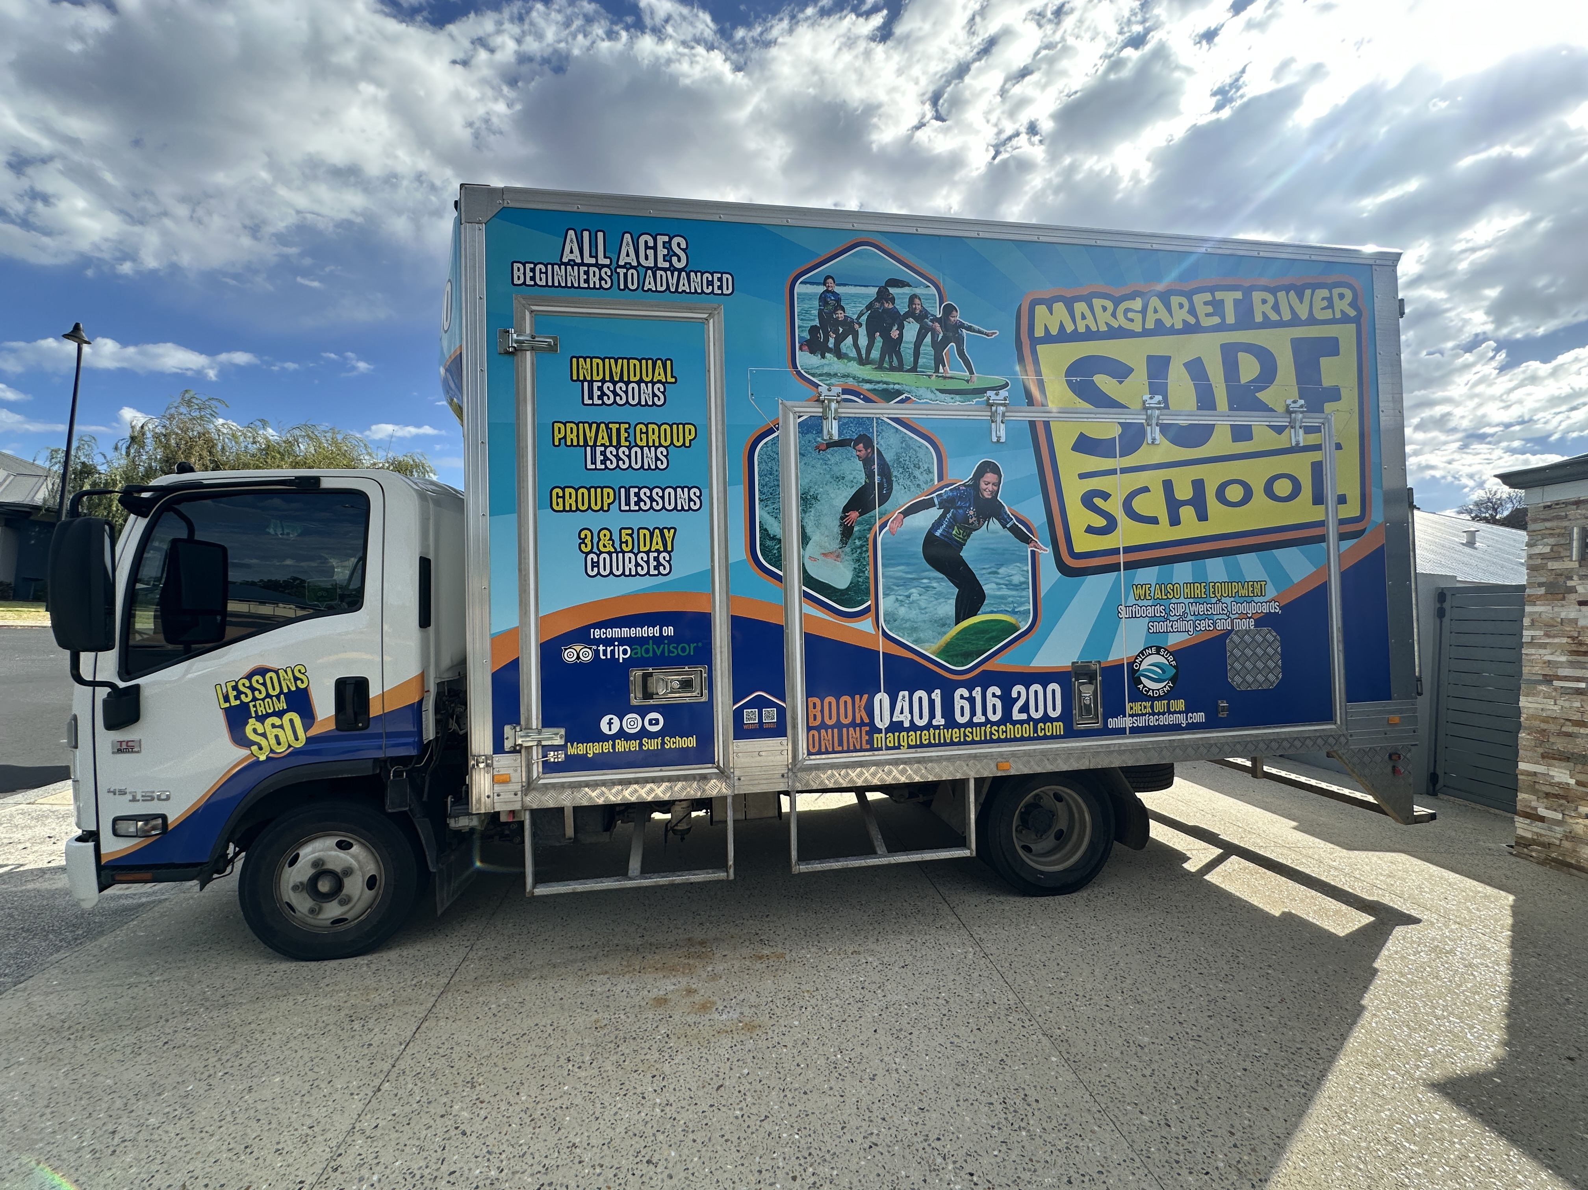
IMG_8188.JPG
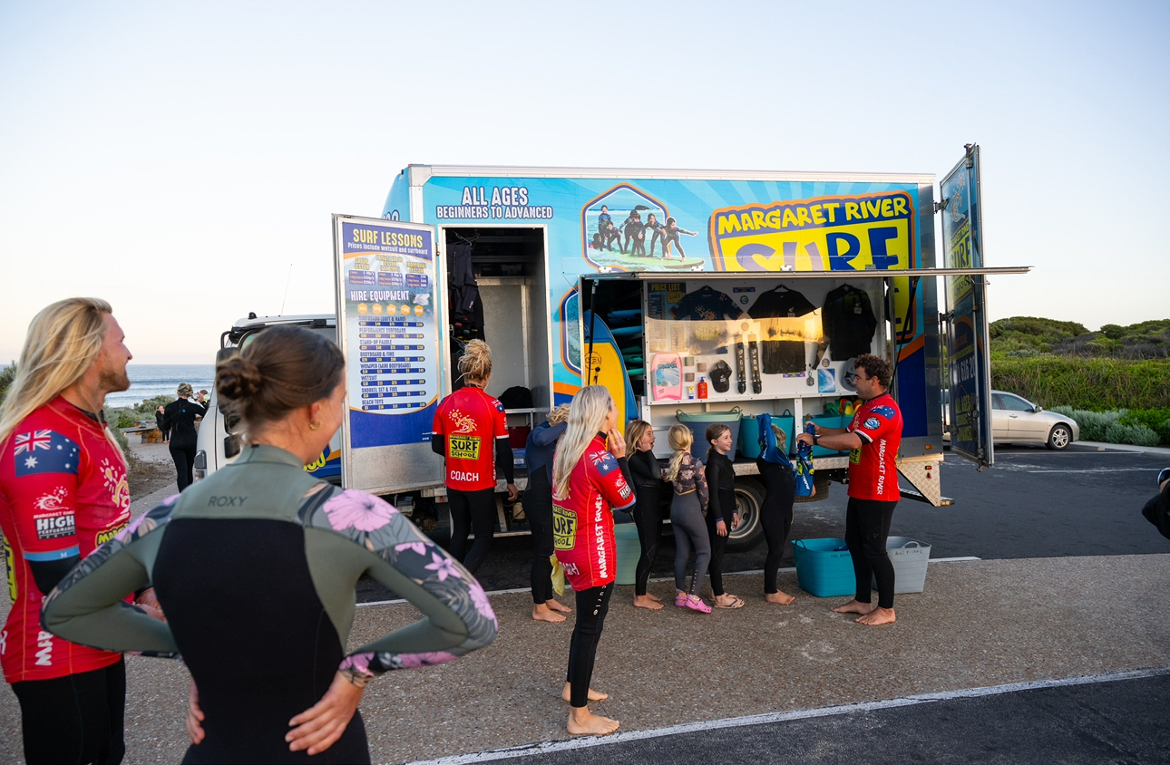
IMG_0854
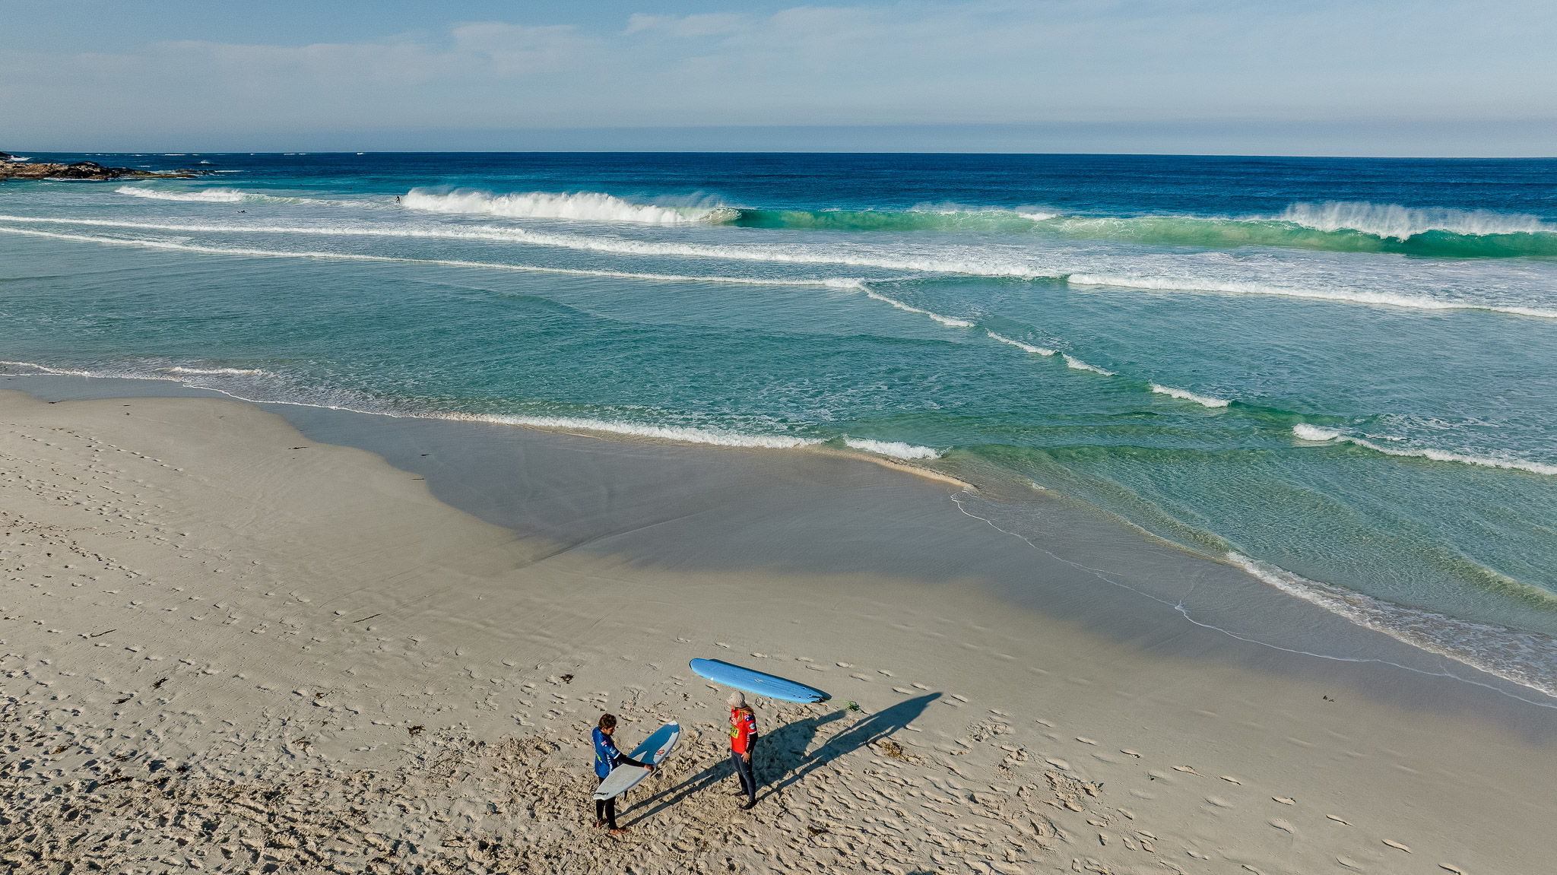
DJI_0168-edit-w.JPG
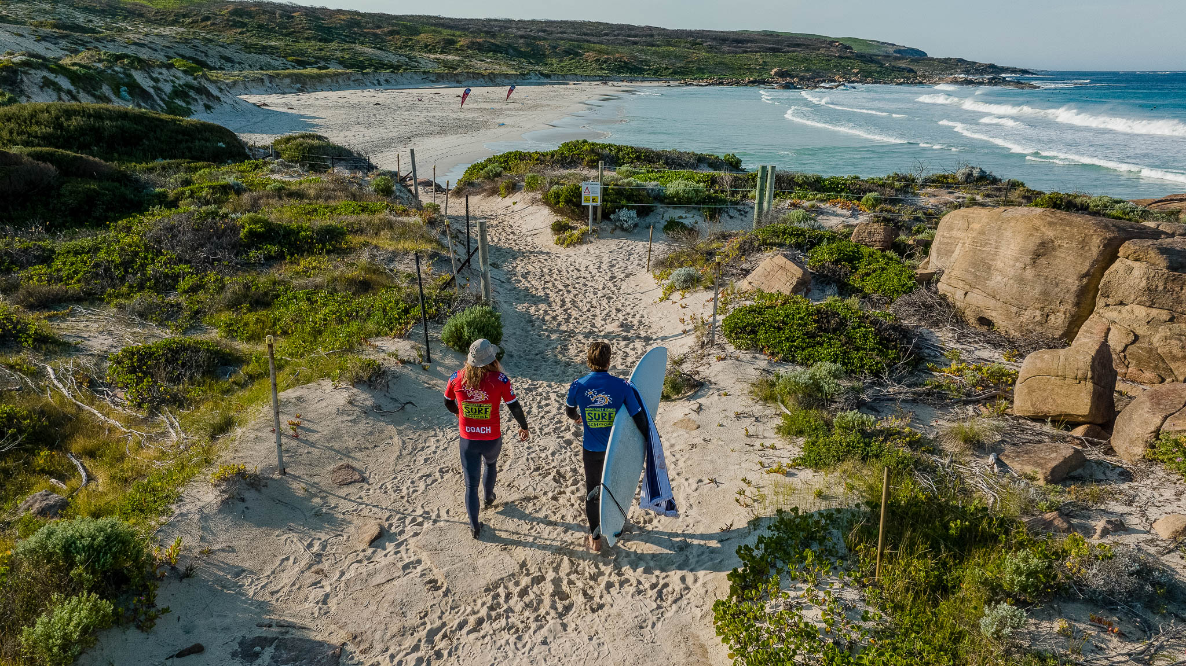
DJI_0151-edit-w.JPG
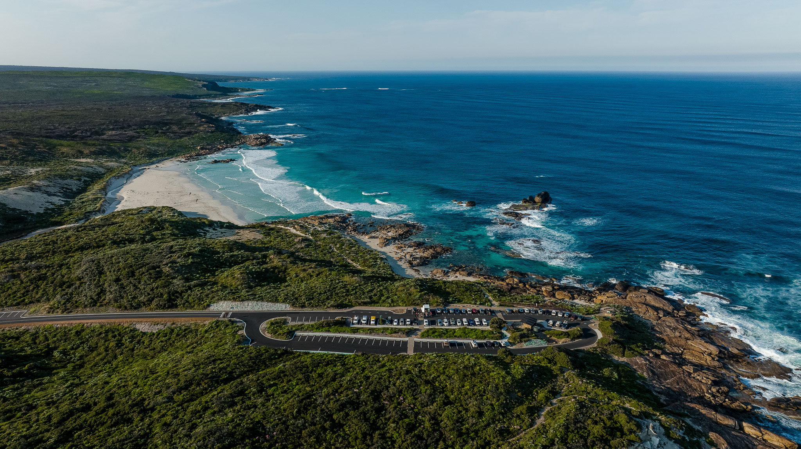
DJI_0138-2-edit-w.JPG
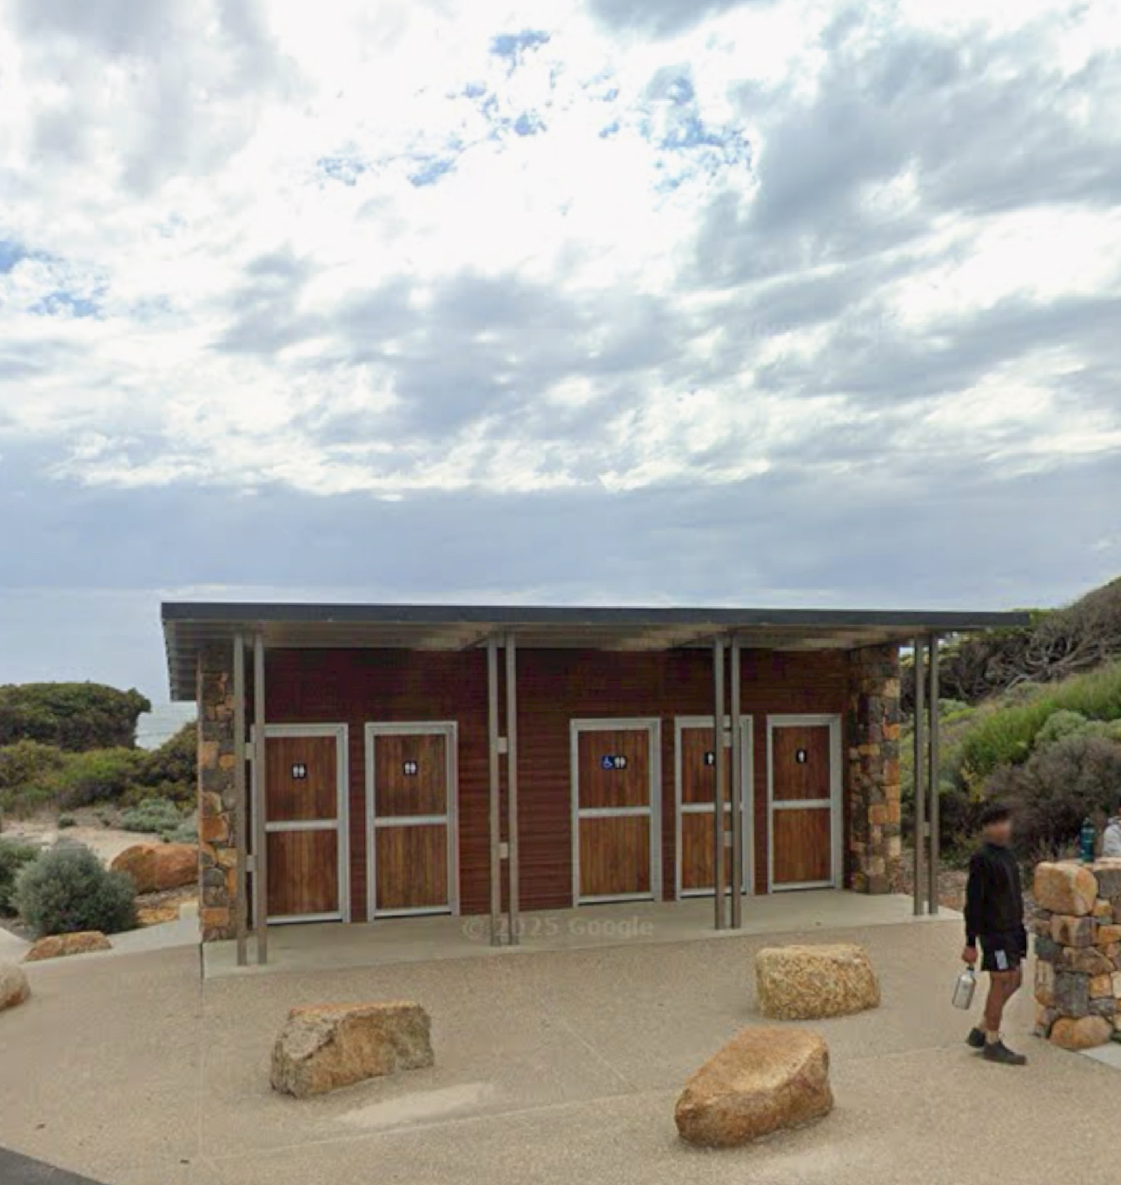
IMG_0855
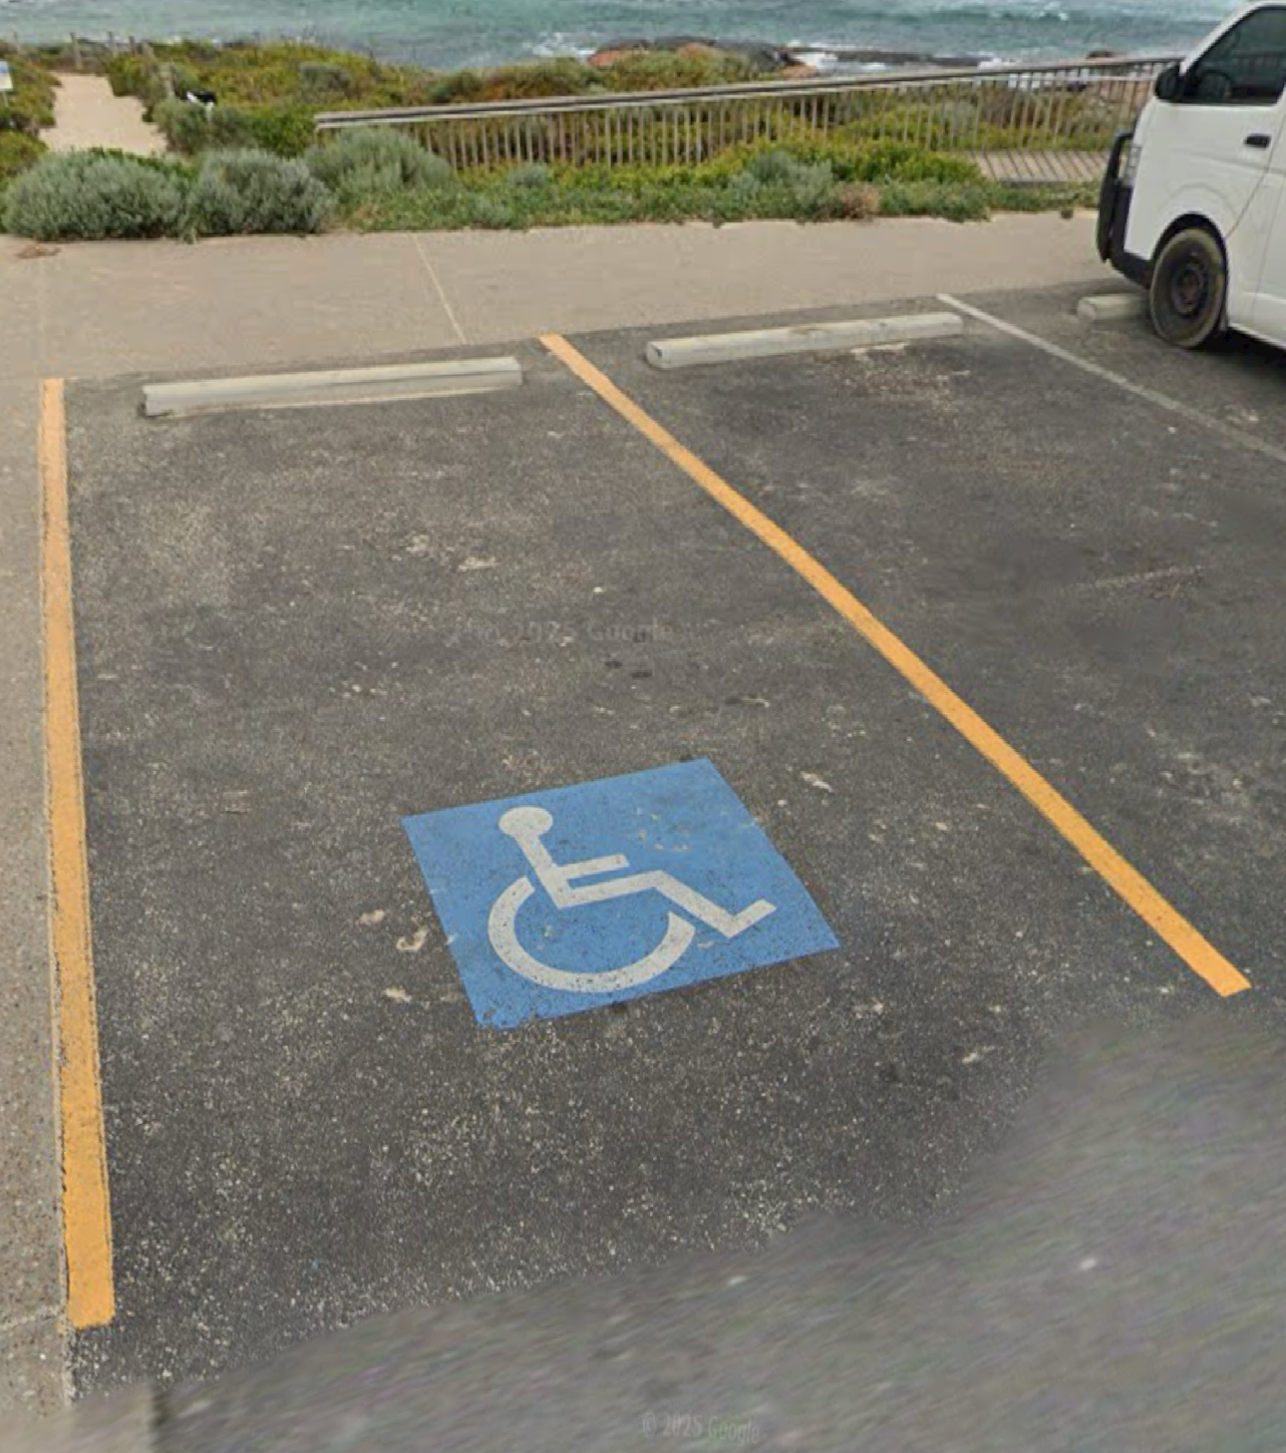
IMG_0856

COMMON AREAS

Report Disclaimer
Please note that this business report, provided as a result of the use of the diagnostic assessment, is for information purposes only.
Australian Tourism Industry Council (ATIC) cannot guarantee the accuracy of respondent’s answers, or that they are fully representative of your business. Therefore, ATIC does not warrant or guarantee any particular outcome in respect of your businesses self-assessment.
This report is intended as guidance only for your business and should not be relied on for future marketing considerations. ATIC recommends that you seek your own independent advice as well as the results from the diagnostic.
Links to external web sites are inserted for convenience and do not constitute endorsement of material at those sites, or any associated organisation, product or service.
ATIC does not:
- Assume any legal liability for the accuracy, completeness, or usefulness of any information from this report or any links provided; or
- Accept responsibility for any loss associated directly or indirectly from the use of this report.

