ATIC Accessibility
To support the accessible community in making informed travel decisions for their individual needs

This report prepared for:
Business name: | Adventure Sailing Pty Ltd
Address: | 8 Forth St
Town: | Abbey
Contact for enquiries: | Emma McPherson
Contact Number: | 0458772581
Contact Email: | paul@adventuresailing.com.au
Website: | adventuresailing.com.au
Date: | 2026-10-01 08:37

ATIC Accessibility
The following pages provides travellers with information on the businesses facilities and amenities which aims to support the traveller to make an informed decision on whether the business is suitable for their individual needs.
OVERVIEW 4
Business Overview 4
Bookings 4
Emergency Management 5
Communications 5
Guide Dog and Service Animals 5
GENERAL 6
Pre-arrival, arrival and reception 6
Cognitive Impairment Support 6
Car Park and Access amenities 6
Entry 6
Internal Spaces 7
Public areas 7
External Paths 7
Ramps 8
Public Toilets/Adult change facilities 8
TOUR OPERATORS 9
Tour/Transport Services 9
Route Planning 9
Guides 9
ACCOMMODATION 10
Bathrooms 10
FOOD AND DRINK 11
Dining Spaces 11
ADVENTURE ACTIVITIES 12
Report Disclaimer 14

OVERVIEW

Business Overview

The business has the following products/services available
- Tour/Transport
- Adventure

Our business caters for the following disability types:
- Blind or low vision
- Deaf or low hearing
- Limited mobility
- Wheelchairs or mobility scooters
- Food allergies or intolerances
- Cognitive or people on the Autism Spectrum
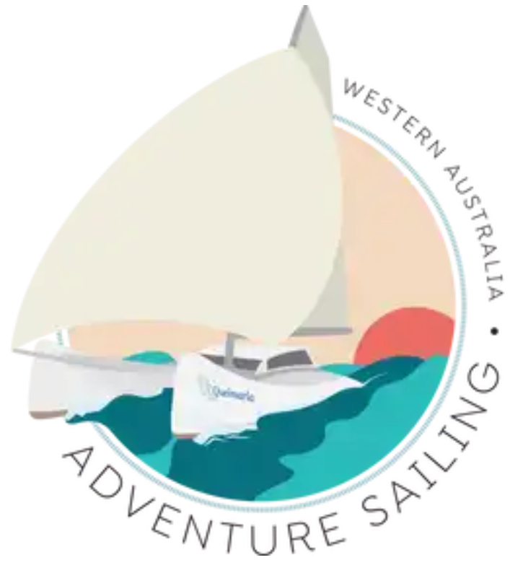

Bookings

The business offers the following methods for bookings and enquiries:
- Phone
- Email
- Webportal
- Our forms have high contract boxes and submit boxes

Emergency Management
- Emergency and evacuation procedures are explained on arrival
- Exit signs are clear and easy to see
- Exit access is free and clear at all times
We ensure exit access is free and clear at all times by:
Regular inspection and cleaning
- Exit doors are able to be opened by all occupants
- Exits to the emergency evacuation point does not include stairways
- In addition, the following further information can assist guests:
We request any medical, dietary or disability upon booking
- In addition, the following further information can assist guests:
Staff 1st aid and surf bronze qualified

Communications
- Our business offers the following alternative communication methods
- Plain English

We are a training organization. Students with learning difficulties are identified and accomadated with modified training and assessment

Guide Dog and Service Animals
- The business provides a secure area with shade and water for service animals
The business provides the following services for services animals:
shade and water

GENERAL

Pre-arrival, arrival and reception
The business has the following in place to support guests during pre-arrival, arrival and reception
- There is a reception/public entryway.
- Seating available at reception
- A lower counter at reception/ticket office
- Lighting in the reception area is even and glare free
- A familiarisation tour
- In addition, the following further information can assist guests:
Airconditioned reception/ classroom area with seating

Cognitive Impairment Support
- Documents are available in plain English for people with cognitive impairment (This may include instructions, guides, menus and general information)

Car Park and Access amenities
The business has the following Car Park and Access amenities
- A drop off zone
- Designated disabled parking bays
- The accessible entrance is clearly signed from the parking bay
- Kerb ramps are in place where a pavement or walkway needs to be crossed
- In addition, the following further information can assist guests:
Public car park at Port Geographe Marina

Entry
The business has the following amenities/systems in place for entry
- A drop off point close to the entrance
- A path of access to the building is slip resistance and even
- A path of access to the building is clear of obstruction
- Self opening entry doors or fitted with a self closer
- Glass doors are fitted with a visual sighting strip
- Door jams/doors are of a contrasting colour to surrounding walls
- Door handles are of a contrasting colour to the door
- Signage is written in a contrasting colour
- Signage is written in a Sans Serif font and use upper and lower case letters
- The entry door is a minimum of 850mm wide
- The entrance sill is less than 13mm
- There a clear space of at least 1500mm x 1500mm in front of all doors.
- The entrance door mats have a thickness less than 13mm and a width of 7500mm or greater

Internal Spaces
- Clear and unobstructed routes through and between buildings
- Interior walls are matte or low sheen
- Floors, walls, counters and furniture are of contrasting colours
- Any protruding or overhanging obstructions are at least 2meters above the floor or are protected
- Floor surfaces are hard or short pile carpet
- Seating is available for guests unable to stand for long periods
- Accessible facilities are clearly signed and visible from all areas
- All corridors greater than 900mm
- There is a quiet space for parents and children on the Autism Spectrum
- In addition, the following further information can assist guests:
We can working individually with participants with specific needs

Public areas
The public areas have the following amenities in place
- Even lighting
- Seating

External Paths
External paths of travel
- Surfaces are concrete, asphalt, smooth paving or hard packed fine gravel (max aggregate size 13mm)
- Paths or slopes longer than 15 metres have resting places or seats
- Pathways are wider than 900mm

No steps

Ramps
Ramps have the following amenities are in place
- There are ramps.
- All fixed ramps are 1:14 or less
- Hand rails are fitted
- Long ramps (more than 10m) are 1:20 or less
- Temporary ramps are available
- Temporary ramps are in place for the duration of the guests stay
- Ramps have a raised edge of at least 100mm
- In addition, the following further information can assist guests:
Ramp access to vessels

Public Toilets/Adult change facilities
Public Toilets/Adult change facilities have the following amenities are in place
- There is an accessible toilet for public use
- The door is at least 850mm wide
- There is a minimum of 850mm beside the toilet
- Handrails are fitted
- The toilet seat is 460mm above the floor
- The toilet seat of a contrasting colour to the floor
- The toilet seat is460mm above the floor
- There is a registered changing places facility
- There is a 'Changing Place' within 10m of our business
- In addition, the following further information can assist guests:
Public toilets located in Port Geographe Marina

TOUR OPERATORS

Tour/Transport Services
The tour/transport services have the following facilities/amenities in place
- Buses/Coaches
- nil vehicles have wheelchair lifts or ramps
- nil vehicles have low floors with ramped entry
The maximum wheelchair capacity available in the fleet is:
0

Route Planning
- In addition, the following further information can assist guests:
Toilet located down stairs on board
- Overnight Stops
The total number of wheelchair passengers that can be catered for at overnight stops are:
0

Guides
- Use of clear/simple English
- Correct pronunciation for lip readers
- Marine

ACCOMMODATION
- In addition, the following further information can assist guests:
No Rooms

Bathrooms
The bathrooms have the following facilities/amenities in place
- All heating appliances and hot water pipes are protected or insulated
- All shower, bath and basin taps are clearly differentiated between hot and cold
- Fixtures and fittings have rounded edges
- The hot water is thermostatically controlled to 41 degrees
- The door is at least 850mm wide
- There is a minimum of 850mm beside the toilet
- There is a minimum of 1400mm of clear space in front of the toilet
- The toilet seat is a contrasting colour to the floor
- The toilet seat is 460mm above the floor
- There is a portable shower head on flexible hose
- A door is fitted to the shower
- A door is fitted to the showers with an outward swing at minimum width of 900 mm
- In addition, the following further information can assist guests:
Public toilet facilities at the Port Geographe Marina. No disabled toiltet facilities on board vessels

FOOD AND DRINK

Dining Spaces
The dining spaces have the following facilities/amenities in place
- The entrance has level access
- The doorway is at least 850mm wide
- There is level access through the dining area
- There are areas of full lighting
- There is an accessible toilet close by that is open during our business hours

Our business caters for the following dietary requirements
- Sugar free (diabetic)
- Gluten free (celiac)
- Lactose free (dairy free)
- Low fat and fibre with no gastric content
- Low potassium
- Low sodium
- Nut free
- Additive free
- Organic
- Vegetarian
- Vegan
- Kosher
- Halal
- In addition, the following further information can assist guests:
Students cook there own meals
- In addition, the following further information can assist guests:
We are not a resturant. No menus

ADVENTURE ACTIVITIES

Report Disclaimer
Please note that this business report, provided as a result of the use of the diagnostic assessment, is for information purposes only.
Australian Tourism Industry Council (ATIC) cannot guarantee the accuracy of respondent’s answers, or that they are fully representative of your business. Therefore, ATIC does not warrant or guarantee any particular outcome in respect of your businesses self-assessment.
This report is intended as guidance only for your business and should not be relied on for future marketing considerations. ATIC recommends that you seek your own independent advice as well as the results from the diagnostic.
Links to external web sites are inserted for convenience and do not constitute endorsement of material at those sites, or any associated organisation, product or service.
ATIC does not:
- Assume any legal liability for the accuracy, completeness, or usefulness of any information from this report or any links provided; or
- Accept responsibility for any loss associated directly or indirectly from the use of this report.

