ATIC Accessibility
To support the accessible community in making informed travel decisions for their individual needs

This report prepared for:
Business name: | Trek Ningaloo
Address: | 26 Fyfe Street
Town: | Exmouth
Contact for enquiries: | Ian Vickers
Contact Number: | 0422570043
Contact Email: | ian@trekningaloo.com.au
Website: | www.trekningaloo.com.au
Date: | 2026-10-01 09:22

ATIC Accessibility
The following pages provides travellers with information on the businesses facilities and amenities which aims to support the traveller to make an informed decision on whether the business is suitable for their individual needs.
OVERVIEW 3
Business Overview 3
Bookings 3
Emergency Management 3
Guide Dog and Service Animals 3
GENERAL 4
Car Park and Access amenities 4
Displays, exhibits, commentary and live performances 4
TOUR OPERATORS 5
Route Planning 5
Guides 5
Report Disclaimer 7

OVERVIEW

Business Overview

Our business caters for the following disability types:
- Food allergies or intolerances


Bookings

The business offers the following methods for bookings and enquiries:
- Phone
- Webportal

Emergency Management
- Emergency and evacuation procedures are explained on arrival

Guide Dog and Service Animals
The business provides the following services for services animals:
none

GENERAL
- In addition, the following further information can assist guests:
none
- In addition, the following further information can assist guests:
Trek Ningaloo offers off track, trekking tours that traverse rough, rugged terrain, as such all participants need to be able to carry a pack and negotiate steep gorges and canyons over long distances

Car Park and Access amenities
The business has the following Car Park and Access amenities
- A drop off zone

Displays, exhibits, commentary and live performances
For displays, exhibits, commentary and live performances the following amenities are in place
The width of the smallest pathway is:
N/A
- In addition, the following further information can assist guests:
Trek Ningaloo offers off track, trekking tours that traverse rough, rugged terrain, as such all participants need to be able to carry a pack and negotiate steep gorges and canyons over long distances
- There is N/A mm of clear space in front of the toilet

TOUR OPERATORS

Route Planning
- Route Planning
- Walking Tours

Guides

Guides have been trained in the following
- Use of clear/simple English
- Correct pronunciation for lip readers
- There is a audio description of surroundings
  - Image(s)
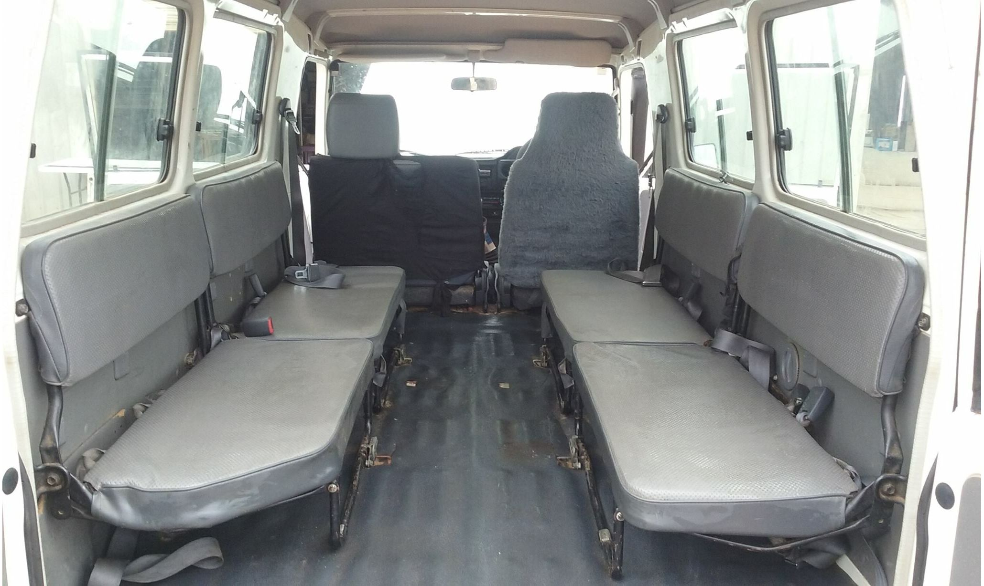
Troopy

Report Disclaimer
Please note that this business report, provided as a result of the use of the diagnostic assessment, is for information purposes only.
Australian Tourism Industry Council (ATIC) cannot guarantee the accuracy of respondent’s answers, or that they are fully representative of your business. Therefore, ATIC does not warrant or guarantee any particular outcome in respect of your businesses self-assessment.
This report is intended as guidance only for your business and should not be relied on for future marketing considerations. ATIC recommends that you seek your own independent advice as well as the results from the diagnostic.
Links to external web sites are inserted for convenience and do not constitute endorsement of material at those sites, or any associated organisation, product or service.
ATIC does not:
- Assume any legal liability for the accuracy, completeness, or usefulness of any information from this report or any links provided; or
- Accept responsibility for any loss associated directly or indirectly from the use of this report.

