ATIC Accessibility
To support the accessible community in making informed travel decisions for their individual needs

This report prepared for:
Business name: | Villa Carlotta Travel
Address: | Suite 2
Town: | Busselton
Contact for enquiries: | Michelle Sorgiovanni
Contact Number: | 0897542026
Contact Email: | travel@villa.com.au
Website: | www.villa.com.au
Date: | 2026-10-15 10:28

ATIC Accessibility
The following pages provides travellers with information on the businesses facilities and amenities which aims to support the traveller to make an informed decision on whether the business is suitable for their individual needs.
OVERVIEW 4
Business Overview 4
Bookings 4
Emergency Management 4
Guide Dog and Service Animals 5
GENERAL 6
Pre-arrival, arrival and reception 6
Cognitive Impairment Support 6
Car Park and Access amenities 6
Entry 7
Internal Spaces 7
Public areas 8
External Paths 8
TOUR OPERATORS 9
Tour/Transport Services 9
Route Planning 9
Guides 9
Report Disclaimer 12

OVERVIEW

Business Overview

The business has the following products/services available
- Tour/Transport

Our business caters for the following disability types:
- Limited mobility
- Food allergies or intolerances
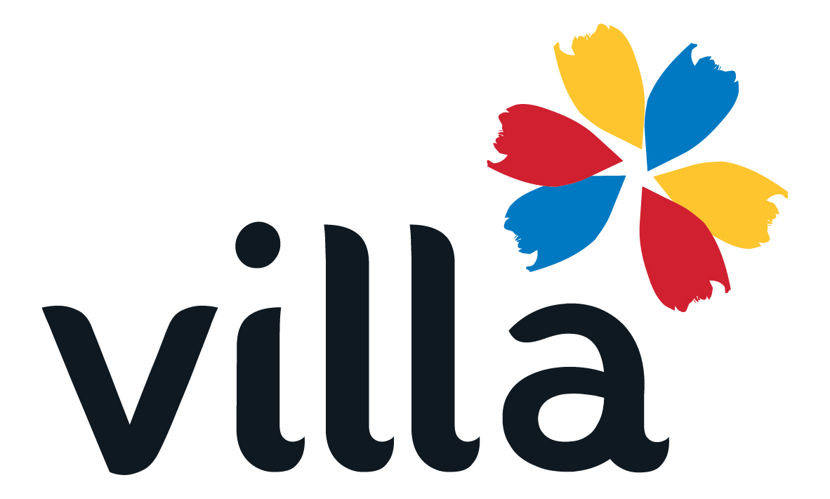

Bookings

The business offers the following methods for bookings and enquiries:
- Phone
- Email

Emergency Management
- Emergency and evacuation procedures are explained on arrival
- Exit signs are clear and easy to see
- Exit access is free and clear at all times
We ensure exit access is free and clear at all times by:
Emergency access is the same access to board and disembark coaches, it is only obstructed by people boarding and disembarking the vehicle
- Exit doors are able to be opened by all occupants
- Exits to the emergency evacuation point does not include stairways
- The evacuation point is clearly marked by a sign
- In addition, the following further information can assist guests:
Passengers are assisted on our tours by their travelling companions. Our staff observe and check in with any passengers who may need assistance during the tour. We defer to each venue's procedures regarding emergency procedures.
- In addition, the following further information can assist guests:
Emergency procedures for the touring coaches, and defer to venue staff at specific locations

Guide Dog and Service Animals
The business provides the following services for services animals:
None as touring coaches are not accessible to the general public

GENERAL

Pre-arrival, arrival and reception
The business has the following in place to support guests during pre-arrival, arrival and reception
- There is a reception/public entryway.
- Seating available at reception
- A lower counter at reception/ticket office
- A clipboard to allow check-in/ticket purchase whilst seated
- Information and maps are available in written form
- In addition, the following further information can assist guests:
N/A
- In addition, the following further information can assist guests:
Our escorted touring programs are designed to help guests explore the diverse and often remote landscapes of Western Australia, and we want every traveller to have a safe, comfortable, and genuinely enjoyable experience. Because our tours venture into regional and remote environments — across natural terrain, heritage sites, and locations with limited infrastructure — they involve varying levels of physical activity that may not suit everyone at every stage of life. Each tour carries a clearly defined Activity Level to help assess suitability, we encourage everyone to review these carefully before booking. If anyone has any questions about whether a tour is the right fit, we warmly invite them to reach out — we're happy to talk through their needs, explain what's involved, and help them find the perfect journey.

Cognitive Impairment Support
- Documents are available in plain English for people with cognitive impairment (This may include instructions, guides, menus and general information)
- Quiet periods or early opening times for people on the Autism Spectrum

Car Park and Access amenities
The business has the following Car Park and Access amenities
- Designated disabled parking bays
- Level or ramped access from the car park to the entrance
- The accessible entrance is clearly signed from the parking bay
- In addition, the following further information can assist guests:
Our escorted touring programs are designed to help guests explore the diverse and often remote landscapes of Western Australia, and we want every traveller to have a safe, comfortable, and genuinely enjoyable experience. Because our tours venture into regional and remote environments — across natural terrain, heritage sites, and locations with limited infrastructure — they involve varying levels of physical activity that may not suit everyone at every stage of life. Each tour carries a clearly defined Activity Level to help assess suitability, we encourage everyone to review these carefully before booking. If anyone has any questions about whether a tour is the right fit, we warmly invite them to reach out — we're happy to talk through their needs, explain what's involved, and help them find the perfect journey.

Entry
The business has the following amenities/systems in place for entry
- A drop off point close to the entrance
- A path of access to the building is slip resistance and even
- A path of access to the building is clear of obstruction
- Self opening entry doors or fitted with a self closer
- Glass doors are fitted with a visual sighting strip
- Door jams/doors are of a contrasting colour to surrounding walls
- The entry door is a minimum of 850mm wide
- The entry door has self opening or a light opening pressure (for manual operations)
- There a clear space of at least 1500mm x 1500mm in front of all doors.
- The entrance door mats have a thickness less than 13mm and a width of 7500mm or greater
- In addition, the following further information can assist guests:
Reception area is staffed during open hours
- In addition, the following further information can assist guests:
N/A

Internal Spaces
- Clear and unobstructed routes through and between buildings
- Interior walls are matte or low sheen
- Floors, walls, counters and furniture are of contrasting colours
- Floor surfaces are hard or short pile carpet
- Seating is available for guests unable to stand for long periods
- Accessible facilities are clearly signed and visible from all areas
- All corridors greater than 900mm

Public areas
The public areas have the following amenities in place
- Even lighting
- Seating

External Paths
External paths of travel
- Surfaces are concrete, asphalt, smooth paving or hard packed fine gravel (max aggregate size 13mm)
- Pathways are wider than 900mm
- In addition, the following further information can assist guests:
There are not steps to access the reception area
- In addition, the following further information can assist guests:
N/A

TOUR OPERATORS

Tour/Transport Services
The tour/transport services have the following facilities/amenities in place
- Buses/Coaches
- None vehicles have wheelchair lifts or ramps
- None vehicles have low floors with ramped entry
The maximum wheelchair capacity available in the fleet is:
0

Route Planning
- Route Planning
- The tour route includes stops with accessible toilet facilities
- In addition, the following further information can assist guests:
Our escorted touring programs are designed to help guests explore the diverse and often remote landscapes of Western Australia, and we want every traveller to have a safe, comfortable, and genuinely enjoyable experience. Because our tours venture into regional and remote environments — across natural terrain, heritage sites, and locations with limited infrastructure — they involve varying levels of physical activity that may not suit everyone at every stage of life. Each tour carries a clearly defined Activity Level to help assess suitability, we encourage everyone to review these carefully before booking. If anyone has any questions about whether a tour is the right fit, we warmly invite them to reach out — we're happy to talk through their needs, explain what's involved, and help them find the perfect journey.
- Overnight Stops
- For overnight stays, wheelchair accessible rooms are available
The total number of wheelchair passengers that can be catered for at overnight stops are:
0
- Walking Tours
- Multi-paced to account for slower walkers

Guides

Guides have been trained in the following
- Use of clear/simple English
- Correct pronunciation for lip readers
- In addition, the following further information can assist guests:
N/A - we operate 120 different tours across WA, Australia and overseas each year, and have over 300 venues in our database. It is impractical to answer this question.
- In addition, the following further information can assist guests:
We work with approximately 300 different venues, tours and attractions (built and nature based) each year to help deliver our group tour itineraries. In regional and remote locations there is significant variation in the level of accessibility, facilities, and services available. We do our best to secure suitable accessible venues, tours and attractions, we are always happy to discuss individual accessibility needs to help determine the suitability of a particular tour.

Report Disclaimer
Please note that this business report, provided as a result of the use of the diagnostic assessment, is for information purposes only.
Australian Tourism Industry Council (ATIC) cannot guarantee the accuracy of respondent’s answers, or that they are fully representative of your business. Therefore, ATIC does not warrant or guarantee any particular outcome in respect of your businesses self-assessment.
This report is intended as guidance only for your business and should not be relied on for future marketing considerations. ATIC recommends that you seek your own independent advice as well as the results from the diagnostic.
Links to external web sites are inserted for convenience and do not constitute endorsement of material at those sites, or any associated organisation, product or service.
ATIC does not:
- Assume any legal liability for the accuracy, completeness, or usefulness of any information from this report or any links provided; or
- Accept responsibility for any loss associated directly or indirectly from the use of this report.

