ATIC Accessibility
To support the accessible community in making informed travel decisions for their individual needs

This report prepared for:
Business name: | Seppeltsfield Wines
Address: | 730 Seppeltsfield Road
Town: | Seppeltsfield
Contact for enquiries: | Diana Williams
Contact Number: | (08) 8568 6200
Contact Email: | cellarsales@seppeltsfield.com.au
Website: | https://seppeltsfield.com.au/
Date: | 2026-11-04 01:28

ATIC Accessibility
The following pages provides travellers with information on the businesses facilities and amenities which aims to support the traveller to make an informed decision on whether the business is suitable for their individual needs.
OVERVIEW 4
Business Overview 4
Bookings 4
Emergency Management 5
Communications 5
Other Information 6
Guide Dog and Service Animals 6
GENERAL 7
Pre-arrival, arrival and reception 7
Car Park and Access amenities 7
Entry 7
Internal Spaces 8
Public areas 8
Displays, exhibits, commentary and live performances 8
External Paths 9
Steps 9
Ramps 9
Public Toilets/Adult change facilities 9
ATTRACTIONS 11
Attractions Basics 11
COMMON AREAS 16
Parks and gardens 16
FOOD AND DRINK 19
Dining Spaces 19
Report Disclaimer 22

OVERVIEW

Business Overview

The business has the following products/services available
- Attraction
- Food and Drink

Our business caters for the following disability types:
- Blind or low vision
- Deaf or low hearing
- Limited mobility
- Wheelchairs or mobility scooters
- Food allergies or intolerances
- Cognitive or people on the Autism Spectrum
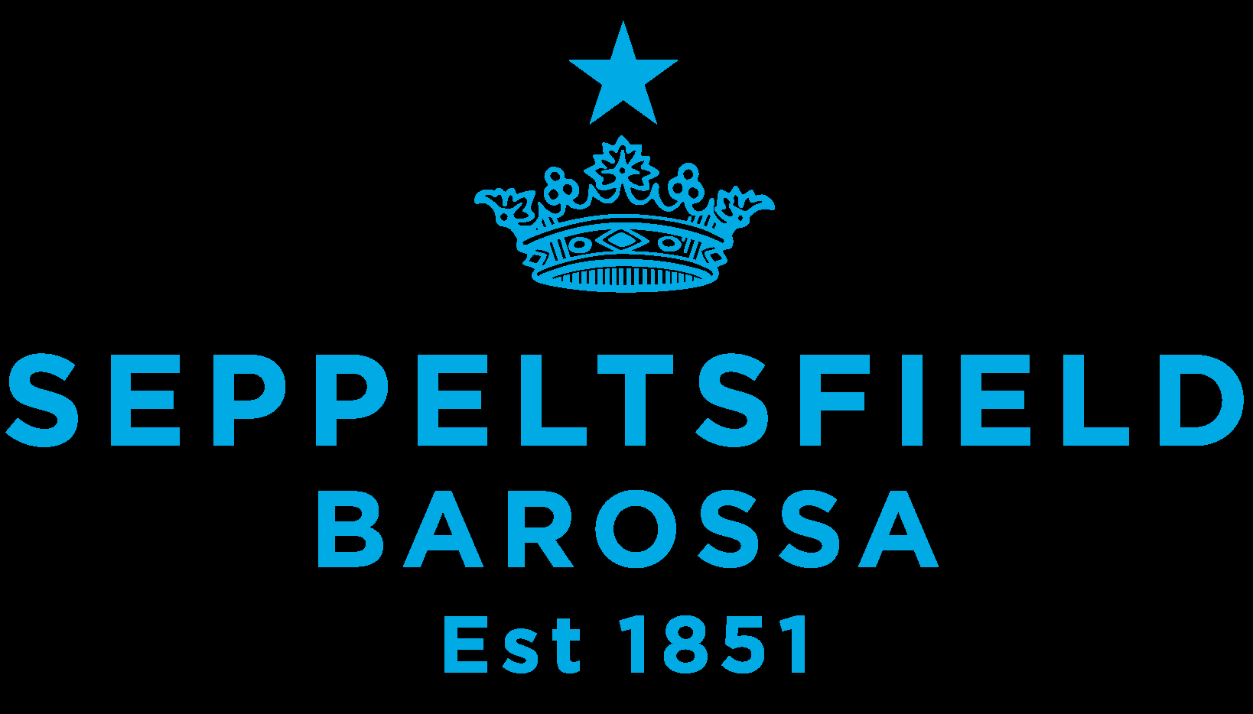

Bookings

The business offers the following methods for bookings and enquiries:
- Phone
- Email
- Webportal
- Our forms have high contract boxes and submit boxes

Emergency Management

Our Estate is open for general public access on a daily basis. Signage is provided inside buildings but visitors are able to wander the grounds in their own time.
- There are Audible device/s to alert occupants to evacuate with instructions on how to evacuate.
- Exit signs are clear and easy to see
- Exit access is free and clear at all times
We ensure exit access is free and clear at all times by:
Staff training and signage to keep access areas clear
- Exits and access to exists are greater than 900mm
- Exit doors are able to be opened by all occupants
- Exits to the emergency evacuation point does not include stairways
- The evacuation point is clearly marked by a sign
- In addition, the following further information can assist guests:
Staff trained as evacuation and fire wardens will check with customers to see if assistance is required.
- In addition, the following further information can assist guests:
Staff trained as evacuation and fire wardens will assist as required.

Communications
- An accessibility guide is available on the website

https://seppeltsfield.com.au/accessibility-at-seppeltsfield/
- Our business offers the following alternative communication methods
- Plain English

Not specified
- There is easy to read signage and information (e.g. menus and emergency information)

Other Information
- For bookings made onsite, the ticket booth/counter/box office is accessible for people using a wheelchair
- The business accepts the companion card

Guide Dog and Service Animals
- The business provides a toilet area for service animals
The business provides the following services for services animals:
Service animals are welcome

GENERAL

Pre-arrival, arrival and reception
The business has the following in place to support guests during pre-arrival, arrival and reception
- Information and maps are available in written form
- A step free map/guide
- In addition, the following further information can assist guests:
Seating is provided around the site for visitors to utilise, including outside cellar door.
- In addition, the following further information can assist guests:
The descriptions for our online bookable experiences include a link to our Accessibility Page and an email address to contact us for any additional questions or specific assistance required.

Car Park and Access amenities
The business has the following Car Park and Access amenities
- A drop off zone
- Designated disabled parking bays
- Level or ramped access from the car park to the entrance
- The accessible entrance is clearly signed from the parking bay
- Kerb ramps are in place where a pavement or walkway needs to be crossed
- In addition, the following further information can assist guests:
Accessibility ramps are in place where possible inside and outside of buildings.

Entry
The business has the following amenities/systems in place for entry
- A drop off point close to the entrance
- A path of access to the building is slip resistance and even
- A path of access to the building is clear of obstruction
- Glass doors are fitted with a visual sighting strip
- Door handles are of a contrasting colour to the door
- Signage is written in a contrasting colour
- The entry door is a minimum of 850mm wide
- The entrance sill is less than 13mm
- There a clear space of at least 1500mm x 1500mm in front of all doors.
- The entrance door mats have a thickness less than 13mm and a width of 7500mm or greater
- In addition, the following further information can assist guests:
All public buildings on the Estate have accessible entrances

Internal Spaces
- Interior walls are matte or low sheen
- Floors, walls, counters and furniture are of contrasting colours
- Tableware/glassware contrast with the table surface or table cloth
- Floor surfaces are hard or short pile carpet
- Seating is available for guests unable to stand for long periods
- All corridors greater than 900mm
- In addition, the following further information can assist guests:
Some areas of our heritage buildings are not accessible to all visitors, but main visitor areas are accessible.

Public areas
The public areas have the following amenities in place
- Display units, Televisions, Video displays etc. are open captioned
- Even lighting
- Seating
- In addition, the following further information can assist guests:
Seating if provided in Cellar Door for guests undertaking a wine tasting

Displays, exhibits, commentary and live performances
For displays, exhibits, commentary and live performances the following amenities are in place
- Seating
- Wheelchair accessible spaces/seating
- In addition, the following further information can assist guests:
Self guided and guided tours around the Estate are offered. Seating is available at various locations on the tour routes.

External Paths
External paths of travel
- Surfaces are concrete, asphalt, smooth paving or hard packed fine gravel (max aggregate size 13mm)
- Pathways are wider than 900mm
- There 3 successive steps or less on any path or at any doorway
- In addition, the following further information can assist guests:
Some areas of the Estate that are not open for daily general public access, are not fully accessible. Some tour routes can be modified, but some private tour locations within the heritage buildings are not fully accessible. This is clearly detailed on our website.

Steps
Steps
- There are steps.
- All steps or staircases have enclosed risers
- The underside of all staircases are enclosed or protected to a height of at least 2 metres
- Handrails fitted to all open sets of steps
- In addition, the following further information can assist guests:
Some private tour locations within the heritage buildings are not fully accessible. This is clearly detailed on our website.

Ramps
Ramps have the following amenities are in place
- There are ramps.
- All fixed ramps are 1:14 or less
- Hand rails are fitted
- In addition, the following further information can assist guests:
Ramps installed within and for access into public buildings

Public Toilets/Adult change facilities
Public Toilets/Adult change facilities have the following amenities are in place
- There is an accessible toilet for public use
- The door is at least 850mm wide
- There is a minimum of 850mm beside the toilet
- Handrails are fitted
- The toilet seat of a contrasting colour to the floor
- The toilet seat is460mm above the floor
- In addition, the following further information can assist guests:
Two accessible toilets are located on our Estate

ATTRACTIONS

Attractions Basics
- A park map is available here:

https://seppeltsfield.com.au/seppeltsfield-site-map/
  - Image(s)
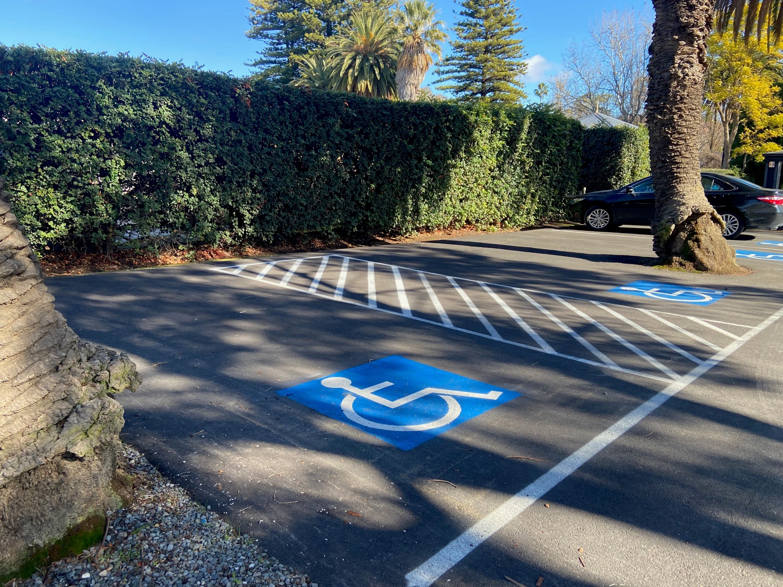
Accessible parking
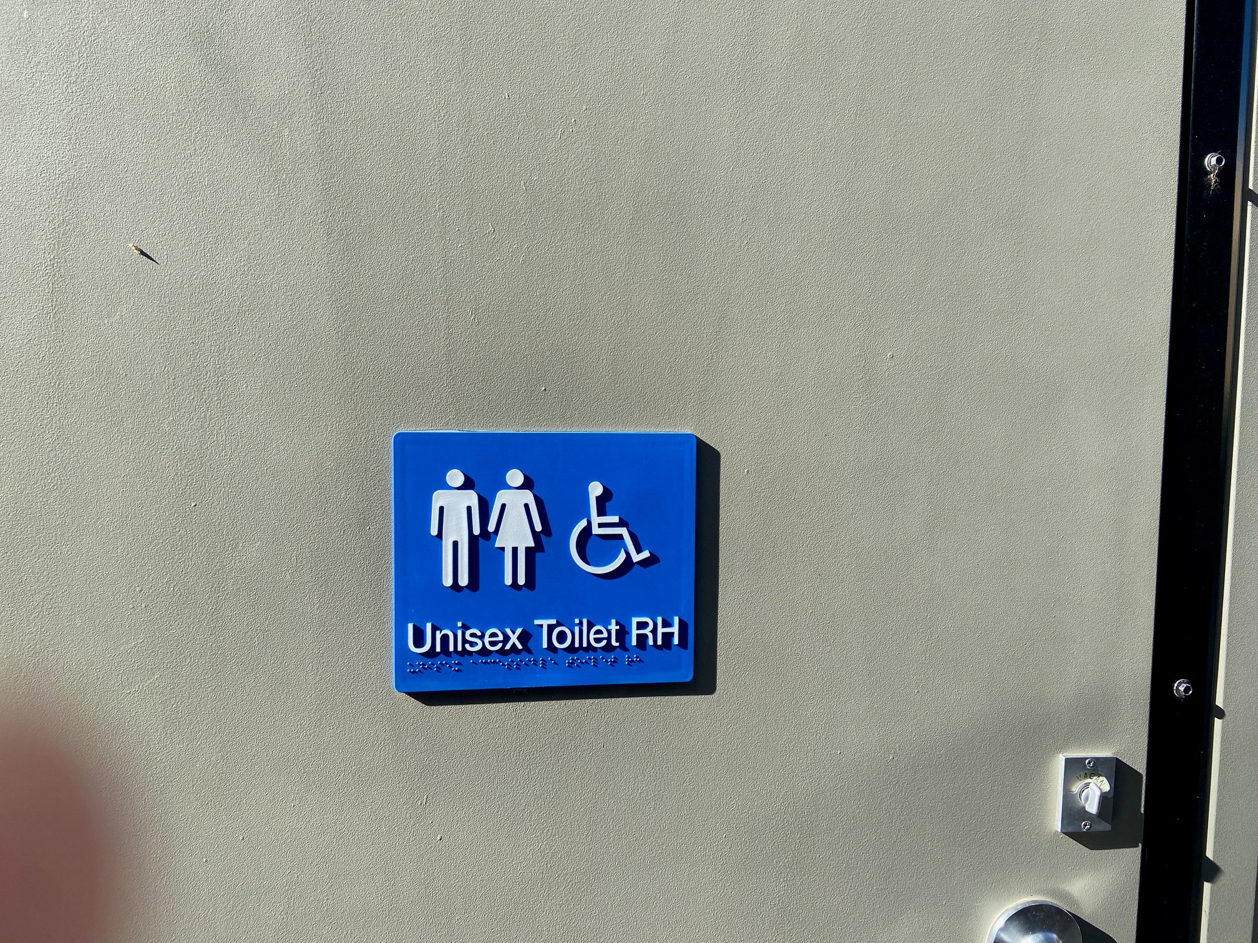
Accessible toilet sign with symbols and braille
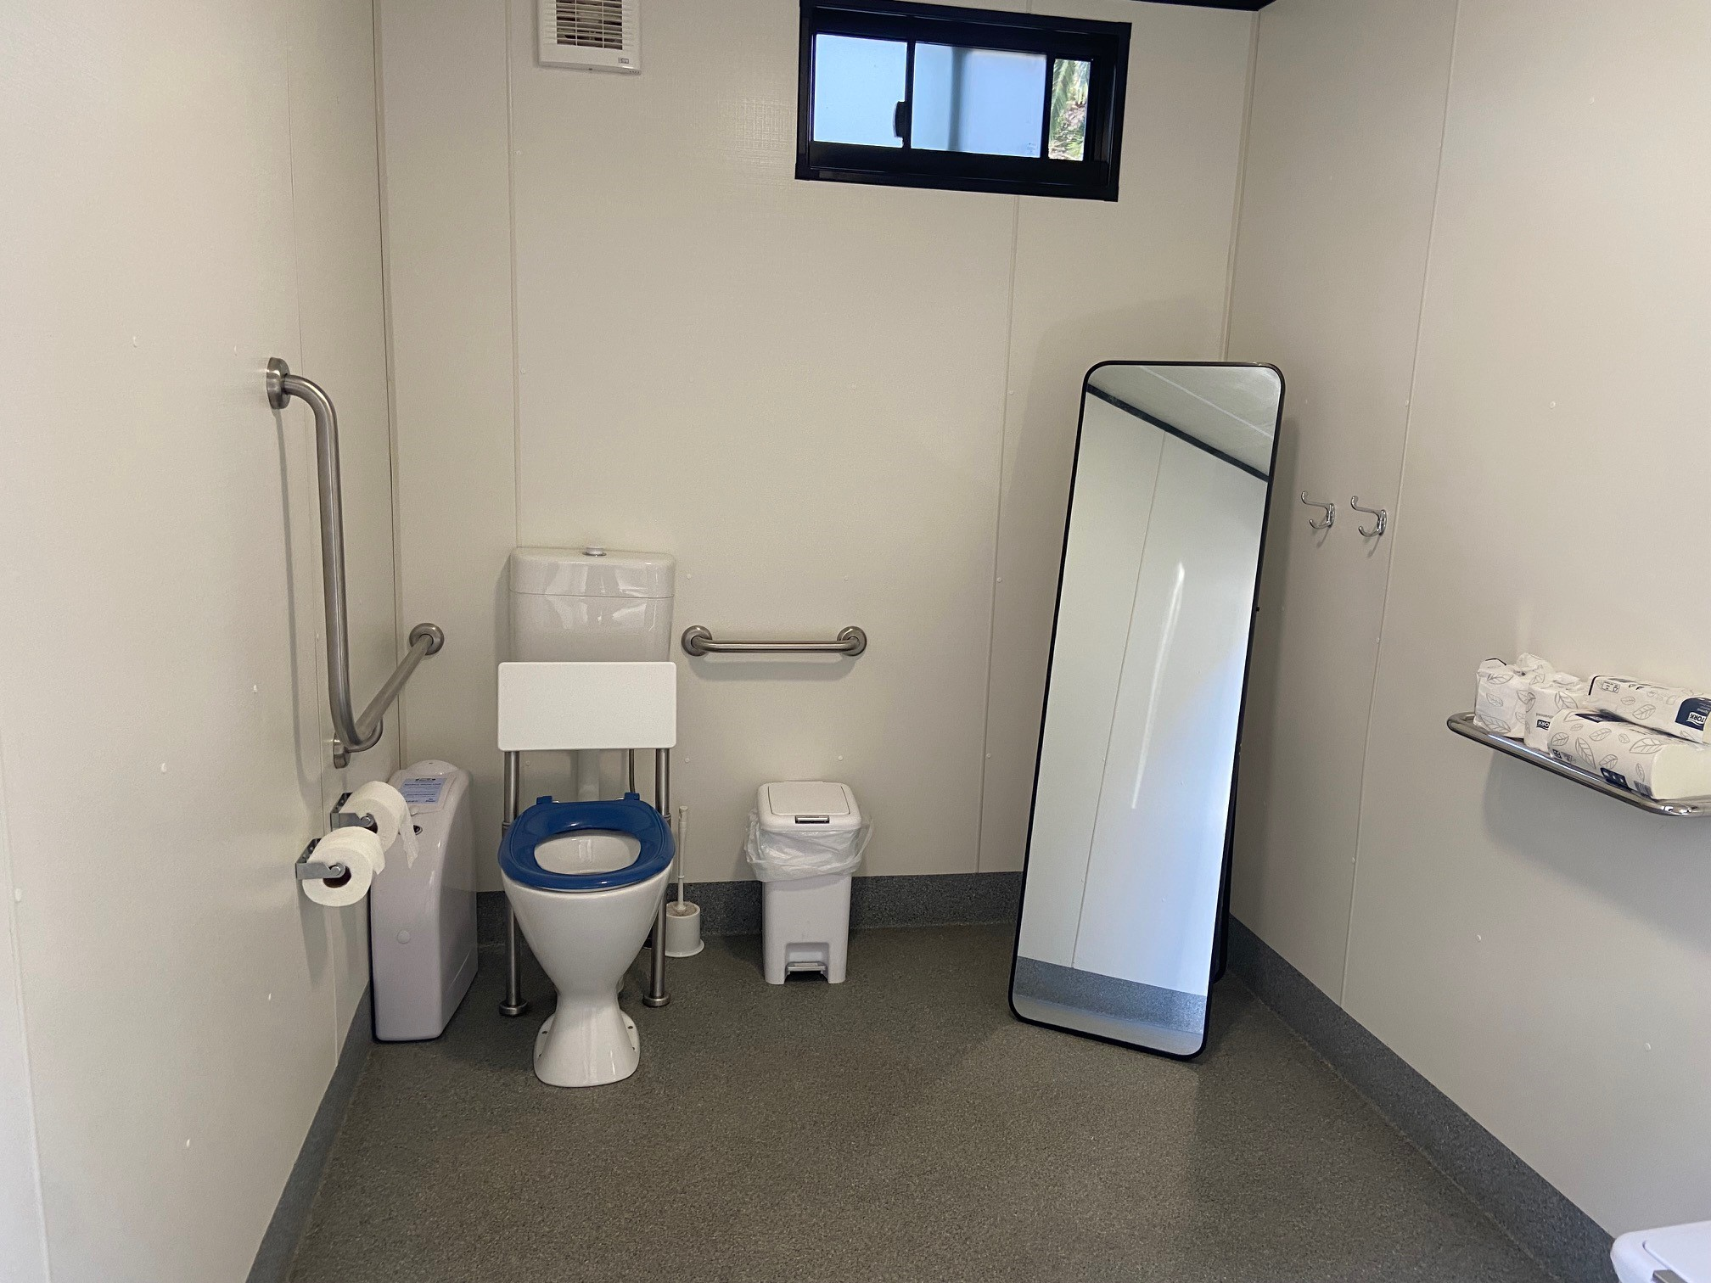
Accessible toilet
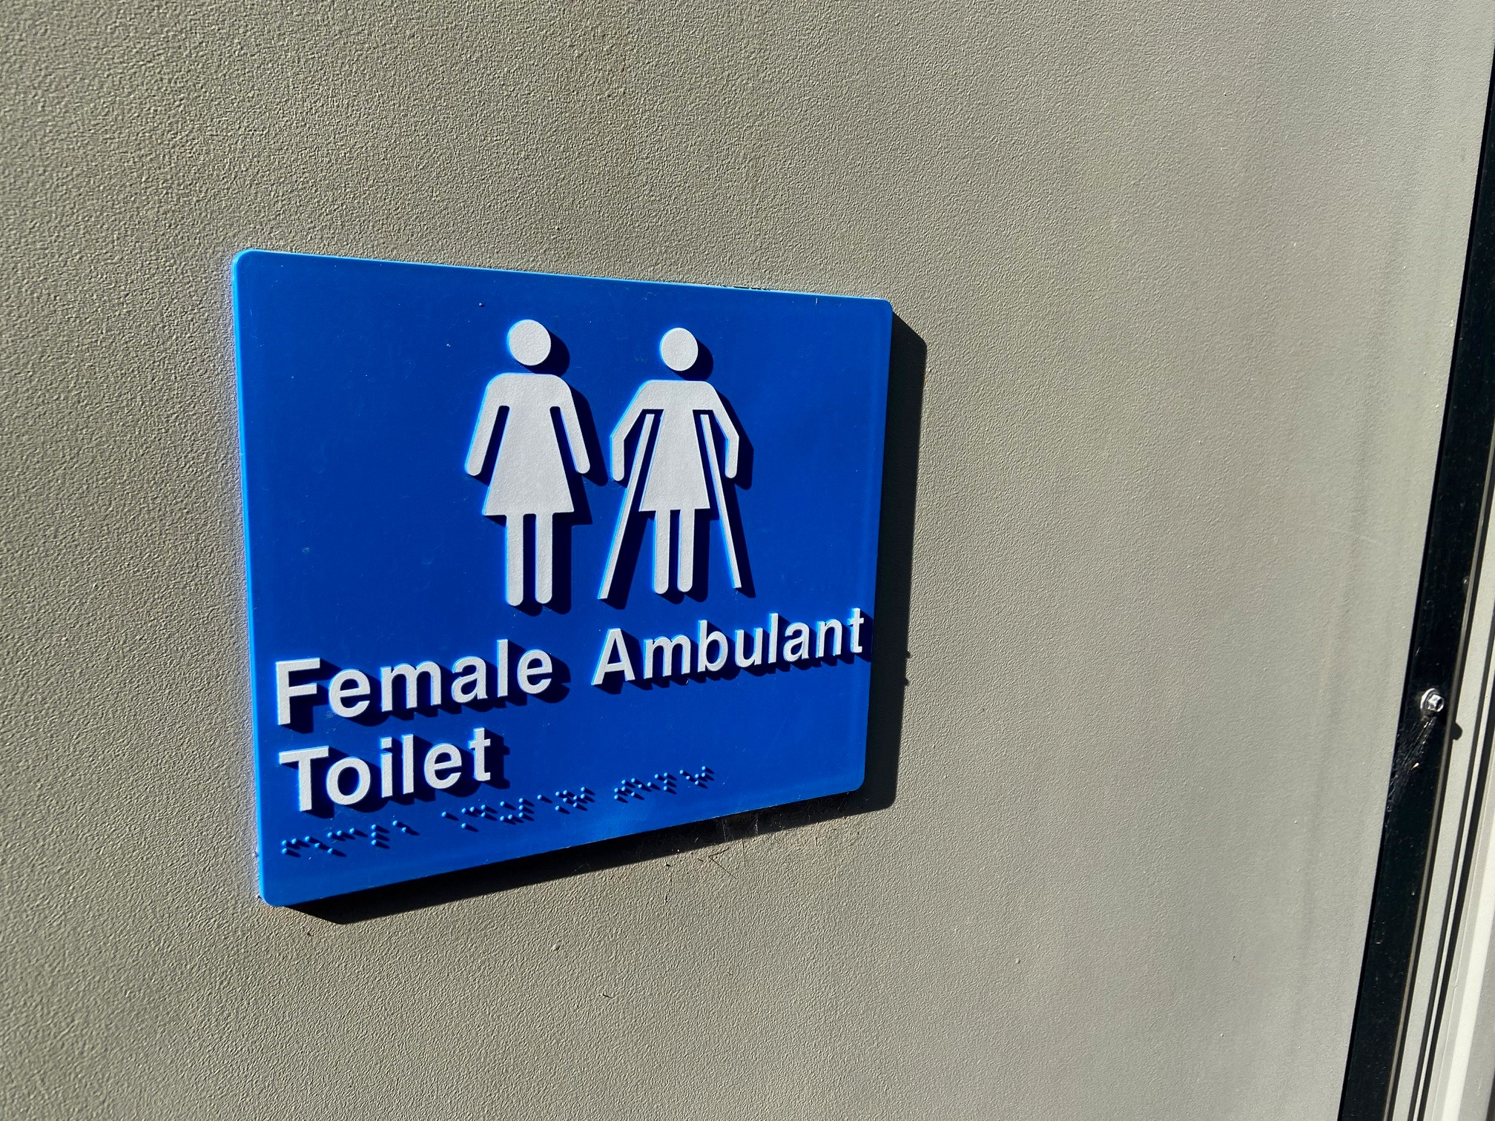
Ambulant toilets with signs with images and braille
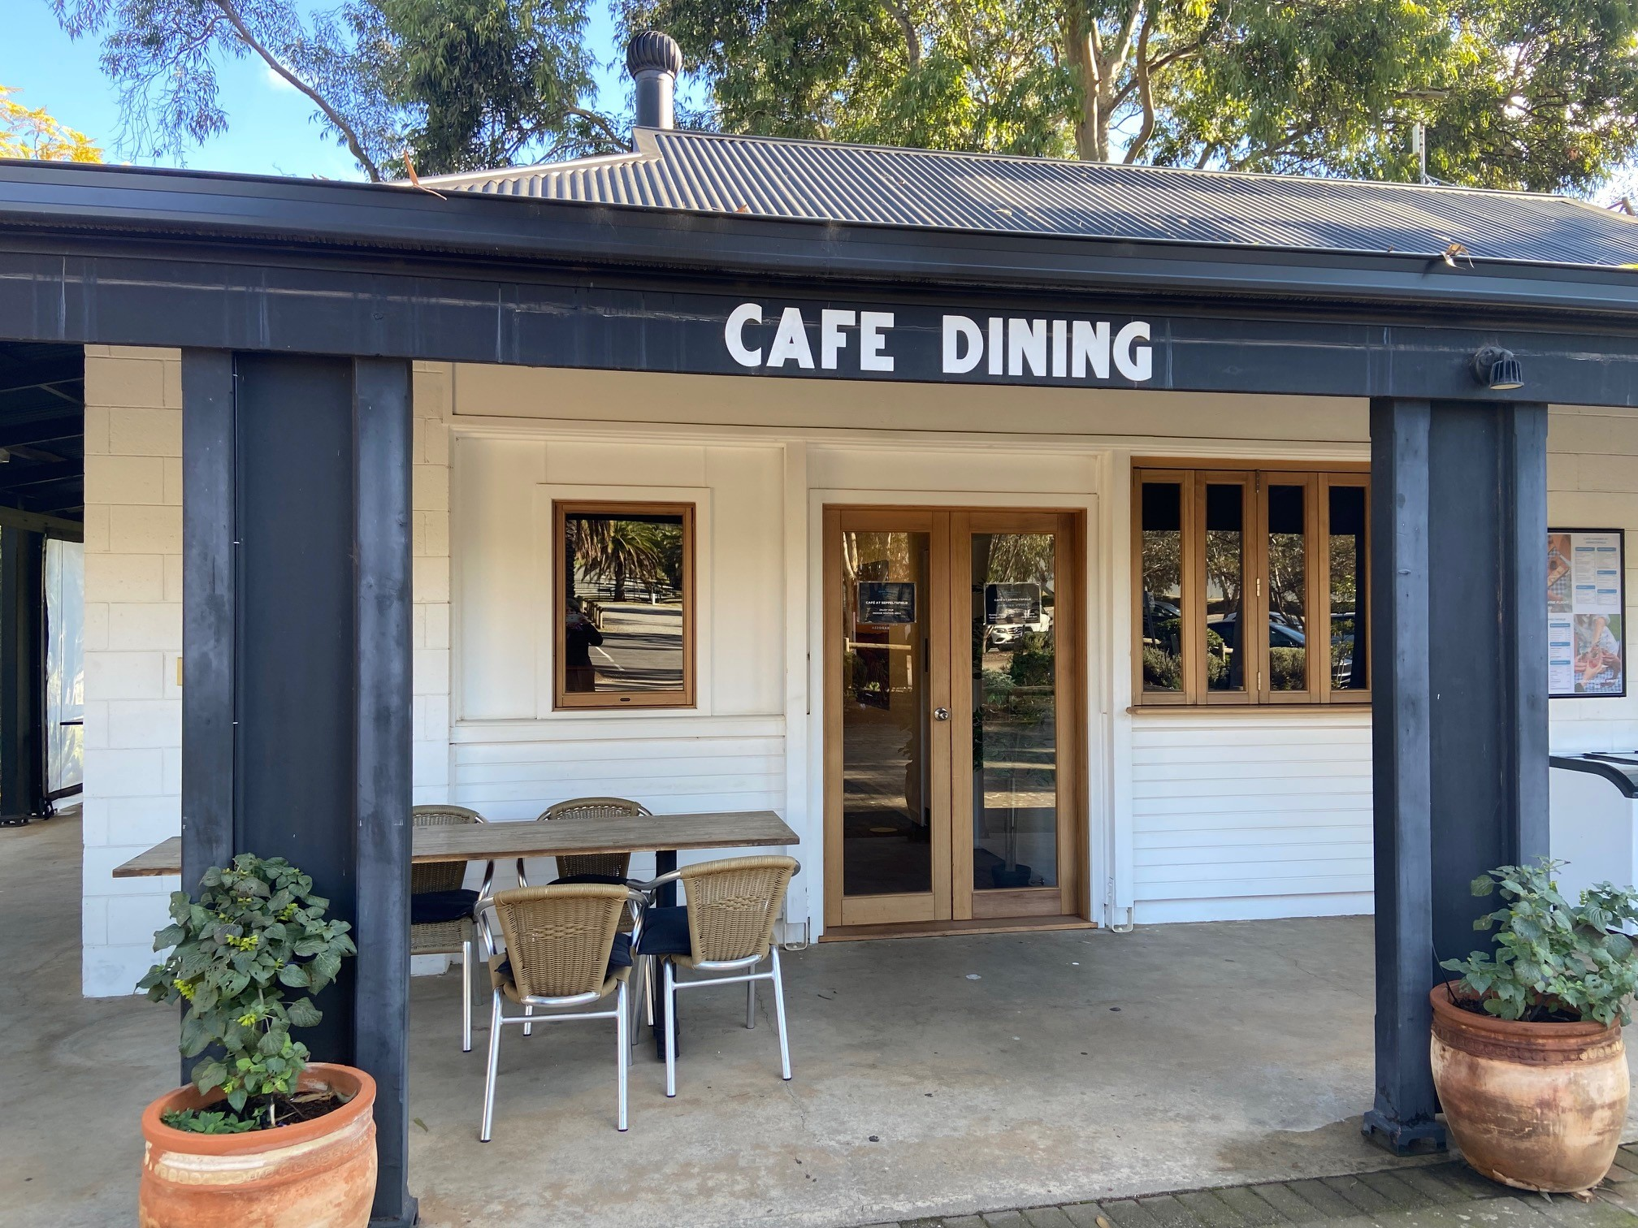
Cafe indoor dining with wide doorways
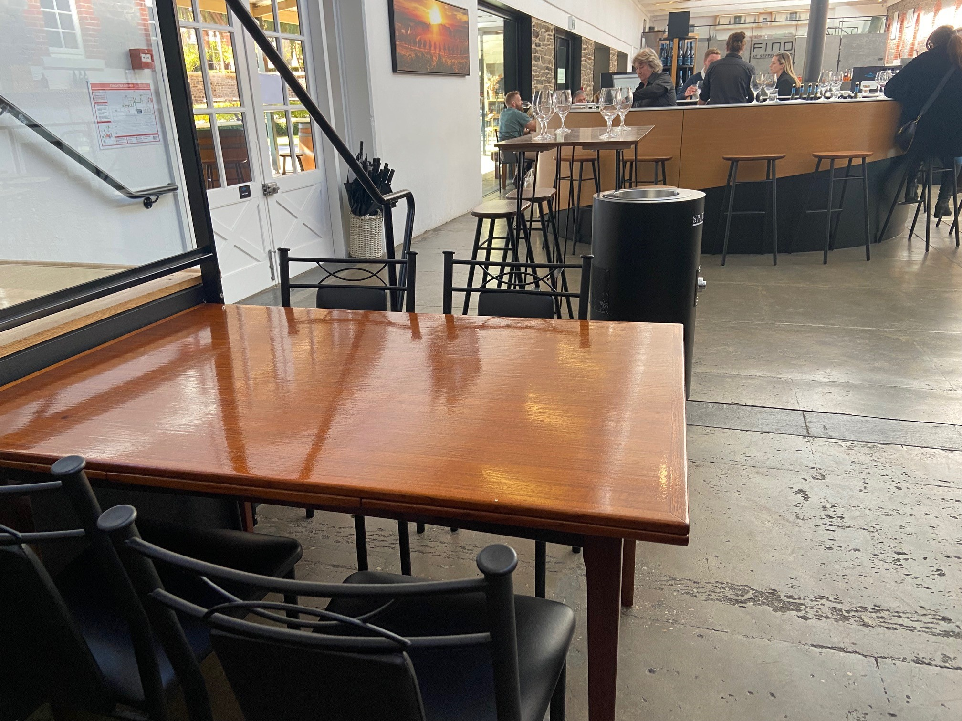
Cellar Door with low tables for visitors needing accessible tasting options
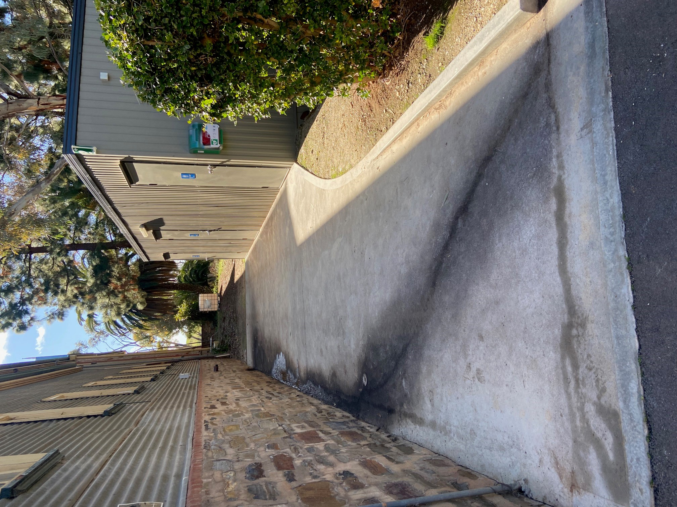
Flat wide access to accessible and ambulant toilets
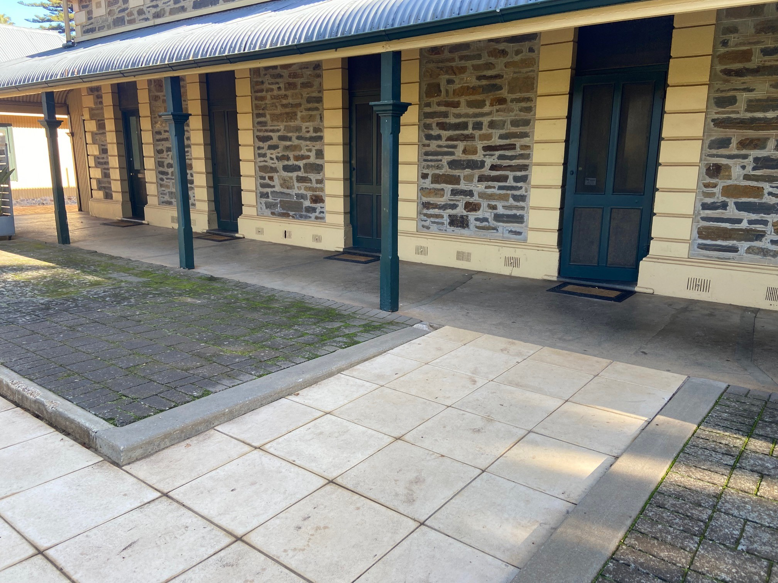
Ramp access to Dining Hall function area
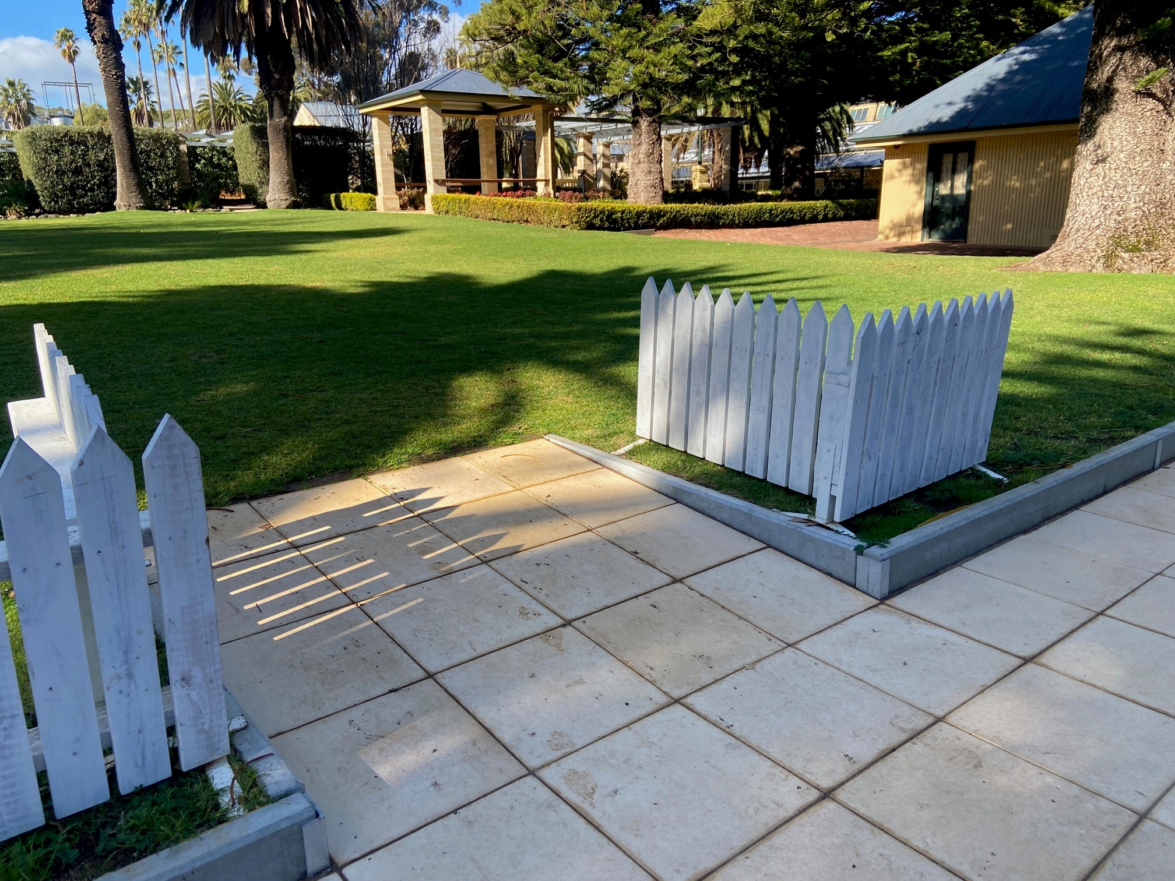
Ramp access to lawn area
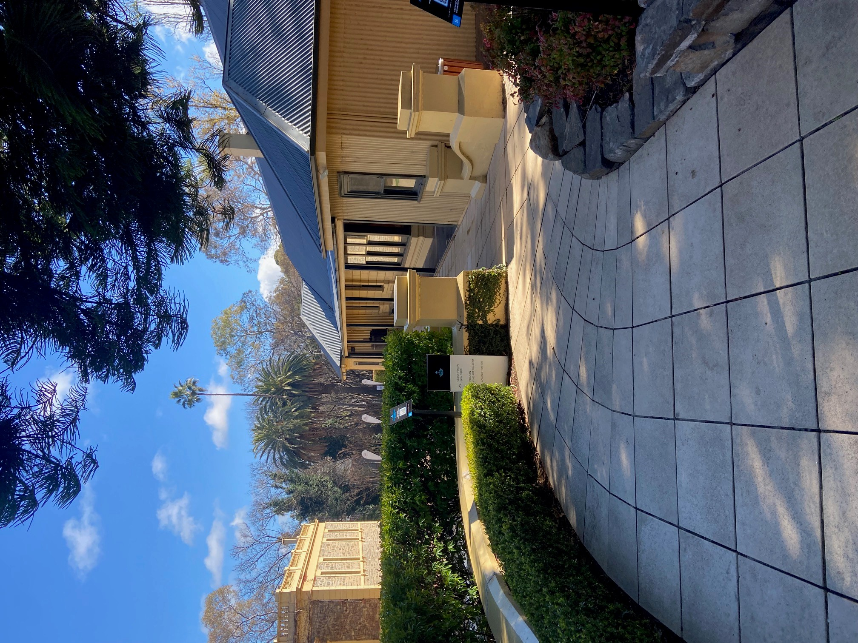
Ramp access towards Cellar Door
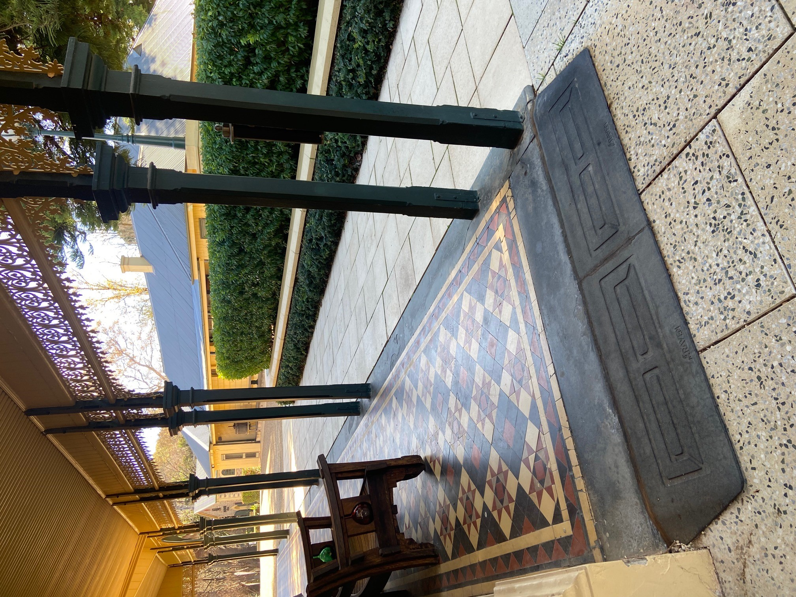
Ramps installed in public outdoor areas
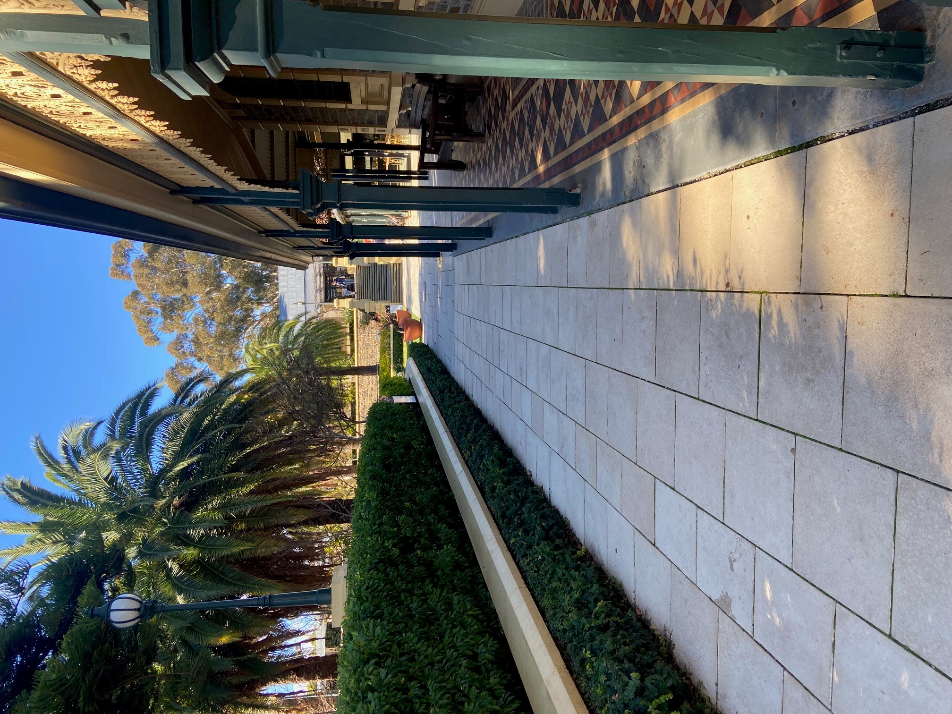
Wide flat paved walkways to Cellar Door
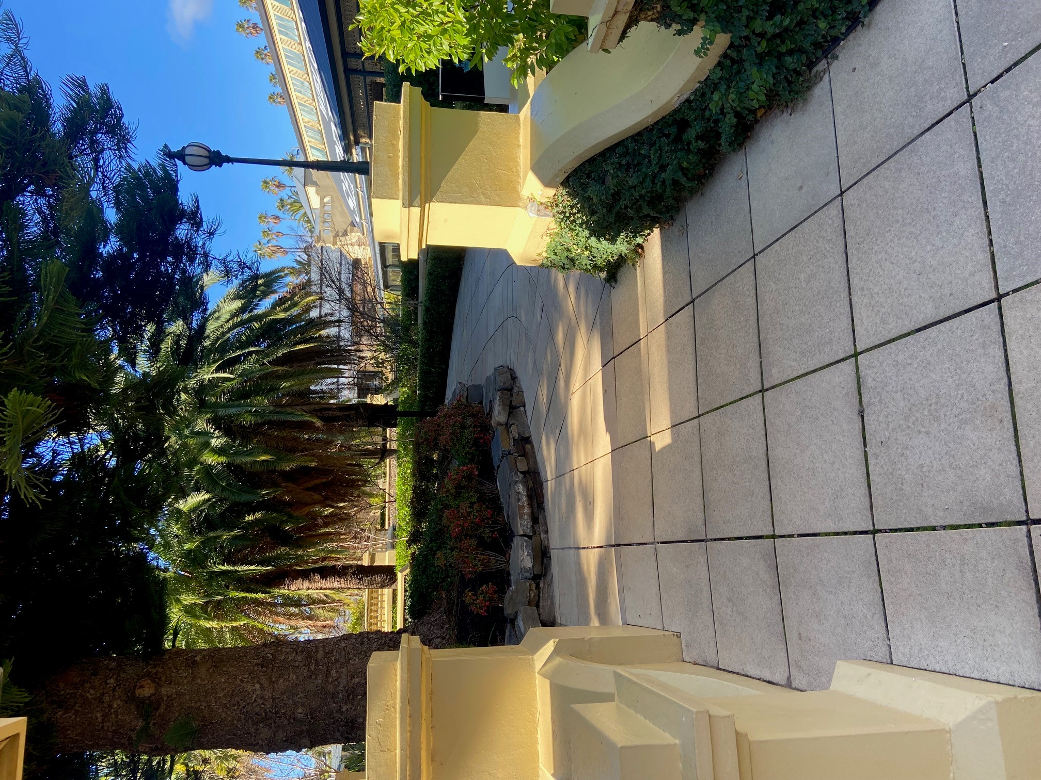
Wide walkways with ramp access outside Cellar Door
- In addition, the following further information can assist guests:
Directions to key locations on the Estate is provided on the website page with the site map to assist with planning a visit

COMMON AREAS

Parks and gardens
- The following parks and gardens amenities are available
- Accessible toilets
- Accessible toilets are signed at regular intervals
- There is a step free map
- This map is available online

https://seppeltsfield.com.au/seppeltsfield-site-map/
- Seats are provided at regular intervals
- Accessible picnic tables
  - Parks and Gardens Access/Entry Image(s)
Ramp access to lawn area
Cafe indoor dining with wide doorways
Accessible parking
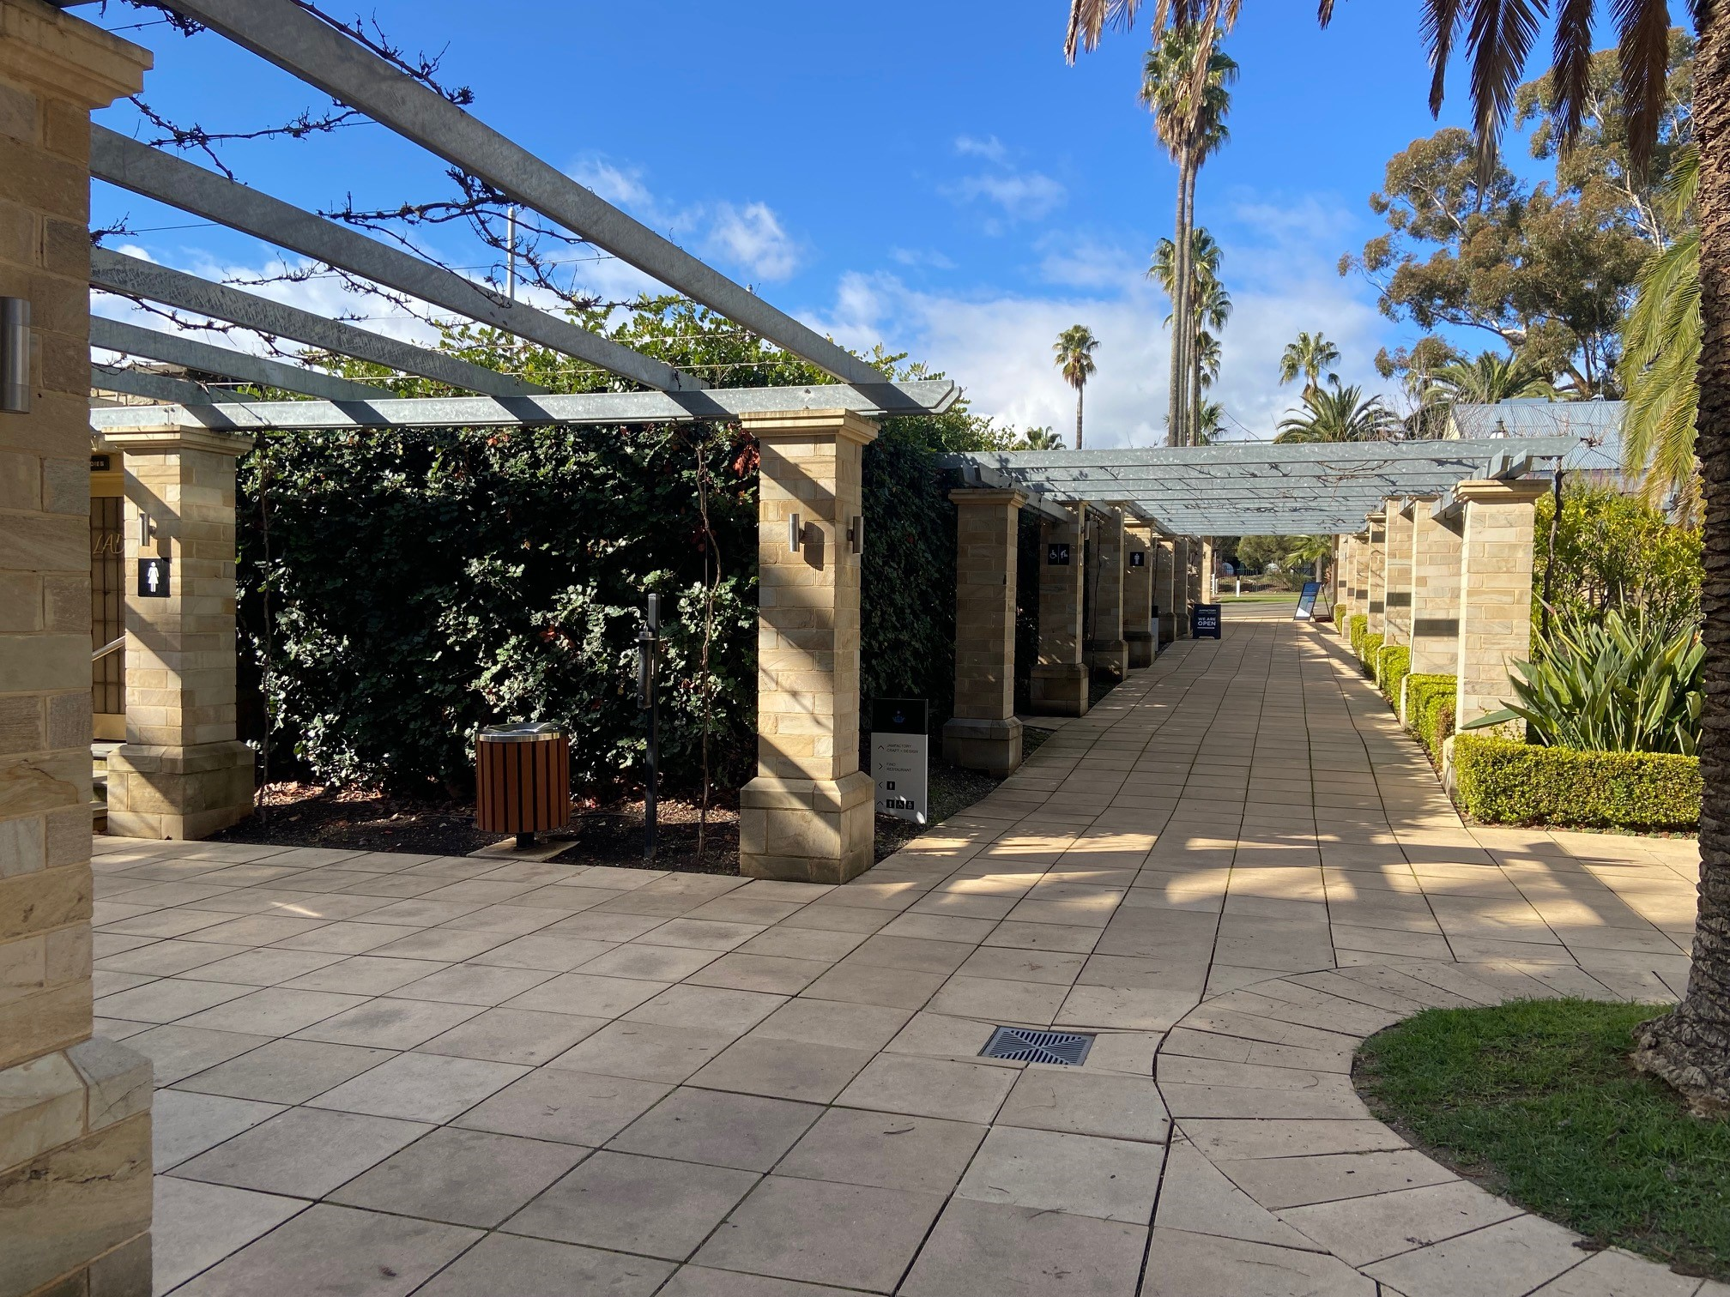
Wide walkways at the centre of the Estate grounds
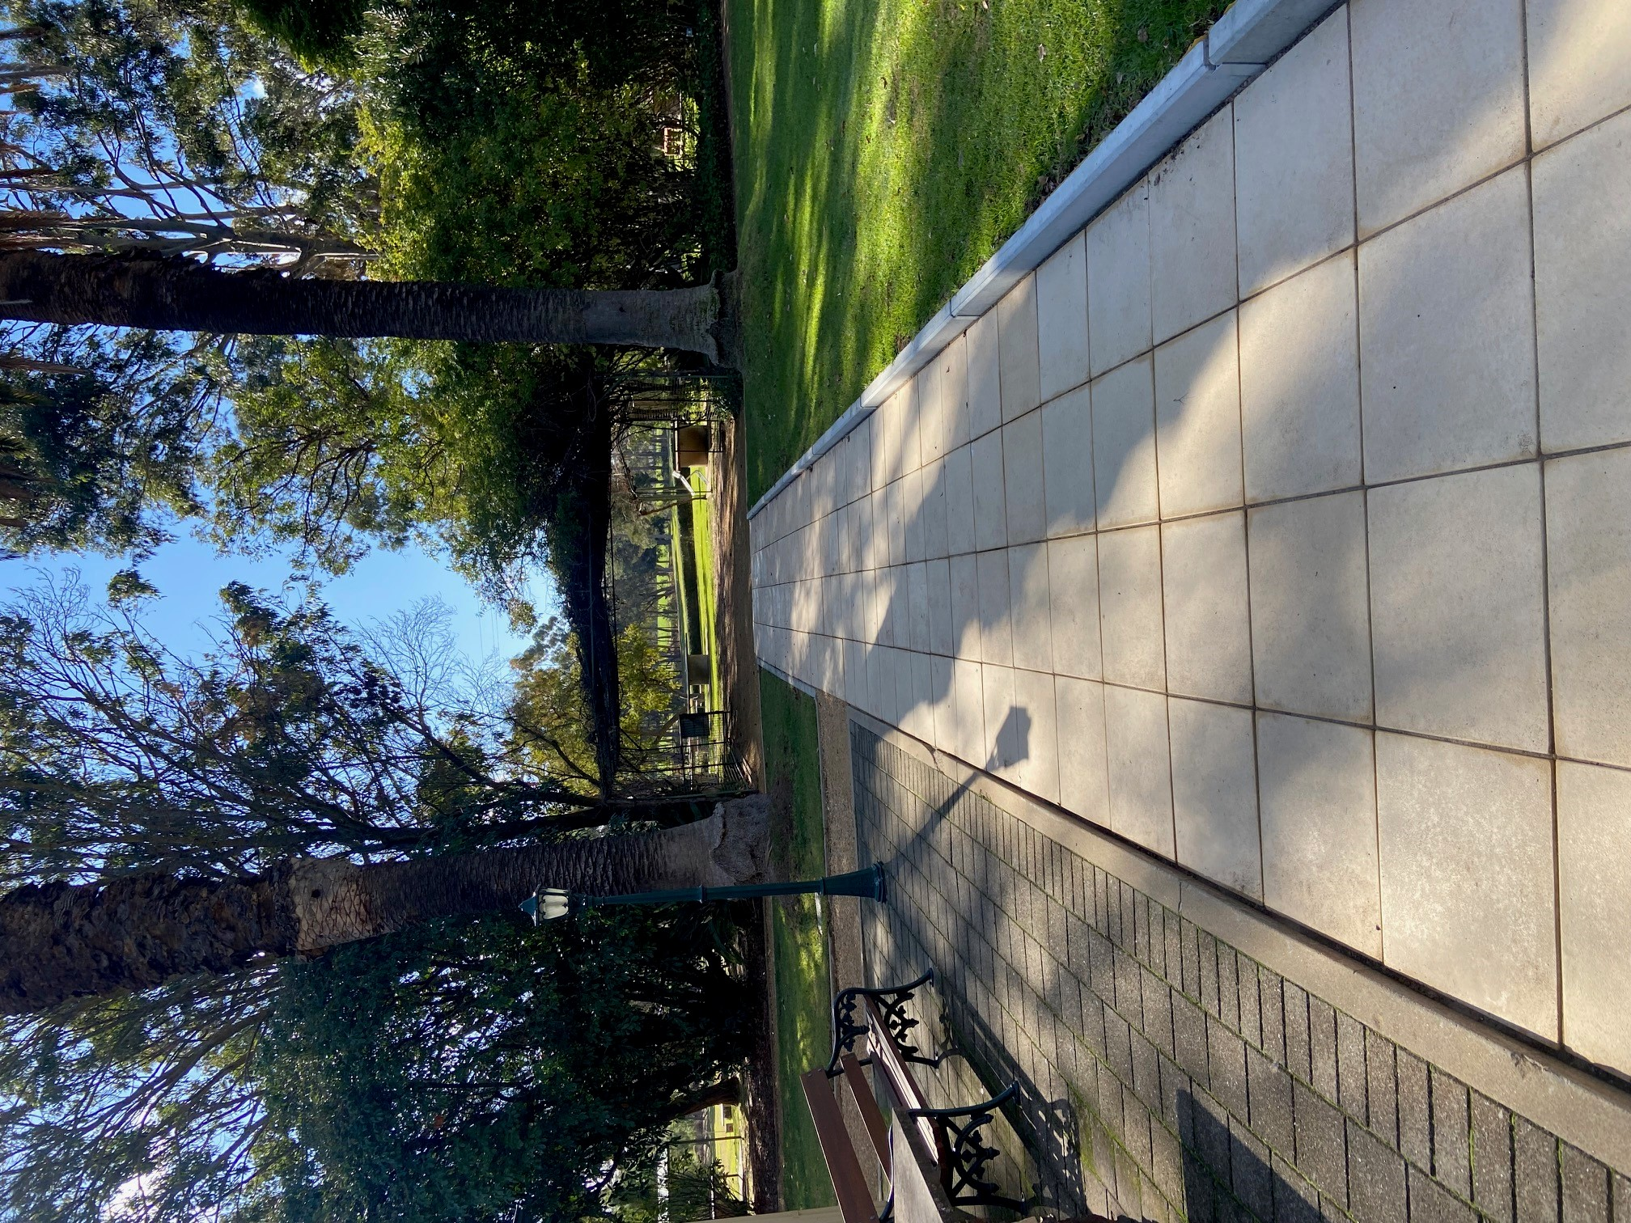
Wide flat paved walkway to the cafe gardens
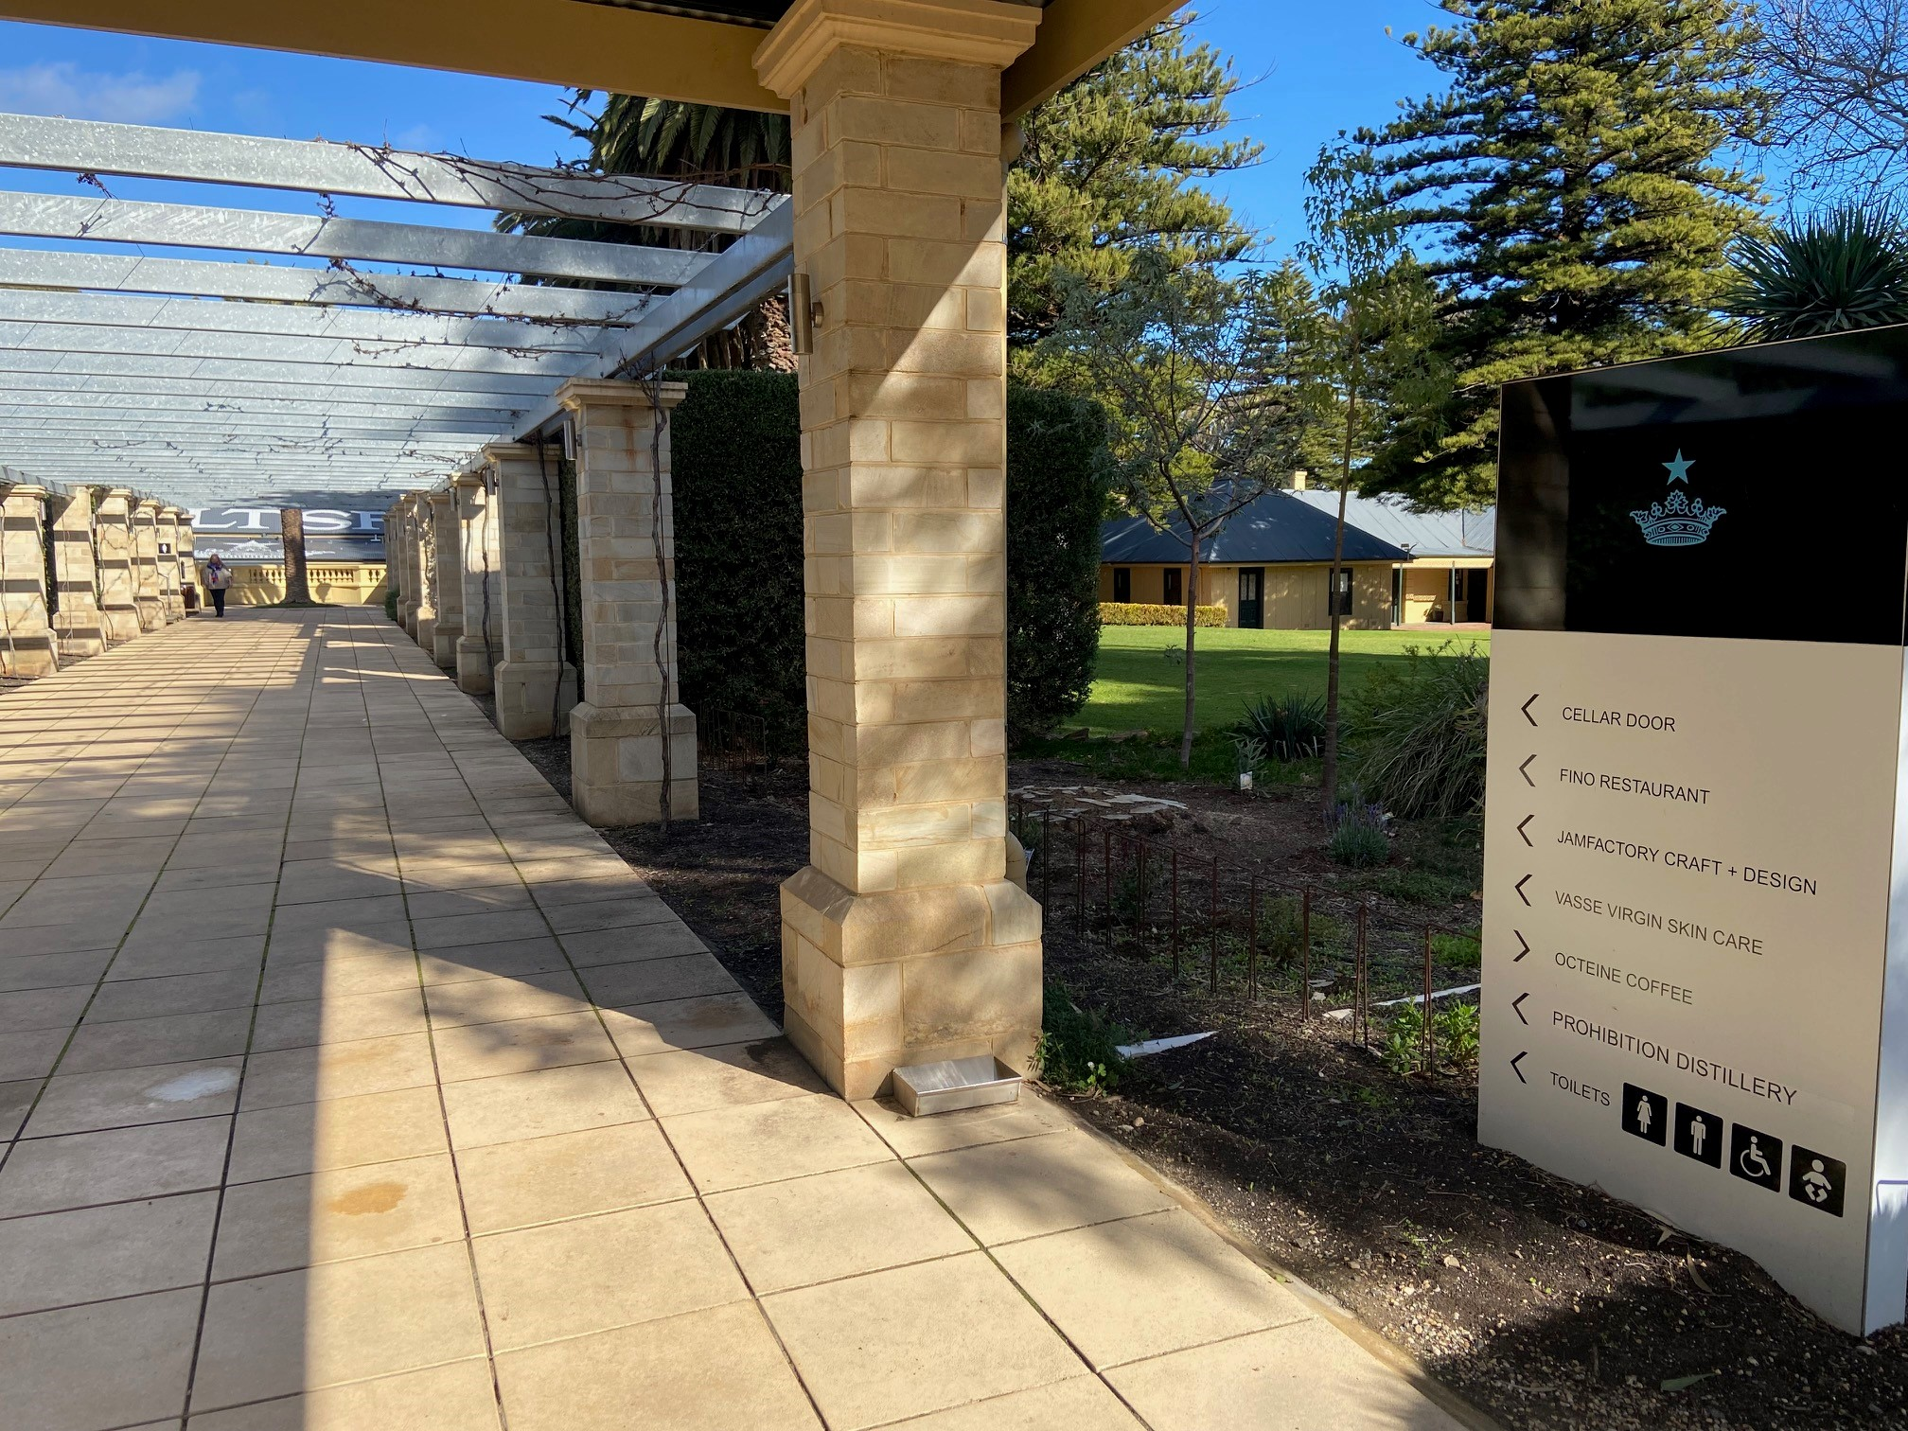
Signage for accessible toilets and key locations
- In addition, the following further information can assist guests:
Directions for key locations on the site are provided on our website to assist visitors to plan their trip to Seppeltsfield Estate.
  - Parks and Gardens Stair entry and exit Image(s)
Ramp access to lawn area
Signage for accessible toilets and key locations

FOOD AND DRINK

Dining Spaces
The dining spaces have the following facilities/amenities in place
- The entrance has level access
- The doorway is at least 850mm wide
- There is level access through the dining area
- Chairs are moveable to allow for wheelchairs to be seated at the tables
- There are areas of full lighting
- There is an accessible toilet

Our business caters for the following dietary requirements
- Sugar free (diabetic)
- Gluten free (celiac)
- Lactose free (dairy free)
- Nut free
- Additive free
- Vegetarian
- In addition, the following further information can assist guests:
Food safety systems in place and all staff are trained in food safety. Designated chopping board and toasty machines used for gluten free options.
- There is a sample menu available online
Sample menu is available here -
https://seppeltsfield.com.au/cafe-seppeltsfield/
  - Food and Beverage Image(s)
Cafe indoor dining with wide doorways
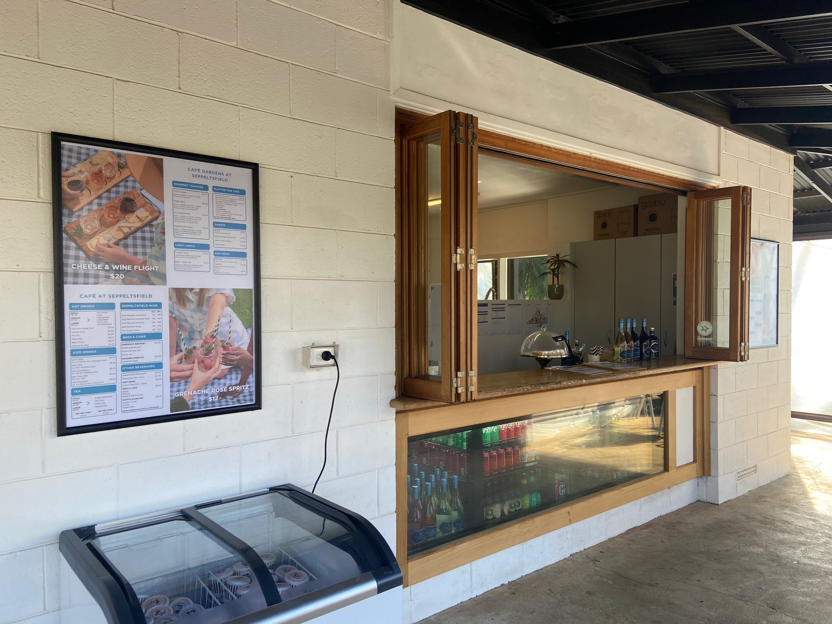
Cafe ordering counter
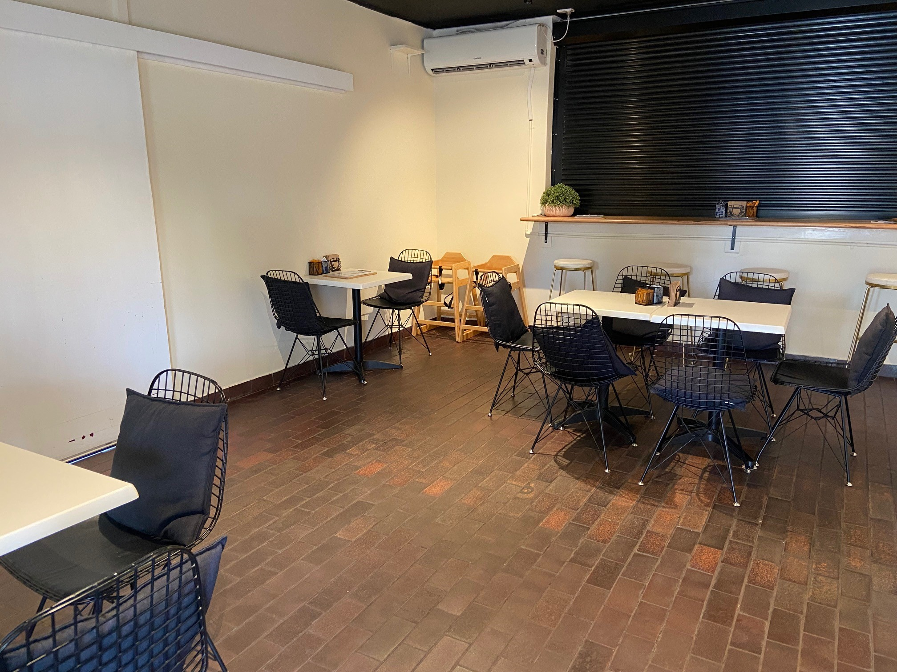
Cafe indoor dining area
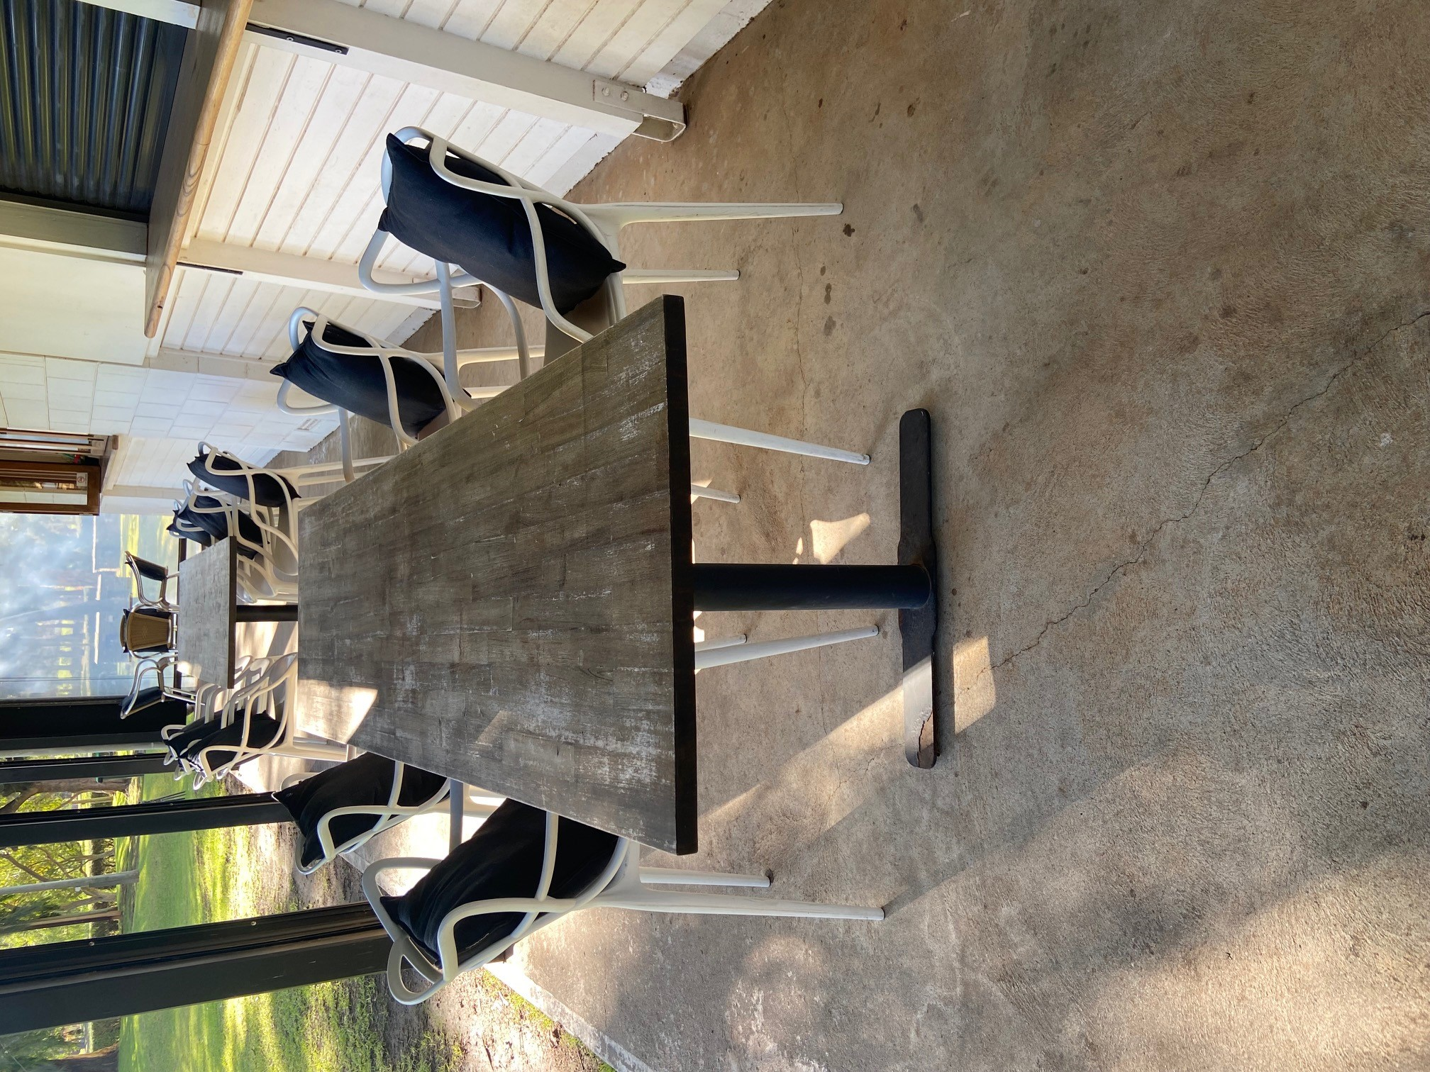
Cafe outdoor dining with easily movable chairs for access

Report Disclaimer
Please note that this business report, provided as a result of the use of the diagnostic assessment, is for information purposes only.
Australian Tourism Industry Council (ATIC) cannot guarantee the accuracy of respondent’s answers, or that they are fully representative of your business. Therefore, ATIC does not warrant or guarantee any particular outcome in respect of your businesses self-assessment.
This report is intended as guidance only for your business and should not be relied on for future marketing considerations. ATIC recommends that you seek your own independent advice as well as the results from the diagnostic.
Links to external web sites are inserted for convenience and do not constitute endorsement of material at those sites, or any associated organisation, product or service.
ATIC does not:
- Assume any legal liability for the accuracy, completeness, or usefulness of any information from this report or any links provided; or
- Accept responsibility for any loss associated directly or indirectly from the use of this report.

