ATIC Accessibility
To support the accessible community in making informed travel decisions for their individual needs

This report prepared for:
Business name: | My Favourite Kitchen
Address: | Box PO 496 Denmark W.A
Town: | Denmark
Contact for enquiries: | Greg Martin
Contact Number: | 0434308000
Contact Email: | myfavouritekitchen23@gmail.com
Website: | https://sites.google.com/view/my-favourite-kitchen/home
Date: | 2026-09-23 16:50

ATIC Accessibility
The following pages provides travellers with information on the businesses facilities and amenities which aims to support the traveller to make an informed decision on whether the business is suitable for their individual needs.
OVERVIEW 3
Business Overview 3
Bookings 3
Guide Dog and Service Animals 3
GENERAL 5
Cognitive Impairment Support 5
Car Park and Access amenities 5
External Paths 5
FOOD AND DRINK 7
Dining Spaces 7
Report Disclaimer 10

OVERVIEW

Business Overview

The business has the following products/services available
- Food and Drink

Our business caters for the following disability types:
- Blind or low vision
- Deaf or low hearing
- Limited mobility
- Wheelchairs or mobility scooters
- Food allergies or intolerances
- Cognitive or people on the Autism Spectrum
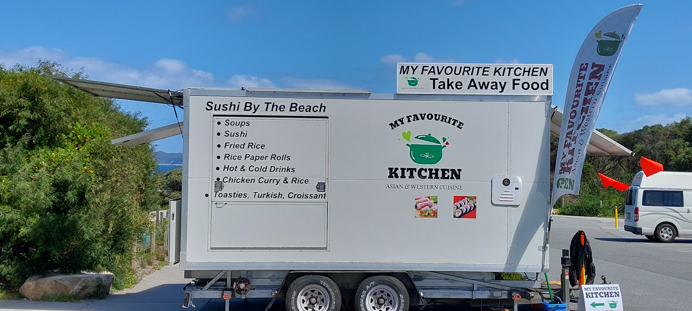

Bookings

The business offers the following methods for bookings and enquiries:
- Phone
- Email

We are a mobile Food Van. The patrons are not within our food van. They are in the car park of the National Park who deal with the Evacuation plans

Guide Dog and Service Animals
The business provides the following services for services animals:
We are a take away food van within a National Park and as such we do not provide the amenities etc within the national park. We are able to assist with food and water within our normal range of take away food and drinks. Sone of which would be suitable for Dogs and other animals. Including water.

GENERAL
- In addition, the following further information can assist guests:
We do provide seating at our food van. Our set up is designed around fast food type service with wait times generally no longer than just a few minutes.
- In addition, the following further information can assist guests:
We have quick turn around times for our food and beverage offerings. We are easily accesable being within the Greens Pool Carpark with ample ACROD parking within 20 to 30 metres of the food van.

Cognitive Impairment Support
- Documents are available in plain English for people with cognitive impairment (This may include instructions, guides, menus and general information)

Car Park and Access amenities
The business has the following Car Park and Access amenities
- A drop off zone
- Designated disabled parking bays
- Level or ramped access from the car park to the entrance
- The accessible entrance is clearly signed from the parking bay
- In addition, the following further information can assist guests:
We are located within the Greens Pool Car park Having easy access to the food van from ample ACROD parking

External Paths
External paths of travel
- Surfaces are concrete, asphalt, smooth paving or hard packed fine gravel (max aggregate size 13mm)
- Pathways are wider than 900mm
- There 3 successive steps or less on any path or at any doorway

There are no Steps between the ACROD Parking and the food van
- In addition, the following further information can assist guests:
There arent Access issues between the ACROD Parking and the food van. The food is displayed in fridges at head type height assisting selection. The staff are friendly, able and very willing to explain and assist re food and beverage selections and what is in the food provided
- In addition, the following further information can assist guests:
No Steps are within the Greens Pool Car park and to reach our food van from your vehicle at the Greens Pool Car Park. We are easily accessible. However if you are wanting to go down to the Greens Pool Beach there are several stairs to navigate. There are some vantage points that can be navigated which are wheelchair friendly.
- In addition, the following further information can assist guests:
We do not provide change rooms or Accessible toilets ourselves as My Favourite Kitchen . However there are wheel chair accessible toilets that are suitable for various disability users within 50 metres of the food van. a Change room with seating is also available within the rest room complex. It should be noted that these toilets are modern Pit type Toilets but are kept clean and do not smell like old fashioned pit type toilets did. It should also be noted that their is no water or waste bins provided by Parks and Wildlife although the toilets are provided with Sanitiser dispensers.

FOOD AND DRINK

Dining Spaces
The dining spaces have the following facilities/amenities in place
- The entrance has level access
- The doorway is at least 850mm wide
- There are areas of full lighting
- There are Plain English menus
- There is an accessible toilet

Our business caters for the following dietary requirements
- Sugar free (diabetic)
- Gluten free (celiac)
- Lactose free (dairy free)
- Low fat and fibre with no gastric content
- Low potassium
- Low sodium
- Nut free
- Additive free
- Organic
- Vegetarian
- Vegan
- In addition, the following further information can assist guests:
We are a nut free food van and our offerings of foods are compartmentalised using once use type packaging gloves are always used when handling food outside of their containers and changed between food groups.
- There is a sample menu available online
Sample menu is available here -
https://maps.app.goo.gl/xe3GhtRbMXmJW6Dt8?g_st=am
  - Food and Beverage Image(s)
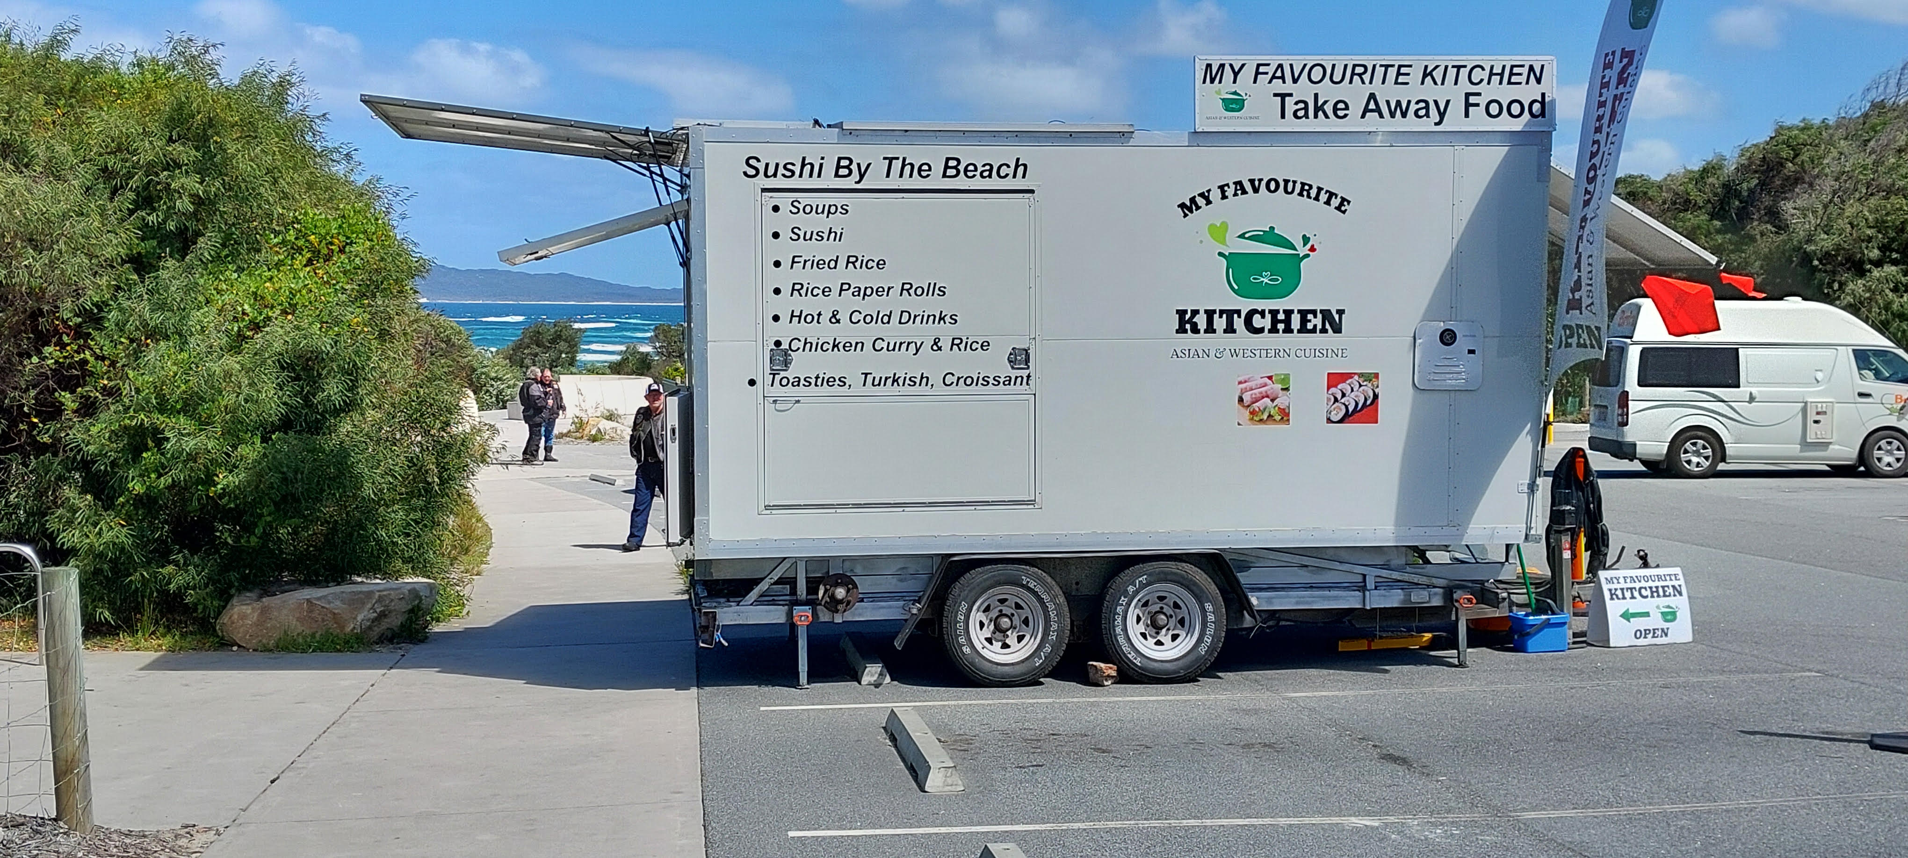
foodvan
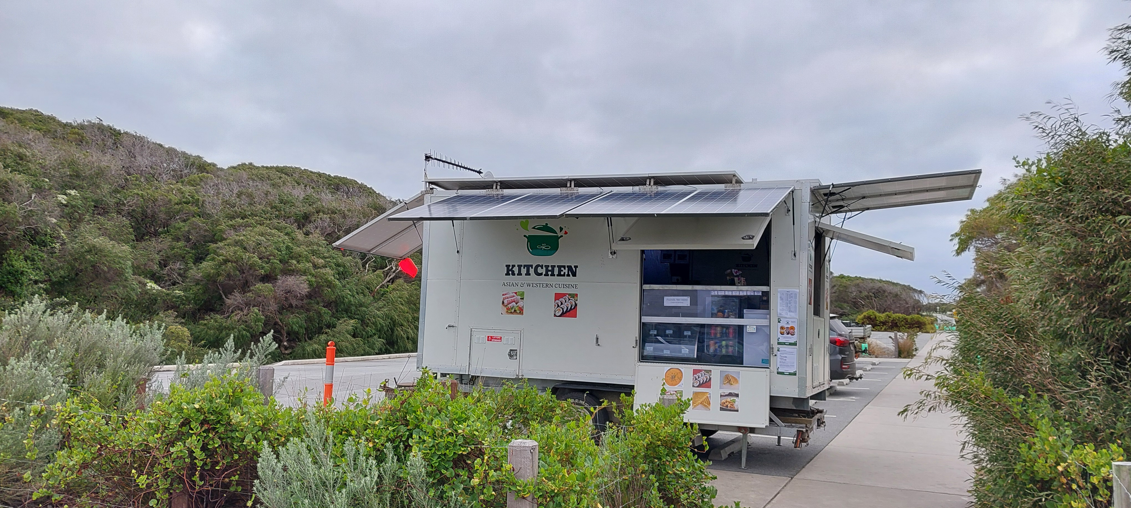
Food Van servery
- In addition, the following further information can assist guests:
If you have any trouble in reaching the service window or seeing our food displays etc. Please let our friendly staff know and we will assist you with your needs.

Report Disclaimer
Please note that this business report, provided as a result of the use of the diagnostic assessment, is for information purposes only.
Australian Tourism Industry Council (ATIC) cannot guarantee the accuracy of respondent’s answers, or that they are fully representative of your business. Therefore, ATIC does not warrant or guarantee any particular outcome in respect of your businesses self-assessment.
This report is intended as guidance only for your business and should not be relied on for future marketing considerations. ATIC recommends that you seek your own independent advice as well as the results from the diagnostic.
Links to external web sites are inserted for convenience and do not constitute endorsement of material at those sites, or any associated organisation, product or service.
ATIC does not:
- Assume any legal liability for the accuracy, completeness, or usefulness of any information from this report or any links provided; or
- Accept responsibility for any loss associated directly or indirectly from the use of this report.

