ATIC Accessibility
To support the accessible community in making informed travel decisions for their individual needs

This report prepared for:
Business name: | Wooramel Station (Wooramel River Retreat)
Address: | Lot 405 north west coastal highway
Town: | carnarvon
Contact for enquiries: | Rachael Steadman
Contact Number: | 0417425801
Contact Email: | info@wooramel.com.au
Website: | www.wooramel.com.au
Date: | 2026-10-11 10:53

ATIC Accessibility
The following pages provides travellers with information on the businesses facilities and amenities which aims to support the traveller to make an informed decision on whether the business is suitable for their individual needs.
OVERVIEW 4
Business Overview 4
Bookings 4
Emergency Management 4
Communications 5
Other Information 5
Guide Dog and Service Animals 5
GENERAL 6
Pre-arrival, arrival and reception 6
Cognitive Impairment Support 6
Car Park and Access amenities 6
Entry 6
Internal Spaces 7
Public areas 7
Displays, exhibits, commentary and live performances 7
External Paths 7
Steps 8
Ramps 8
Public Toilets/Adult change facilities 8
ACCOMMODATION 9
Bedrooms 9
Room Amenities 9
Bathrooms 10
ATTRACTIONS 11
COMMON AREAS 12
Swimming pools, spas and waterparks 12
FOOD AND DRINK 13
Dining Spaces 13
Report Disclaimer 15

OVERVIEW

Business Overview

The business has the following products/services available
- Accommodation
- Food and Drink

Our business caters for the following disability types:
- Deaf or low hearing
- Limited mobility
- Wheelchairs or mobility scooters
- Food allergies or intolerances
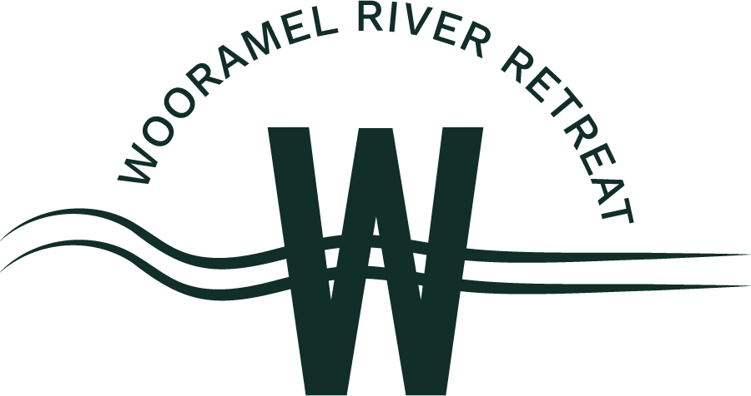

Bookings

The business offers the following methods for bookings and enquiries:
- Phone
- Email
- Webportal
- Our forms have high contract boxes and submit boxes

Emergency Management
- Exit signs are clear and easy to see
- Exit access is free and clear at all times
We ensure exit access is free and clear at all times by:
Visually
- Exits and access to exists are greater than 900mm
- Exit doors are able to be opened by all occupants
- Exits to the emergency evacuation point does not include stairways
- In addition, the following further information can assist guests:
Verbally
- In addition, the following further information can assist guests:
Contact management to arrange

Communications
- Our business offers the following alternative communication methods
- Plain English

Not specified
- There is easy to read signage and information (e.g. menus and emergency information)

Other Information
- For bookings made onsite, the ticket booth/counter/box office is accessible for people using a wheelchair

Guide Dog and Service Animals
- The business provides a secure area with shade and water for service animals
- The business provides a toilet area for service animals
- Bowls, bedding, etc. are provided for service animals
The business provides the following services for services animals:
All animals are welcome around the park on a lead. There are many shaded areas and water bowls are available

GENERAL

Pre-arrival, arrival and reception
The business has the following in place to support guests during pre-arrival, arrival and reception
- There is a reception/public entryway.
- Seating available at reception
- Lighting in the reception area is even and glare free

All checkin are completed by a staff member who can adapt to the requirements of a guest
- Information and maps are available in written form
- In addition, the following further information can assist guests:
The check in process is very fast - about 2-4 minutes. Seating is provided at both Reception and the cafe

Cognitive Impairment Support
- A space for parents and children on the Autism Spectrum

Car Park and Access amenities
The business has the following Car Park and Access amenities
- A drop off zone
- Level or ramped access from the car park to the entrance
- Kerb ramps are in place where a pavement or walkway needs to be crossed

Entry
The business has the following amenities/systems in place for entry
- A drop off point close to the entrance
- A path of access to the building is slip resistance and even
- A path of access to the building is clear of obstruction
- Door jams/doors are of a contrasting colour to surrounding walls
- Signage is written in a contrasting colour
- Signage is written in a Sans Serif font and use upper and lower case letters
- The entry door is a minimum of 850mm wide
- The entrance sill is less than 13mm
- The entrance door mats have a thickness less than 13mm and a width of 7500mm or greater

Internal Spaces
- Clear and unobstructed routes through and between buildings
- Interior walls are matte or low sheen
- Any protruding or overhanging obstructions are at least 2meters above the floor or are protected
- Floor surfaces are hard or short pile carpet
- Seating is available for guests unable to stand for long periods
- All corridors greater than 900mm
- There is a quiet space for parents and children on the Autism Spectrum

Public areas
The public areas have the following amenities in place
- Even lighting
- Seating

Displays, exhibits, commentary and live performances
For displays, exhibits, commentary and live performances the following amenities are in place
- Seating
- Wheelchair accessible spaces/seating

External Paths
External paths of travel
- Surfaces are concrete, asphalt, smooth paving or hard packed fine gravel (max aggregate size 13mm)
- Pathways are wider than 900mm
- There 3 successive steps or less on any path or at any doorway

Steps
Steps
- There are steps.
- The underside of all staircases are enclosed or protected to a height of at least 2 metres
- Where steps are present are there three steps or less

Ramps
Ramps have the following amenities are in place
- There are ramps.
- All fixed ramps are 1:14 or less
- Long ramps (more than 10m) are 1:20 or less

Public Toilets/Adult change facilities
Public Toilets/Adult change facilities have the following amenities are in place
- There is an accessible toilet for public use
- The door is at least 850mm wide
- There is a minimum of 850mm beside the toilet
- Handrails are fitted
- The toilet seat is 460mm above the floor
- There is 2000mm mm of clear space in front of the toilet
- The toilet seat of a contrasting colour to the floor
- The toilet seat is460mm above the floor

ACCOMMODATION

Bedrooms
The bedrooms have the following facilities/amenities in place
- There are 1 rooms available to guests who use a wheelchair
- Bedroom furniture can be re-arranged on request
  - Layout of room Image(s)
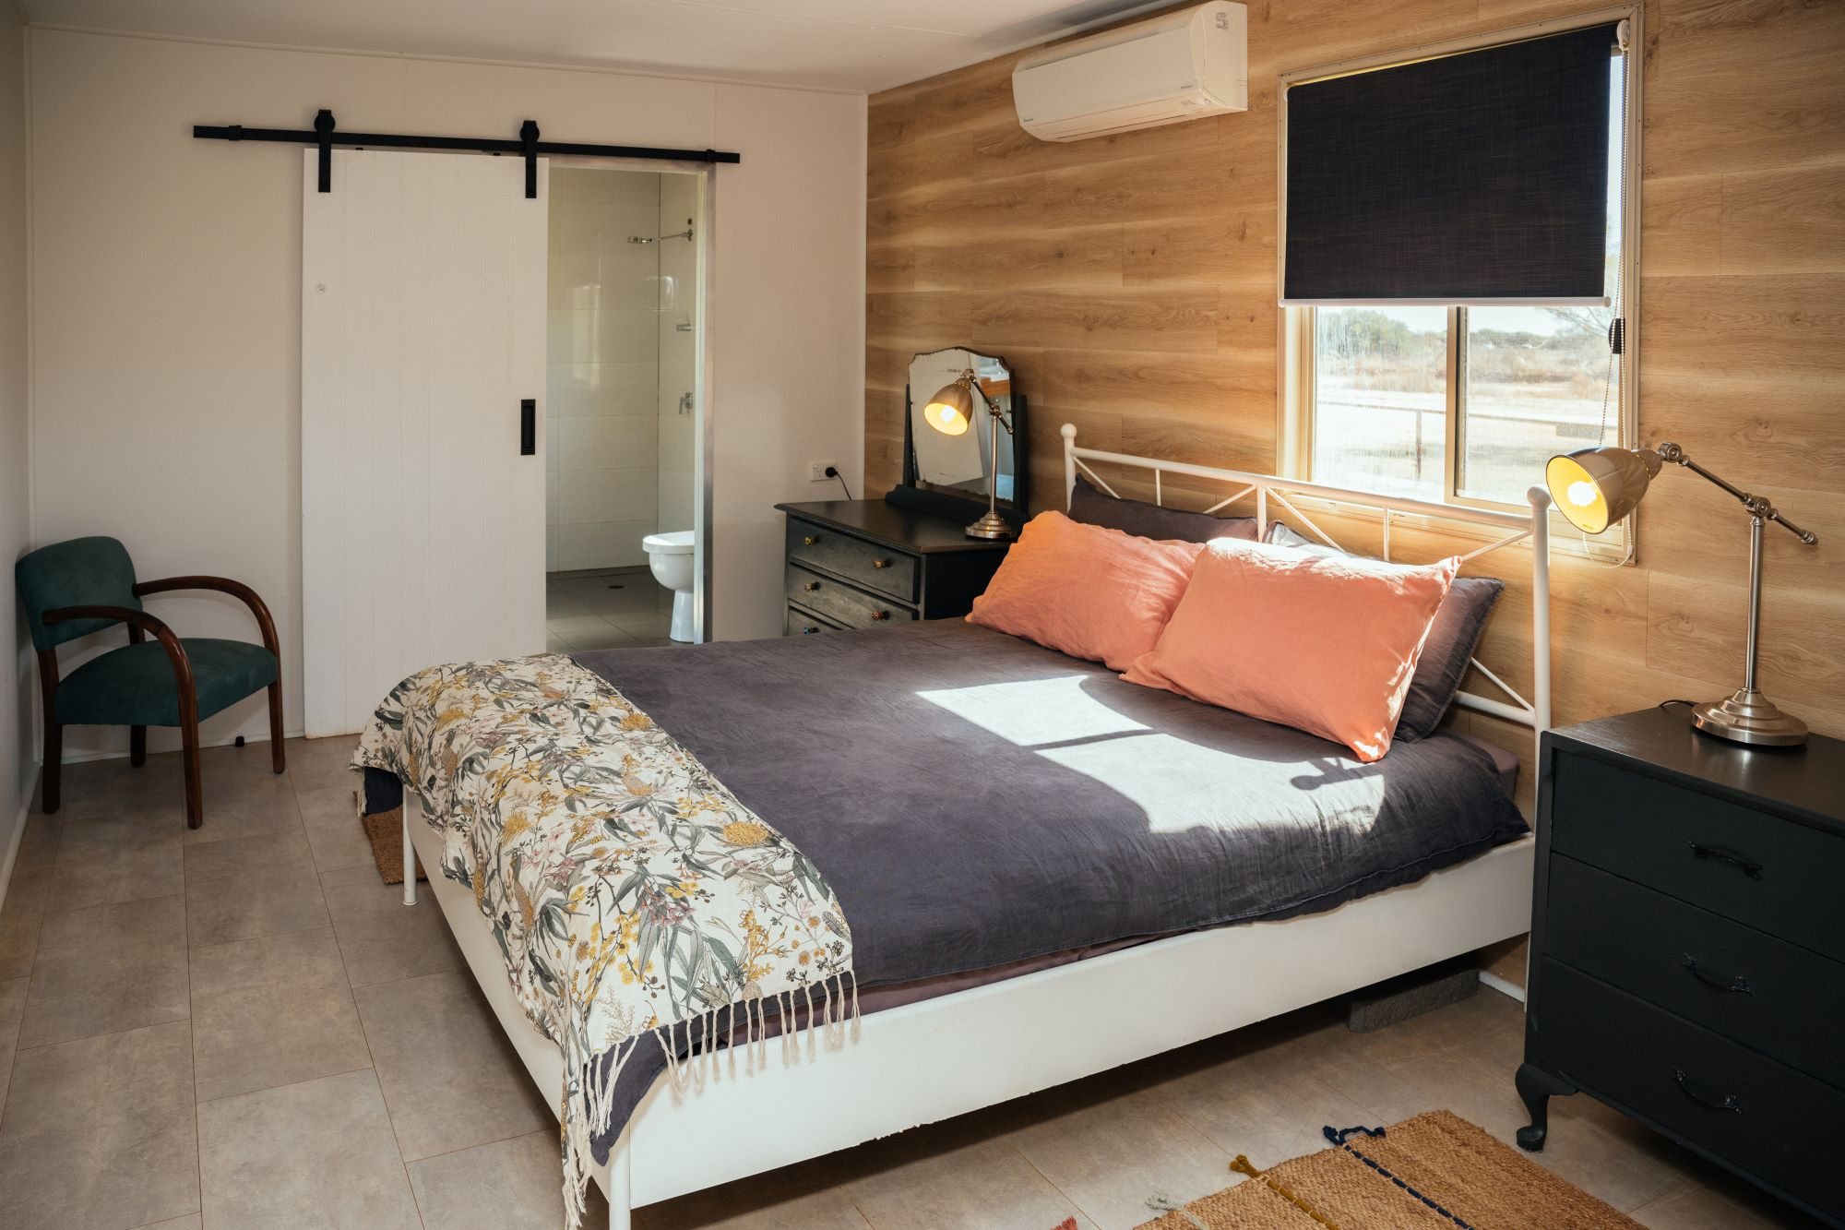
Wooramel Retreat 4Quarters Self Contained (3)

Room Amenities

No wardrobes
- In addition, the following further information can assist guests:
Staff would evacuate all guests in the event of any emergency
- There is contrast between the walls, skirtings, floor and furniture
- There is a clear path through the room
- Doors open fully against the adjoining wall
- There is a clear opening at least 850mm wide
- There at least one chair with rigid arms
- The bedside lamp switch is easy to reach from the bed
- There is at least 850mm clear space beside the bed
- The bed height is no higher than 680mm from the floor
- There is at least 130mm clearance under the bed

Bathrooms
The bathrooms have the following facilities/amenities in place
- All heating appliances and hot water pipes are protected or insulated
- All shower, bath and basin taps are clearly differentiated between hot and cold
- Fixtures and fittings have rounded edges
- The door is at least 850mm wide
- There is a minimum of 850mm beside the toilet
- Handrails are fitted
- There is a minimum of 1400mm of clear space in front of the toilet
- The toilet seat is a contrasting colour to the floor
- The toilet seat is 460mm above the floor
- There is a portable shower head on flexible hose

ATTRACTIONS

https://www.wooramel.com.au/_files/ugd/0e9842_56a4a851b6ac460cb569d55027198f6f.pdf

COMMON AREAS

Swimming pools, spas and waterparks
- The following swimming pools, spas and waterparks amenities are available
- Unisex change facilities with an accessible toilet
  - Pool Access Image(s)
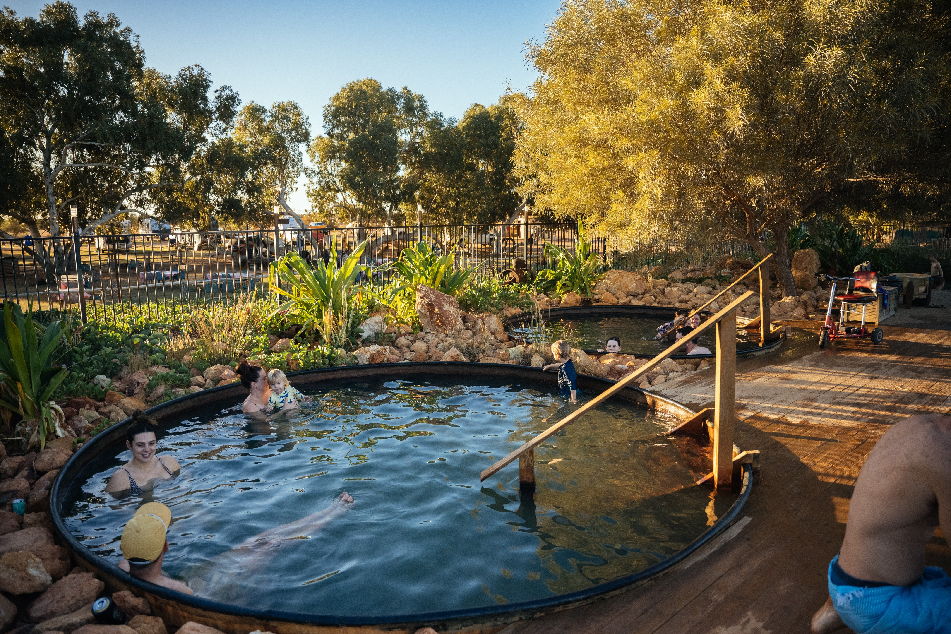
Wooramel Retreat Artesian Baths (12)

FOOD AND DRINK

Dining Spaces
The dining spaces have the following facilities/amenities in place
- The entrance has level access
- The doorway is at least 850mm wide
- There is level access through the dining area
- Chairs are moveable to allow for wheelchairs to be seated at the tables
- All glass doors and full height windows have contrast markings
- There are areas of full lighting
- There are Plain English menus
- There is an accessible toilet

Our business caters for the following dietary requirements
- Gluten free (celiac)
- Lactose free (dairy free)
- Low sodium
- Nut free
- Vegetarian
- Vegan
- In addition, the following further information can assist guests:
Different storage containers, prep boards and utensils
- There is a sample menu available online
Sample menu is available here -
https://www.wooramel.com.au/activities
  - Food and Beverage Image(s)
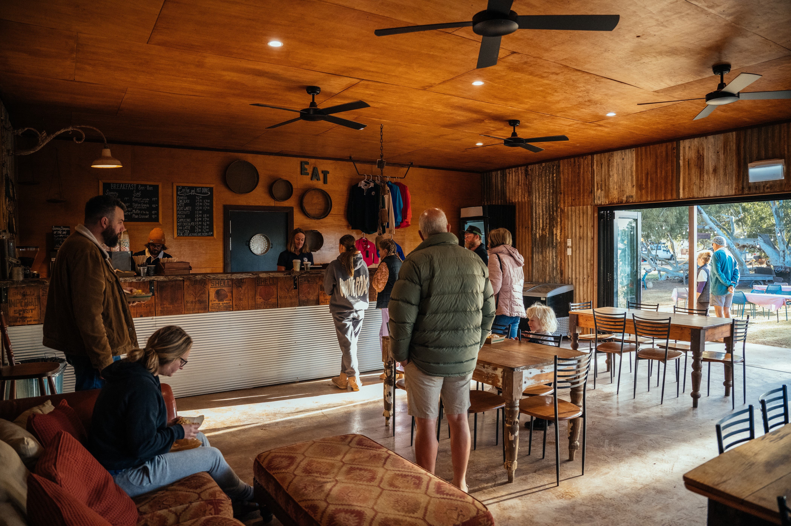
Wooramel Retreat Cafe (7)

Report Disclaimer
Please note that this business report, provided as a result of the use of the diagnostic assessment, is for information purposes only.
Australian Tourism Industry Council (ATIC) cannot guarantee the accuracy of respondent’s answers, or that they are fully representative of your business. Therefore, ATIC does not warrant or guarantee any particular outcome in respect of your businesses self-assessment.
This report is intended as guidance only for your business and should not be relied on for future marketing considerations. ATIC recommends that you seek your own independent advice as well as the results from the diagnostic.
Links to external web sites are inserted for convenience and do not constitute endorsement of material at those sites, or any associated organisation, product or service.
ATIC does not:
- Assume any legal liability for the accuracy, completeness, or usefulness of any information from this report or any links provided; or
- Accept responsibility for any loss associated directly or indirectly from the use of this report.

