ATIC Accessibility
To support the accessible community in making informed travel decisions for their individual needs

This report prepared for:
Business name: | Cascade Brewery Bar
Address: | 140 Cascade Road
Town: | South Hobart
Contact for enquiries: | Lucinda Morrow
Contact Number: | 0448847994
Contact Email: | tours@cascadebreweryco.com.au
Website: | https://www.cascadebreweryco.com.au/
Date: | 2026-05-18 21:33

ATIC Accessibility
The following pages provides travellers with information on the businesses facilities and amenities which aims to support the traveller to make an informed decision on whether the business is suitable for their individual needs.
OVERVIEW 4
Business Overview 4
Bookings 4
Emergency Management 5
Other Information 5
Guide Dog and Service Animals 5
GENERAL 6
Pre-arrival, arrival and reception 6
Car Park and Access amenities 6
Entry 6
Internal Spaces 7
Public areas 7
Displays, exhibits, commentary and live performances 7
External Paths 8
Steps 8
Public Toilets/Adult change facilities 8
TOUR OPERATORS 9
Route Planning 9
Guides 9
ATTRACTIONS 10
COMMON AREAS 11
Parks and gardens 11
FOOD AND DRINK 15
Dining Spaces 15
EVENTS 16
Events 16
Report Disclaimer 18

OVERVIEW

Business Overview

The business has the following products/services available
- Tour/Transport
- Attraction
- Food and Drink
- Event

Our business caters for the following disability types:
- Blind or low vision
- Deaf or low hearing
- Limited mobility
- Wheelchairs or mobility scooters
- Food allergies or intolerances
- Cognitive or people on the Autism Spectrum

Bookings

The business offers the following methods for bookings and enquiries:
- Email
- Webportal
- Our website supports Screen Readers
- Our forms have high contract boxes and submit boxes

Emergency Management
- There are Audible device/s to alert occupants to evacuate with instructions on how to evacuate.
- Exit signs are clear and easy to see
- Exit access is free and clear at all times
We ensure exit access is free and clear at all times by:
Staff are trained to keep these areas free and clear. Customers are informed to move away if blocking these areas. A safety walk of the space is conducted prior to opening to the public each day.
- Exits and access to exists are greater than 900mm
- Exits to the emergency evacuation point does not include stairways
The business identifies guests who need additional assistance should an emergency occur by:
If not apparent from interacting with the guest, our staff would check in and inform all guests of the process in the case of an emergency, flagging that those in need of additional help make themselves known.
The procedure for assisting guests who need assisted rescue is:
No official plan is in place.

Other Information
- The business accepts the companion card

Guide Dog and Service Animals
- The business provides a secure area with shade and water for service animals
- Bowls, bedding, etc. are provided for service animals
The business provides the following services for services animals:
The venue (bar, restaurant and gardens) are set with bowls and bedding can be provided on request. The brewery itself is deemed a food production site and is not open to service animals.

GENERAL

Pre-arrival, arrival and reception
The business has the following in place to support guests during pre-arrival, arrival and reception
- Booking information and websites are compatible with screen readers
- There is a reception/public entryway.
- A tablet with text to voice or pen and paper at reception to aid in communication
- Lighting in the reception area is even and glare free

Digital Registration (no hard copies)
- In addition, the following further information can assist guests:
We do not have queues in our business. If they have to wait at all there is seating available for these guests nearby at all times.
- In addition, the following further information can assist guests:
N/A

Car Park and Access amenities
The business has the following Car Park and Access amenities
- Designated disabled parking bays
- Level or ramped access from the car park to the entrance
- The accessible entrance is clearly signed from the parking bay
- Kerb ramps are in place where a pavement or walkway needs to be crossed
- In addition, the following further information can assist guests:
N/A

Entry
The business has the following amenities/systems in place for entry
- A path of access to the building is slip resistance and even
- A path of access to the building is clear of obstruction
- Glass doors are fitted with a visual sighting strip
- Signage is written in a contrasting colour
- The entry door is a minimum of 850mm wide
- In addition, the following further information can assist guests:
N/A
- In addition, the following further information can assist guests:
N/A

Internal Spaces
- Clear and unobstructed routes through and between buildings
- Interior walls are matte or low sheen
- Floors, walls, counters and furniture are of contrasting colours
- Any protruding or overhanging obstructions are at least 2meters above the floor or are protected
- Floor surfaces are hard or short pile carpet
- Seating is available for guests unable to stand for long periods
- Accessible facilities are clearly signed and visible from all areas
- All corridors greater than 900mm
- In addition, the following further information can assist guests:
N/A

Public areas
The public areas have the following amenities in place
- Even lighting
- Seating
- In addition, the following further information can assist guests:
N/A

Displays, exhibits, commentary and live performances
For displays, exhibits, commentary and live performances the following amenities are in place
- In addition, the following further information can assist guests:
N/A

External Paths
External paths of travel
- Surfaces are concrete, asphalt, smooth paving or hard packed fine gravel (max aggregate size 13mm)
- Pathways are wider than 900mm
- There 3 successive steps or less on any path or at any doorway
- In addition, the following further information can assist guests:
N/A

Steps
Steps
- There are steps.
- The underside of all staircases are enclosed or protected to a height of at least 2 metres
- In addition, the following further information can assist guests:
N/A

Public Toilets/Adult change facilities
Public Toilets/Adult change facilities have the following amenities are in place
- There is an accessible toilet for public use
- The door is at least 850mm wide
- There is a minimum of 850mm beside the toilet
- Handrails are fitted
- The toilet seat is 460mm above the floor
- The toilet seat of a contrasting colour to the floor
- The toilet seat is460mm above the floor
- There is a registered changing places facility
- In addition, the following further information can assist guests:
N/A

TOUR OPERATORS

Route Planning
- Walking Tours

Guides

Guides have been trained in the following
- Use of clear/simple English

ATTRACTIONS

COMMON AREAS

Parks and gardens
- The following parks and gardens amenities are available
- Seats are provided at regular intervals
- In addition, the following further information can assist guests:
N/A
- Handrails and stairs are built as per state/territory building code.
- Slip resistance surfaces are used.
- A handrail is available and at 865-965mm in height.
  - Parks and Gardens Stair entry and exit Image(s)
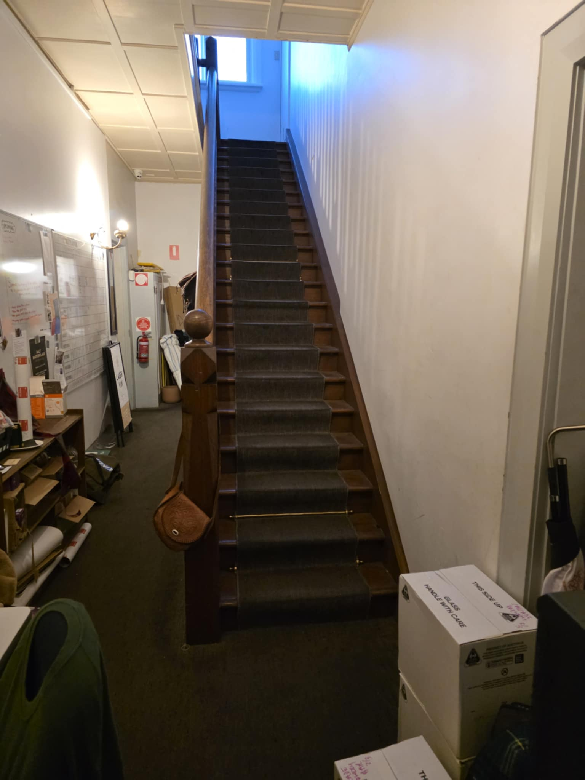
82d1a7cb-72ef-42e3-a607-b1ef2b22715c
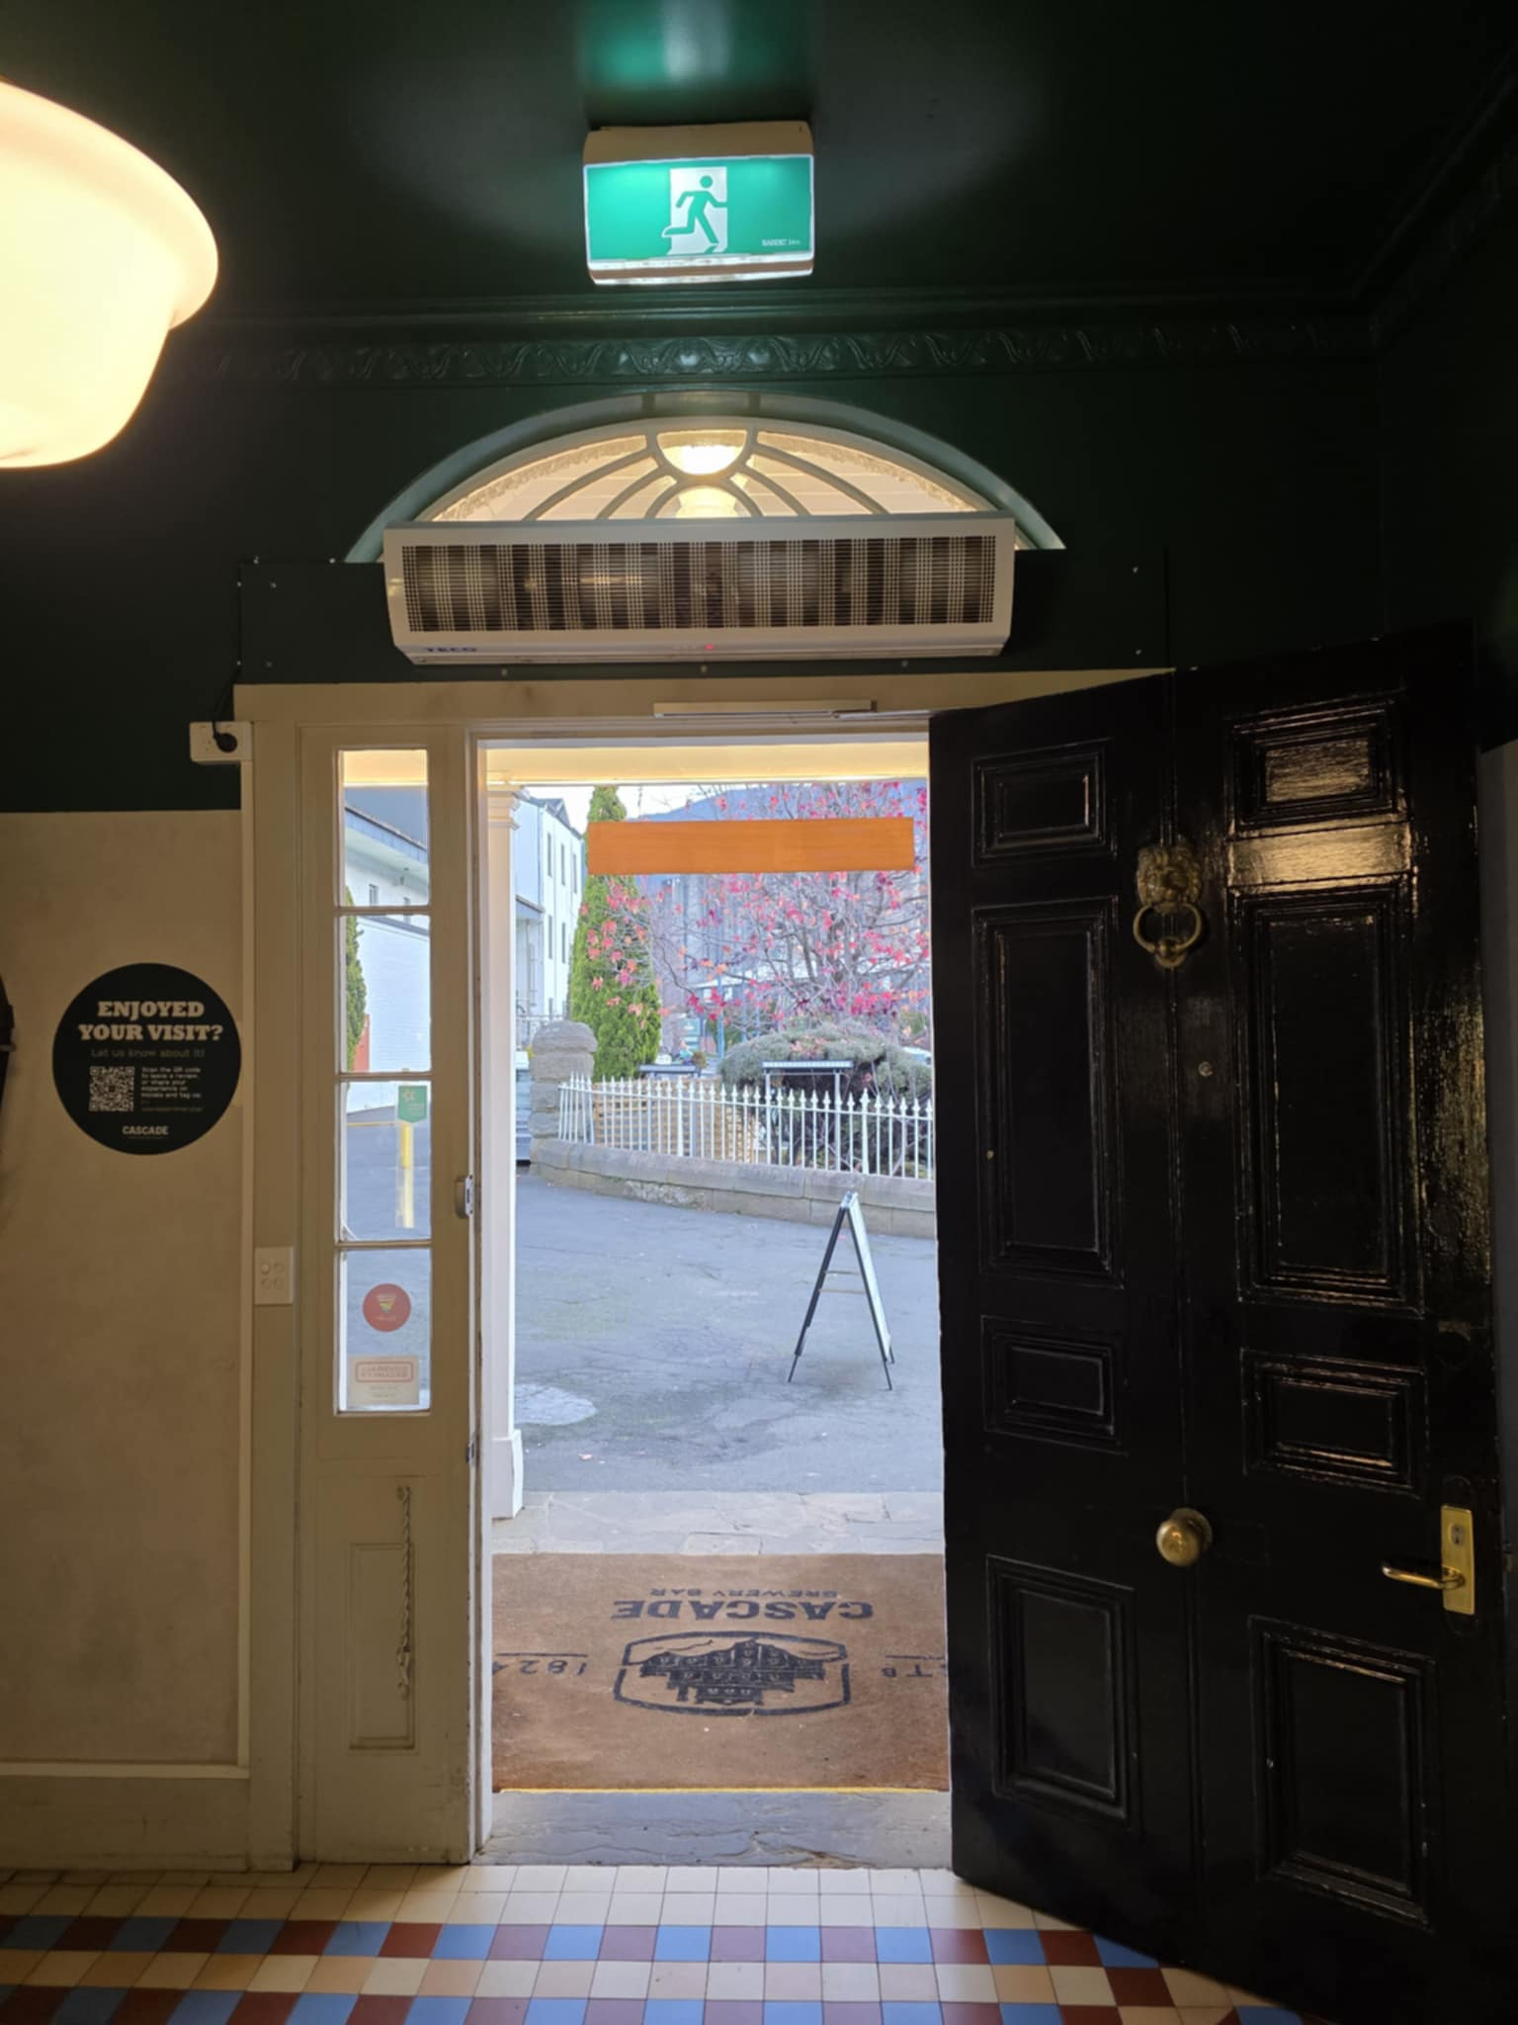
3ef0c346-c2df-4609-9a8e-b7c784b9a916
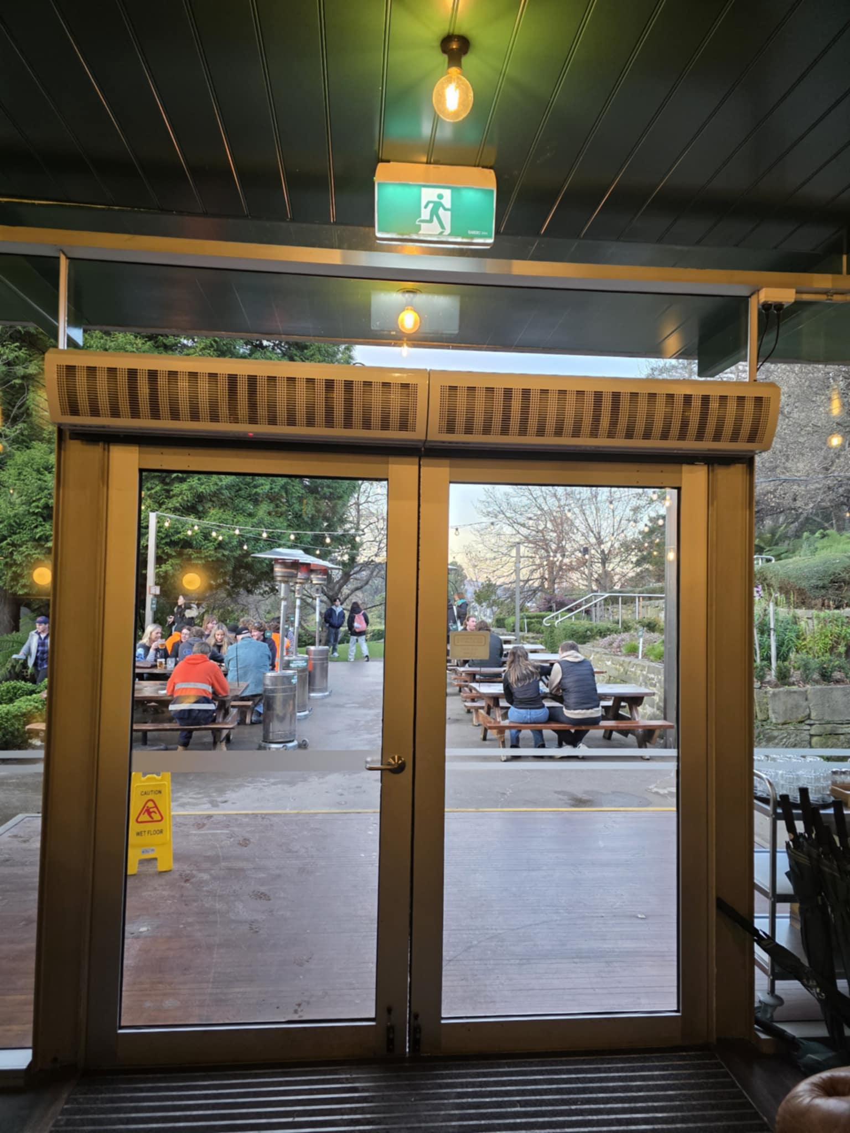
3f95a28a-1e83-444e-91dd-4e671e8773d5
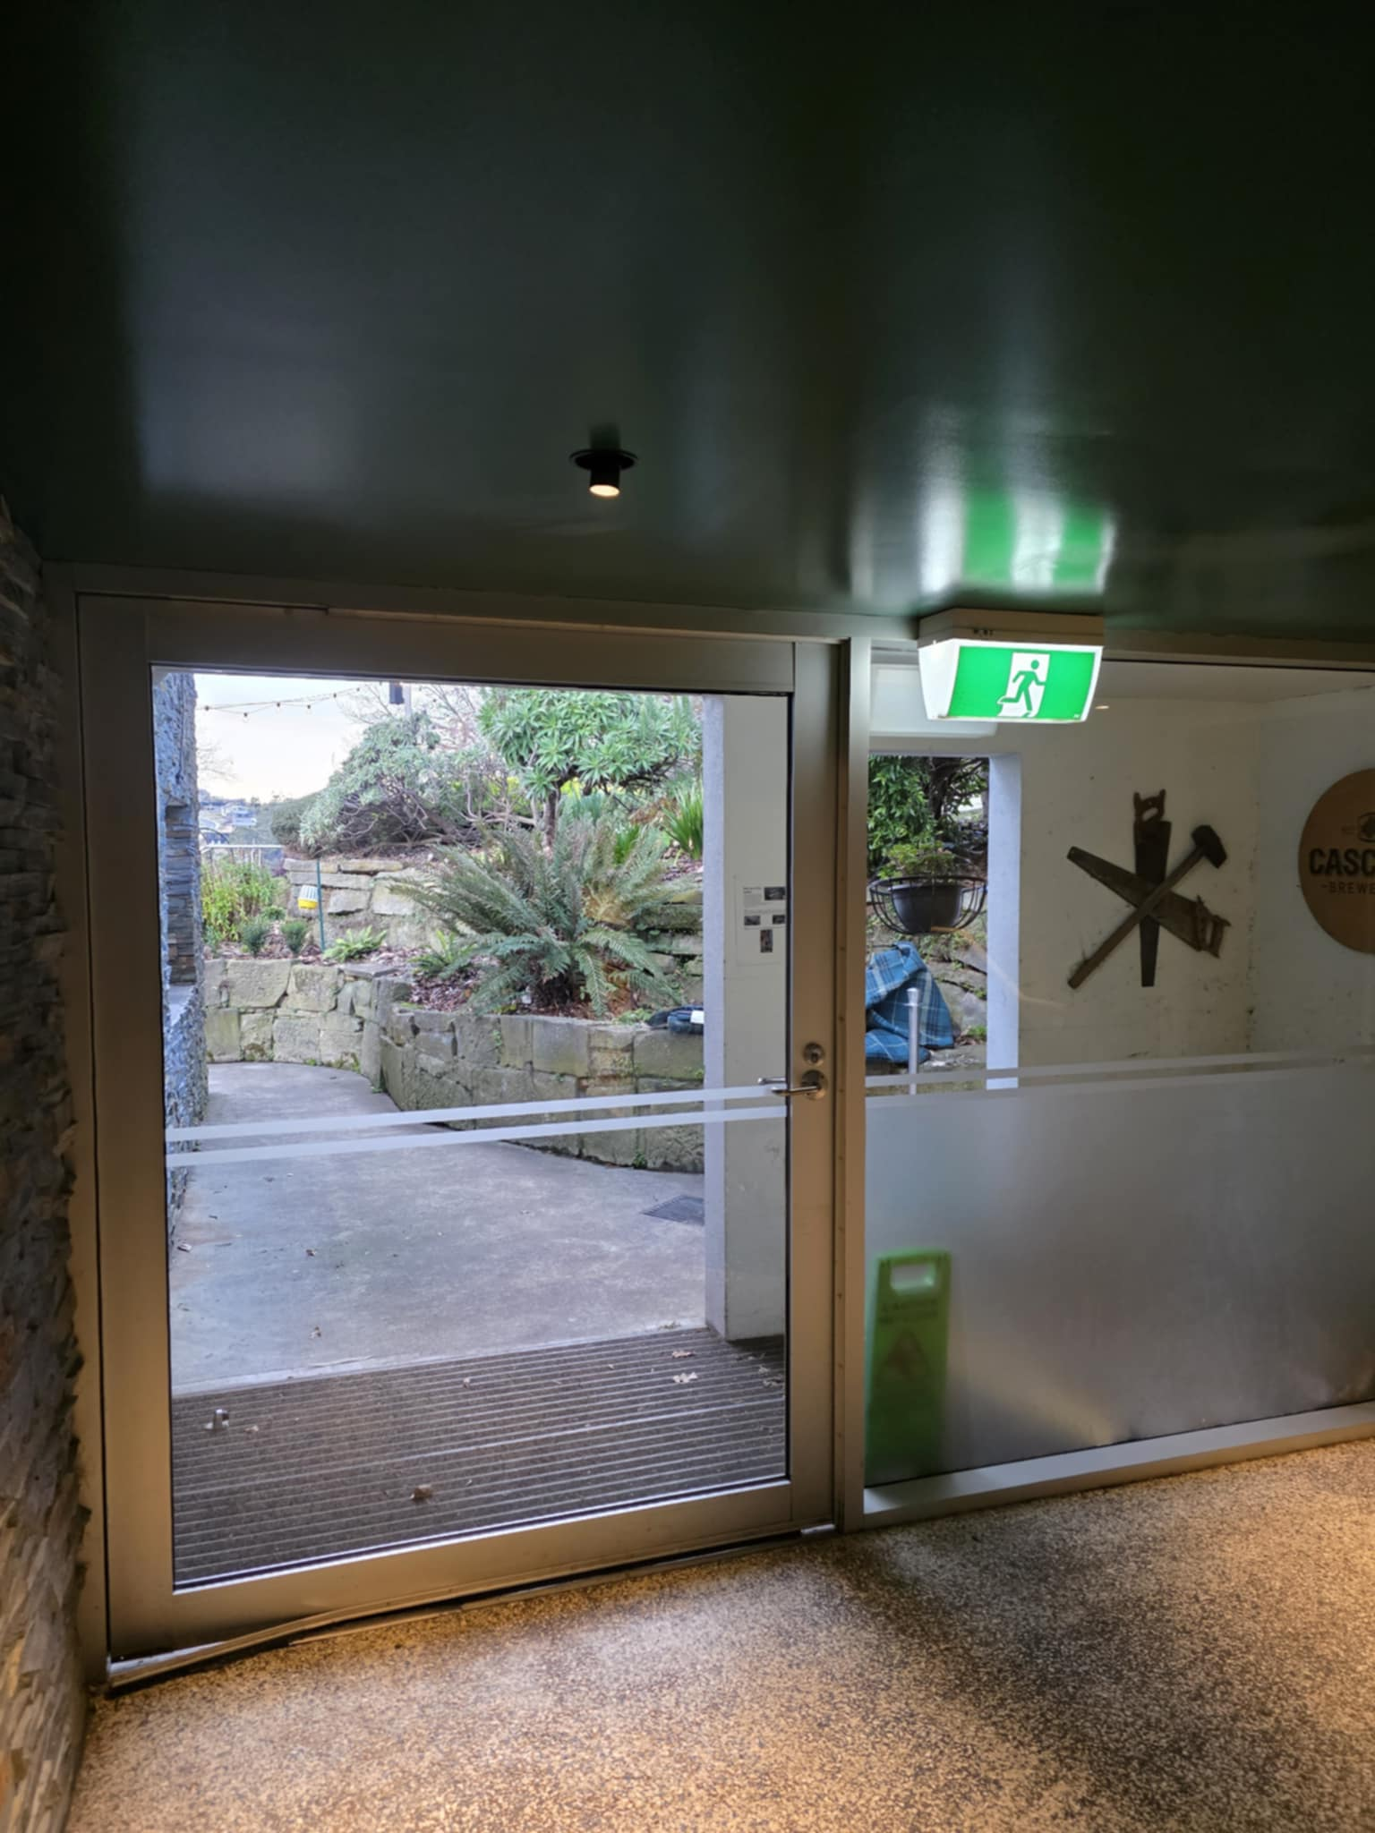
3a7d08e9-e4d3-43aa-9e33-b741845596a7
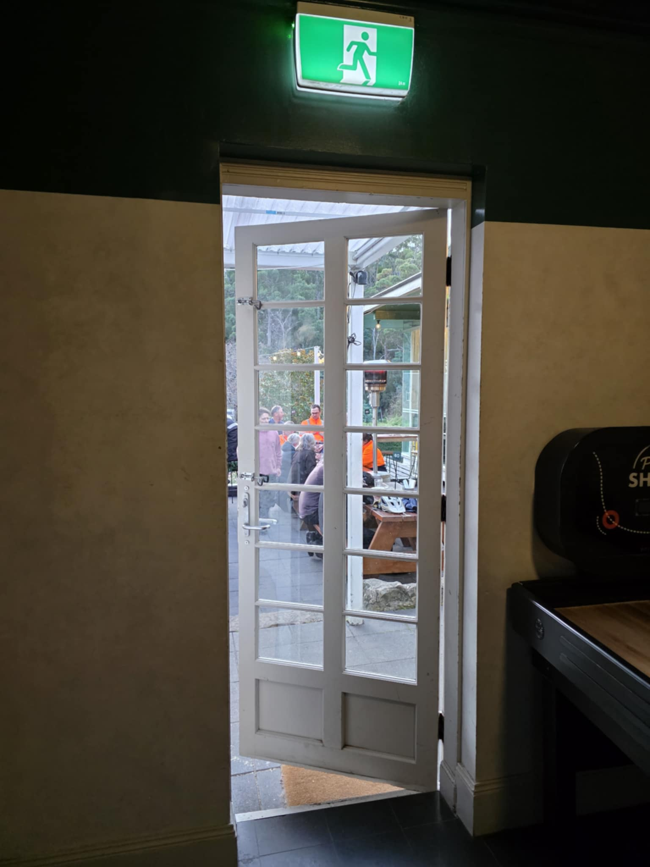
0df50d9d-abec-4d00-a148-82c337919f96
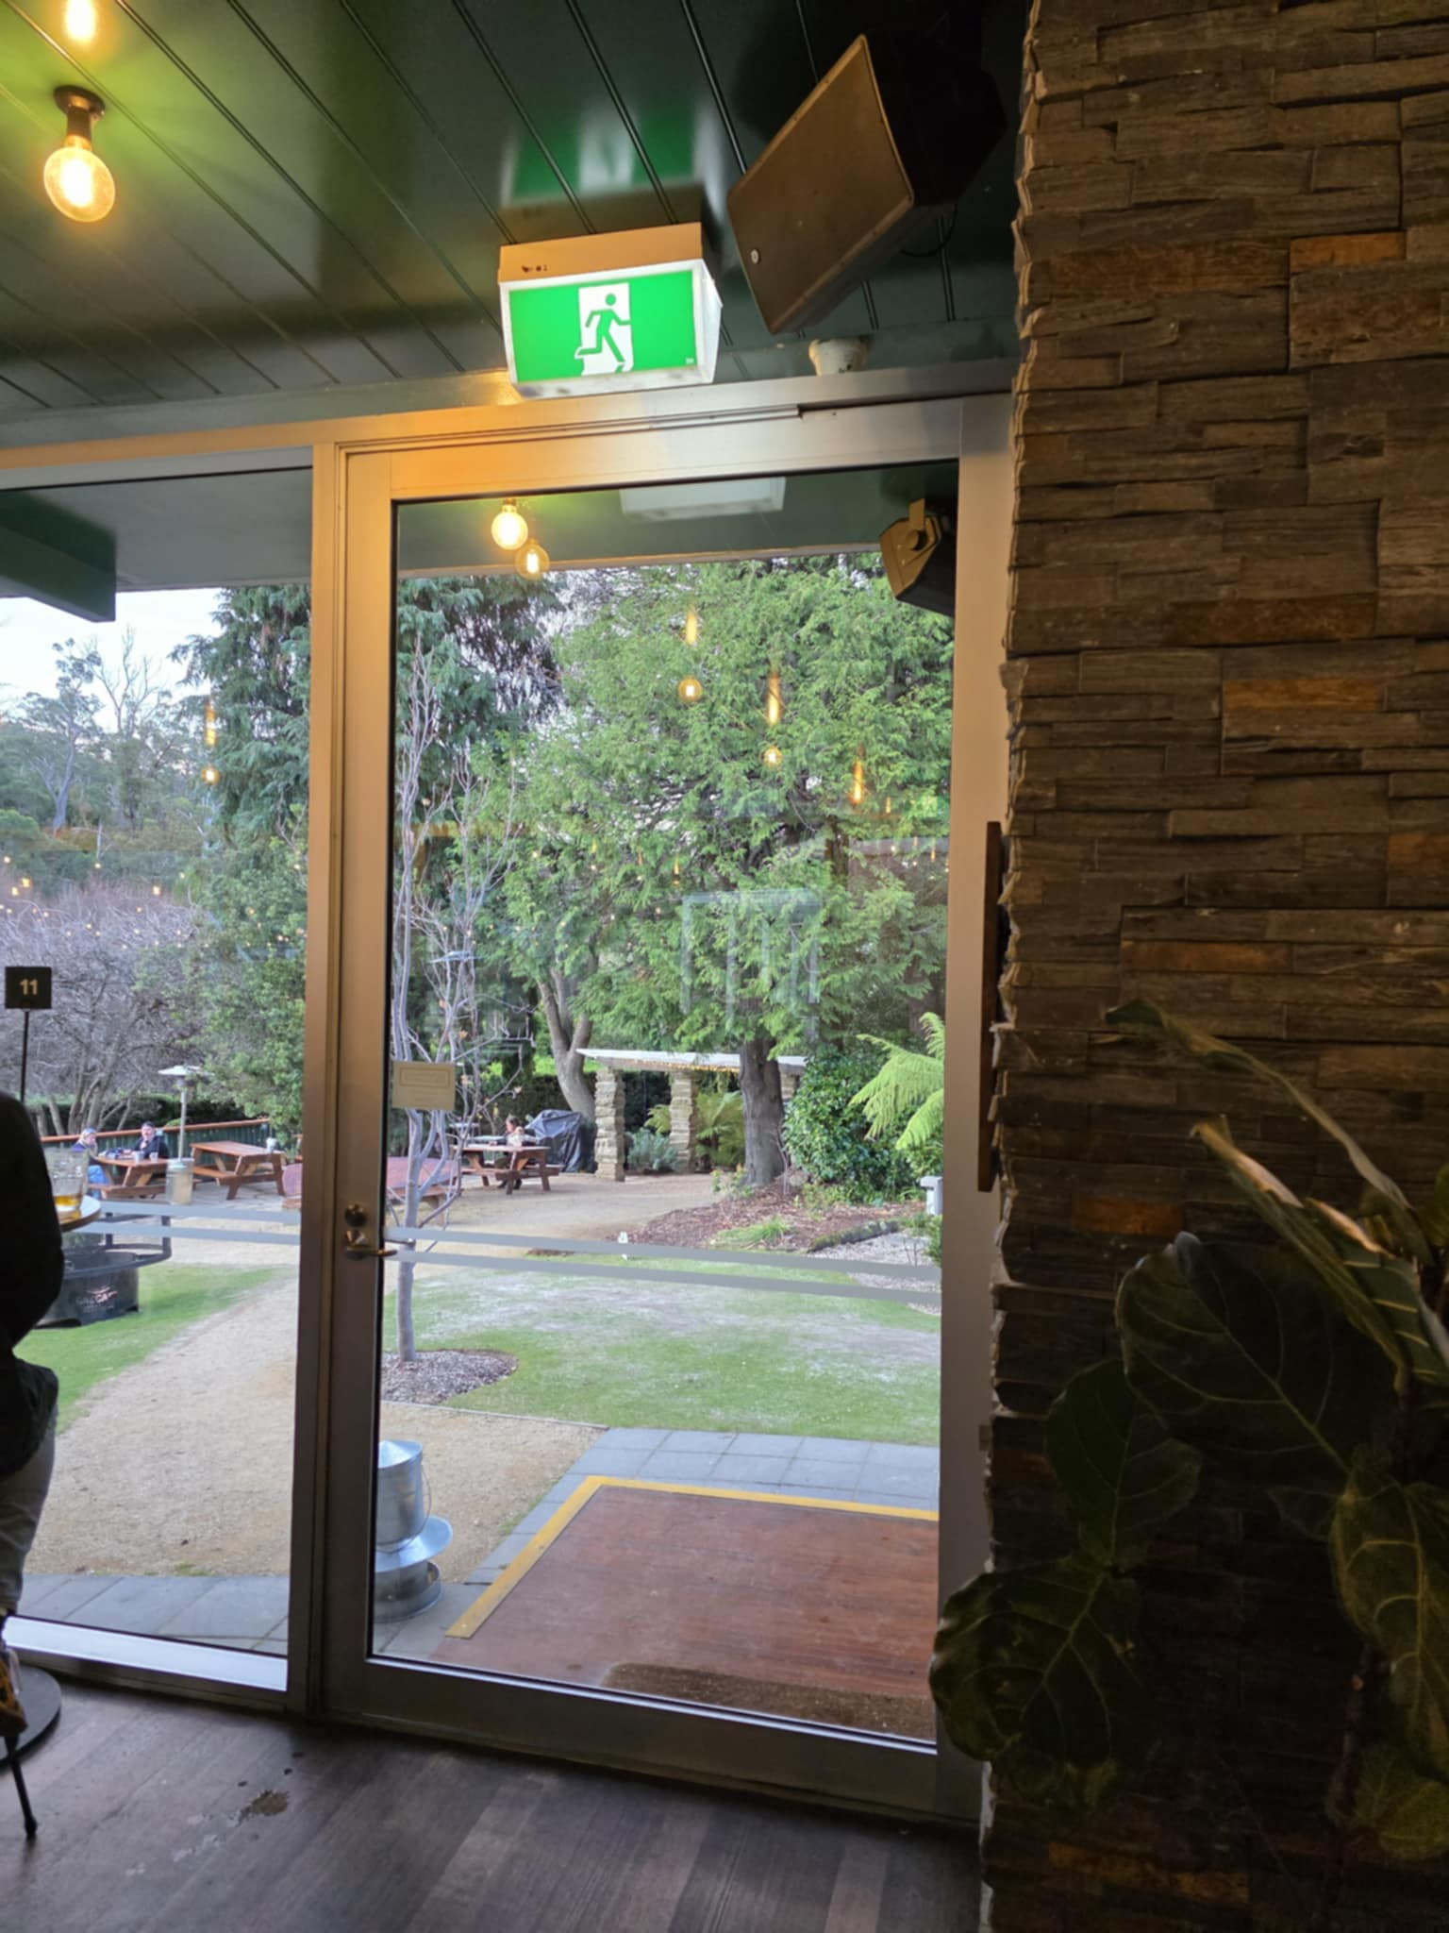
e8460516-a2ac-4b4f-8c06-50bb6ebce879
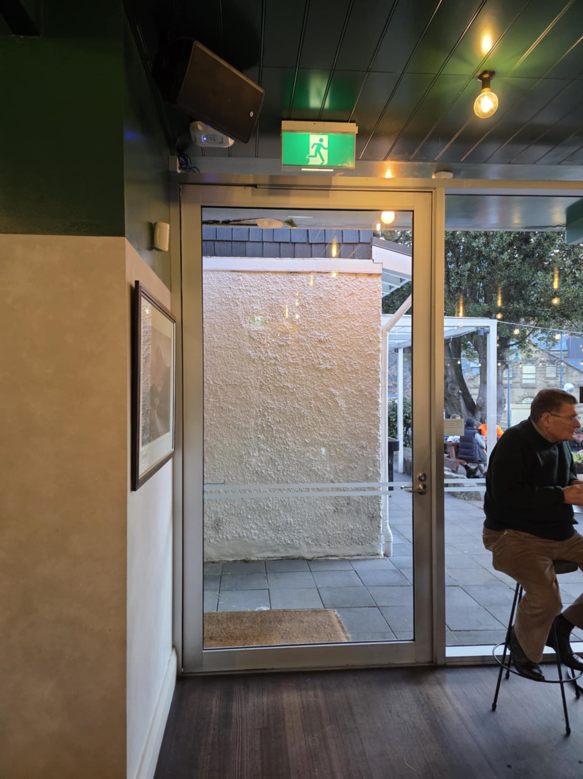
1b5a318f-265b-4d19-80ff-0b86bf28dd7a

FOOD AND DRINK

Dining Spaces
The dining spaces have the following facilities/amenities in place
- The entrance has level access
- The doorway is at least 850mm wide
- There is level access through the dining area
- Chairs are moveable to allow for wheelchairs to be seated at the tables
- All glass doors and full height windows have contrast markings
- There are areas of full lighting
- There are Plain English menus
- There is an accessible toilet

Our business caters for the following dietary requirements
- Gluten free (celiac)
- Lactose free (dairy free)
- Nut free
- Vegetarian
- Vegan
- Halal
- In addition, the following further information can assist guests:
We maintain separate preparation areas for common known food allergens within of kitchen workspace. We maintain rigorous cleaning standards to avoid cross contamination.&nbsp;
- There is a sample menu available online
Sample menu is available here -
https://cdn.shopify.com/s/files/1/0748/4932/1279/files/Bar-Menu_WEB_f0ff44bb-1465-4e23-821b-f8ffd120da6e.pdf?v=1747044790
- In addition, the following further information can assist guests:
N/A

EVENTS

Events
Events have the following facilities/amenities in place
- There is step free access throughout the venue
- Accessible toilets are available at the venue
- Food and water is available for guide and service animals
- The event is outdoors
- Seating is at regular intervals
- Accessible car parking is available
- There is accessible public transport to the venue
- There is an event map available
- The event map shows accessible facilities
- In addition, the following further information can assist guests:
Accessibility may change dependent on event type. The details listed are a general guide.

Report Disclaimer
Please note that this business report, provided as a result of the use of the diagnostic assessment, is for information purposes only.
Australian Tourism Industry Council (ATIC) cannot guarantee the accuracy of respondent’s answers, or that they are fully representative of your business. Therefore, ATIC does not warrant or guarantee any particular outcome in respect of your businesses self-assessment.
This report is intended as guidance only for your business and should not be relied on for future marketing considerations. ATIC recommends that you seek your own independent advice as well as the results from the diagnostic.
Links to external web sites are inserted for convenience and do not constitute endorsement of material at those sites, or any associated organisation, product or service.
ATIC does not:
- Assume any legal liability for the accuracy, completeness, or usefulness of any information from this report or any links provided; or
- Accept responsibility for any loss associated directly or indirectly from the use of this report.

