ATIC Accessibility
To support the accessible community in making informed travel decisions for their individual needs

This report prepared for:
Business name: | Kimberley Day Cruise
Address: | 16 Charles Road
Town: | Cable Beach
Contact for enquiries: | Monique Moor
Contact Number: | 0438005566
Contact Email: | bookings@kimberleydaycruise.com
Website: | www.kimberleydaycruise.com
Date: | 2026-06-27 06:17

ATIC Accessibility
The following pages provides travellers with information on the businesses facilities and amenities which aims to support the traveller to make an informed decision on whether the business is suitable for their individual needs.
OVERVIEW 4
Business Overview 4
Bookings 4
Emergency Management 4
Communications 5
Other Information 6
Guide Dog and Service Animals 7
GENERAL 8
Pre-arrival, arrival and reception 8
Cognitive Impairment Support 8
Car Park and Access amenities 8
Entry 9
Internal Spaces 9
Public areas 9
Displays, exhibits, commentary and live performances 10
External Paths 10
Steps 10
Public Toilets/Adult change facilities 10
TOUR OPERATORS 11
Tour/Transport Services 11
Route Planning 11
Guides 12
Report Disclaimer 17

OVERVIEW

Business Overview

Our business caters for the following disability types:
- Blind or low vision
- Deaf or low hearing
- Limited mobility
- Food allergies or intolerances
- Cognitive or people on the Autism Spectrum
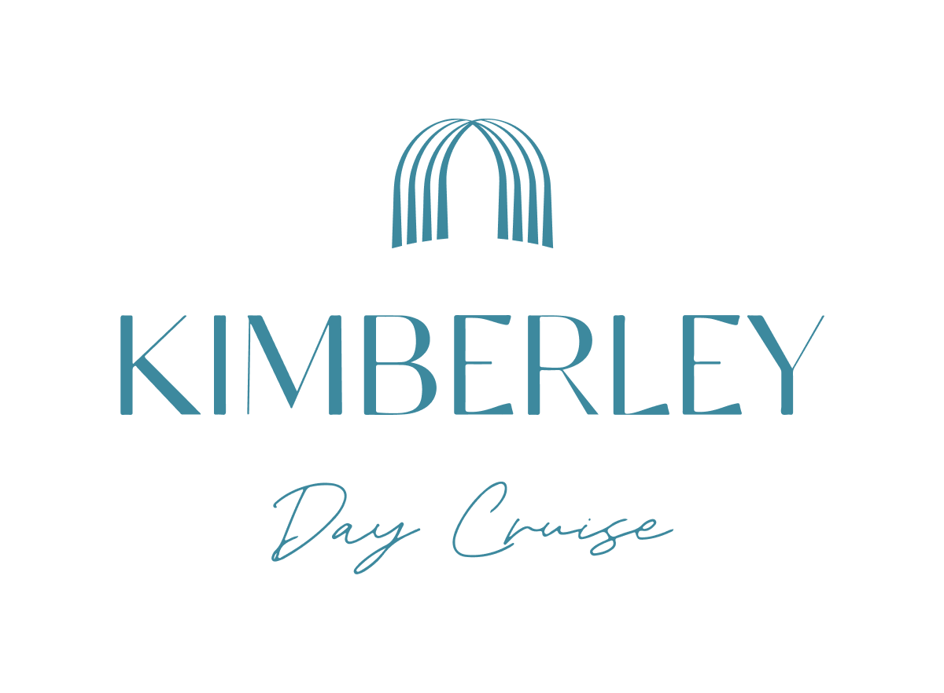

Bookings

The business offers the following methods for bookings and enquiries:
- Phone
- Email
- Webportal
- Our forms have high contract boxes and submit boxes

Emergency Management
- Emergency and evacuation procedures are explained on arrival
- Exit signs are clear and easy to see
- Exit access is free and clear at all times
We ensure exit access is free and clear at all times by:
Ensure nothing is stored in the way, is out the way of seating, work stations or waiting areas
- Exits and access to exists are greater than 900mm
- Exit doors are able to be opened by all occupants
- Exits to the emergency evacuation point does not include stairways
- The evacuation point is clearly marked by a sign
The business identifies guests who need additional assistance should an emergency occur by:
Prior to the tour we ask for additional information from guests to make the staff on the boat aware prior to boarding. Guests are monitored by staff whilst on the boat to be aware of any mobility issues.
The procedure for assisting guests who need assisted rescue is:
Same procedure as standard rescue, clear procedures are set in place for guests including life rafts, jackets, life rings etc
- Guests with disabilities are noted in the guest log book for emergency and evacuation purposes

Communications
- Our website meets WCAG 2.0 accessibility standards
- Our business offers the following alternative communication methods
- Plain English

Not specified
- There is easy to read signage and information (e.g. menus and emergency information)
- There is a Pictorial menu
  - Pictorial Menu Image(s)
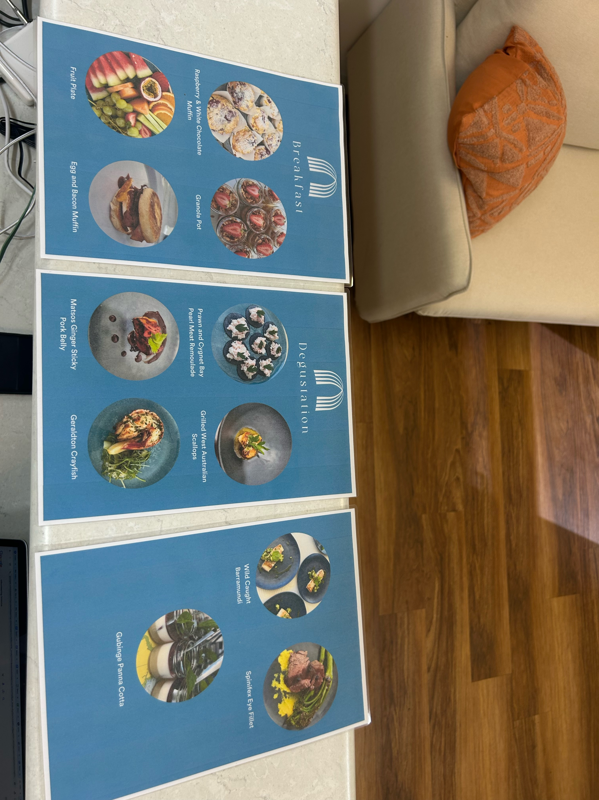
image3
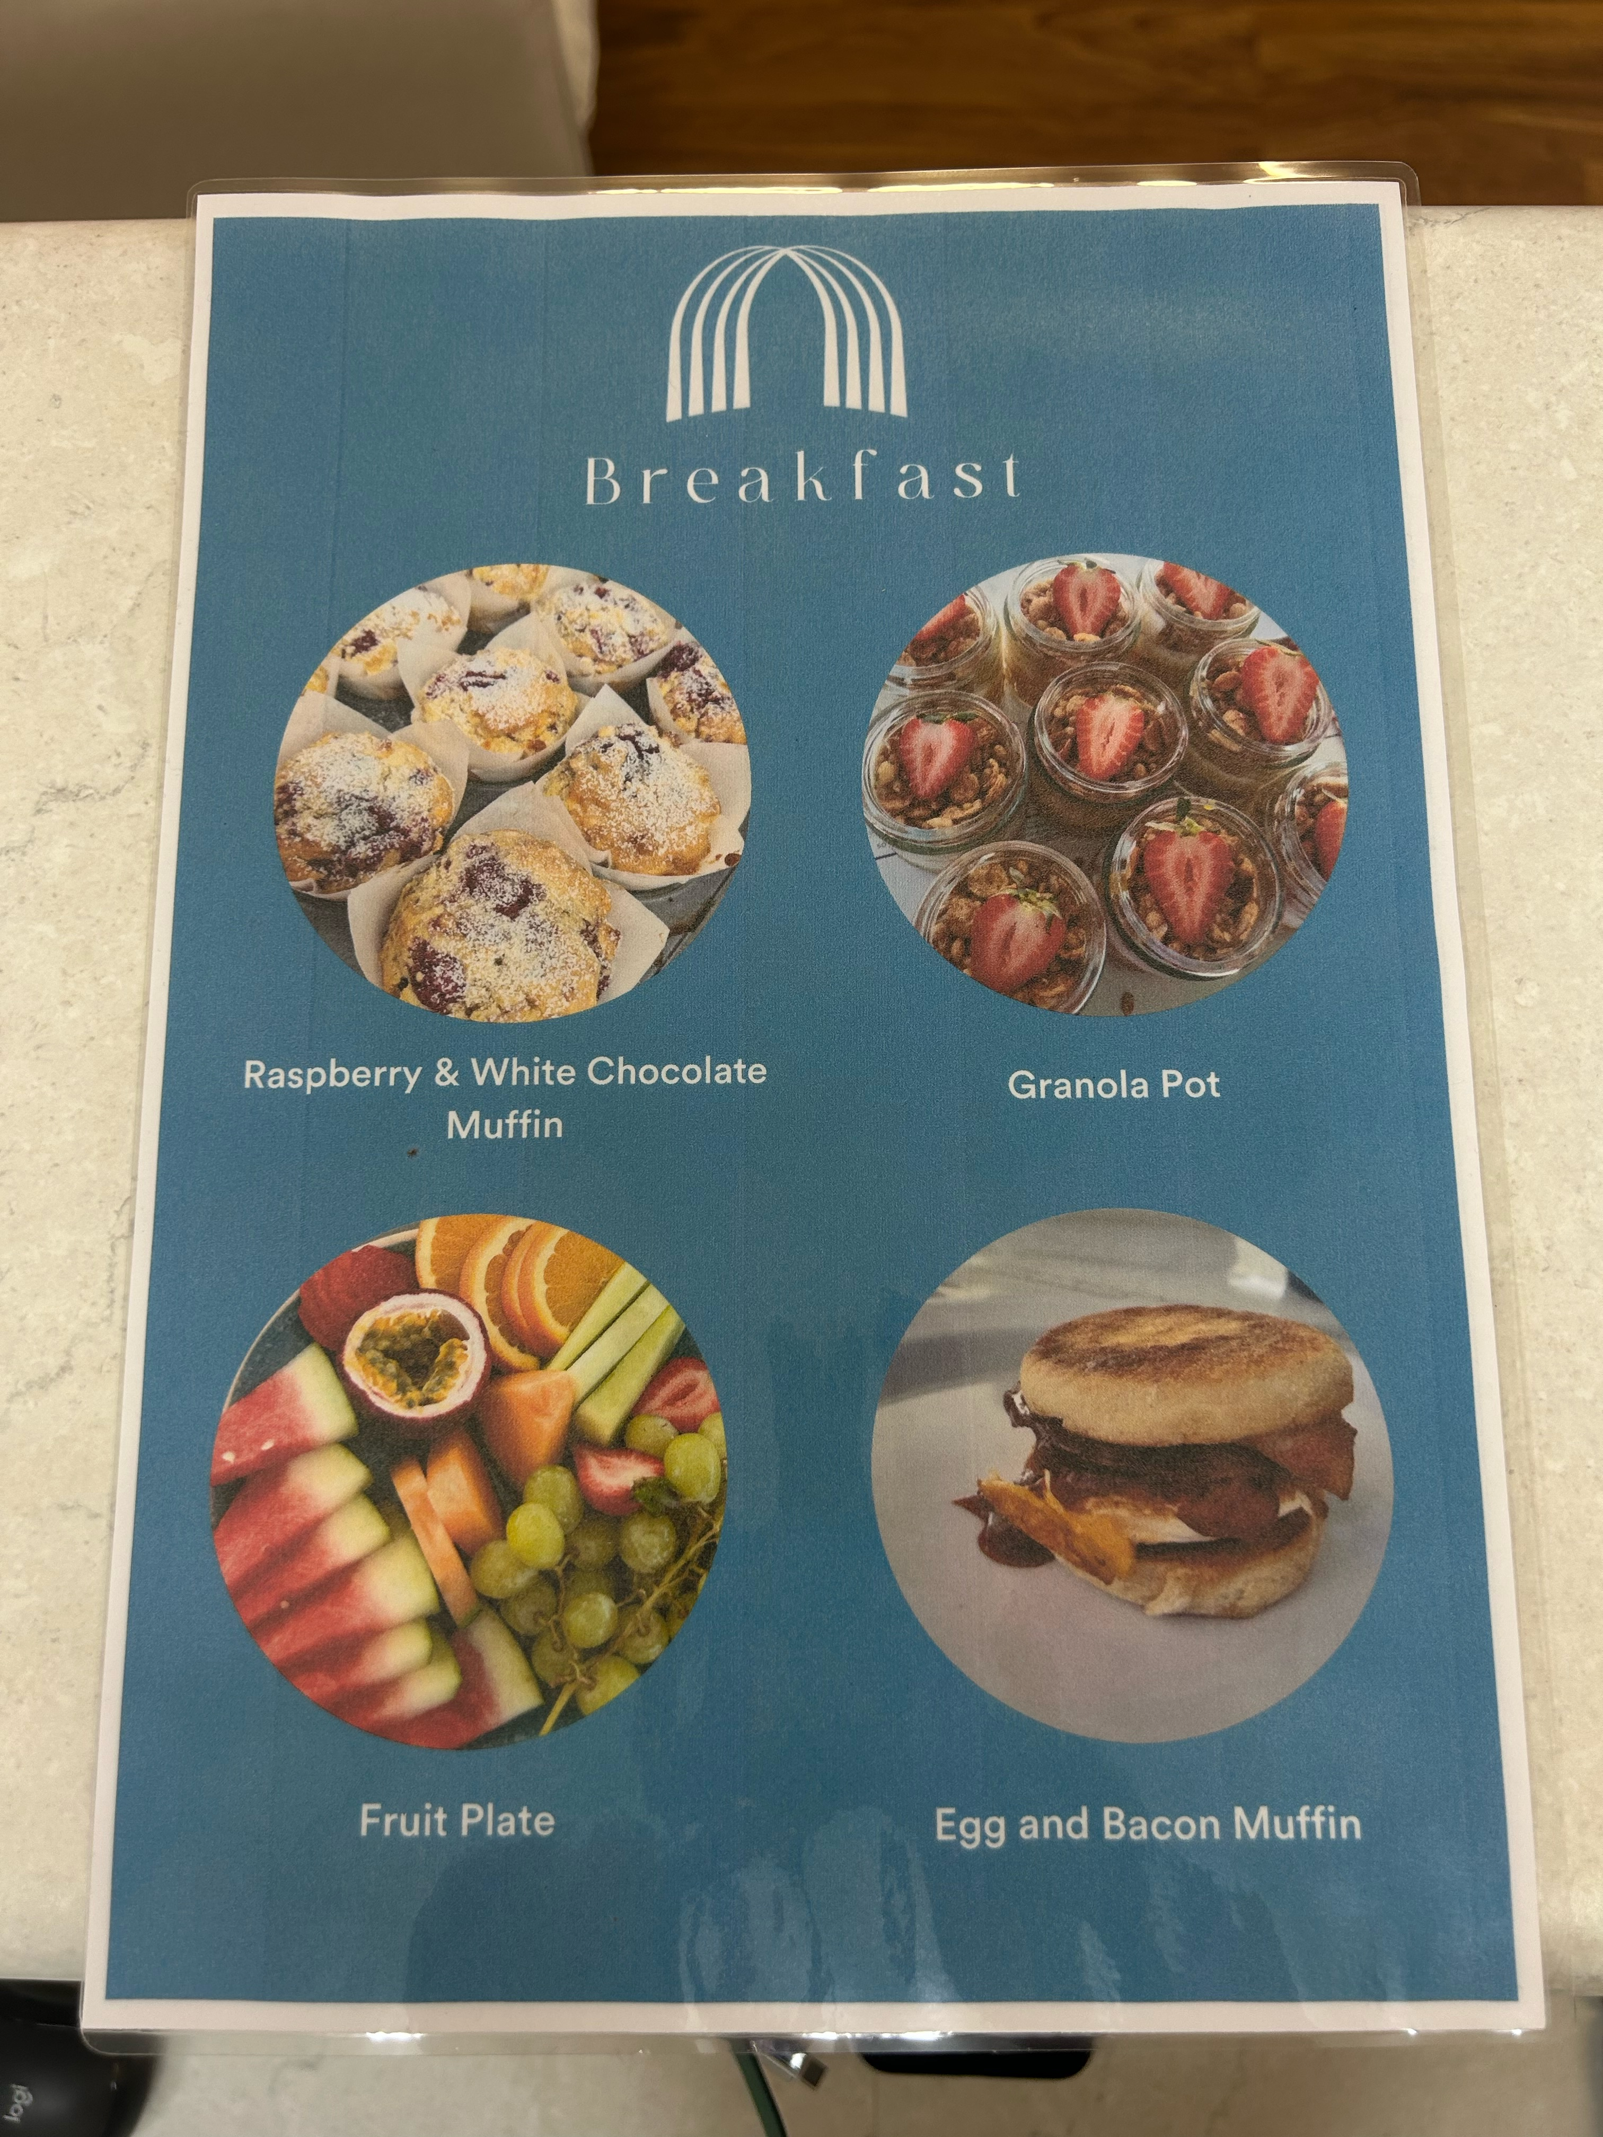
image0
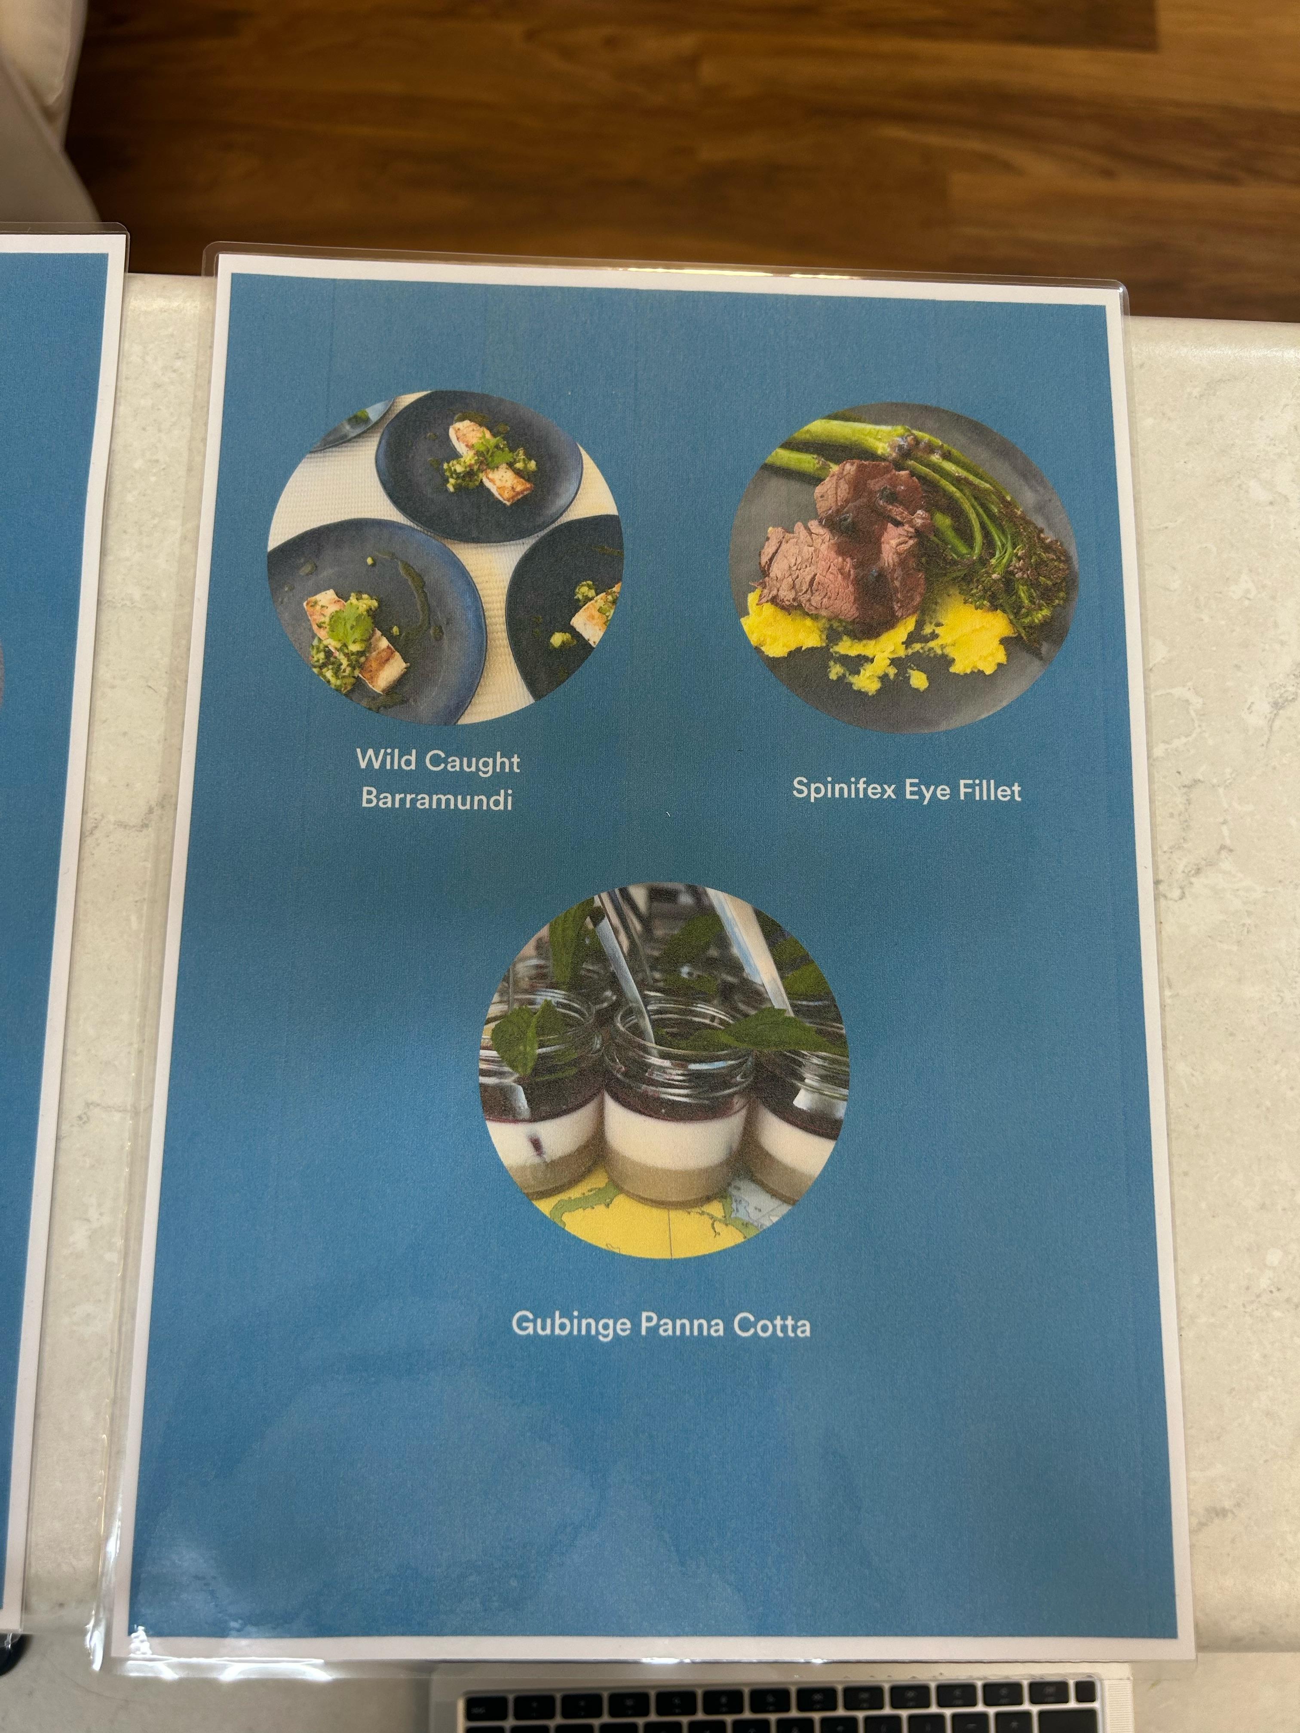
image2
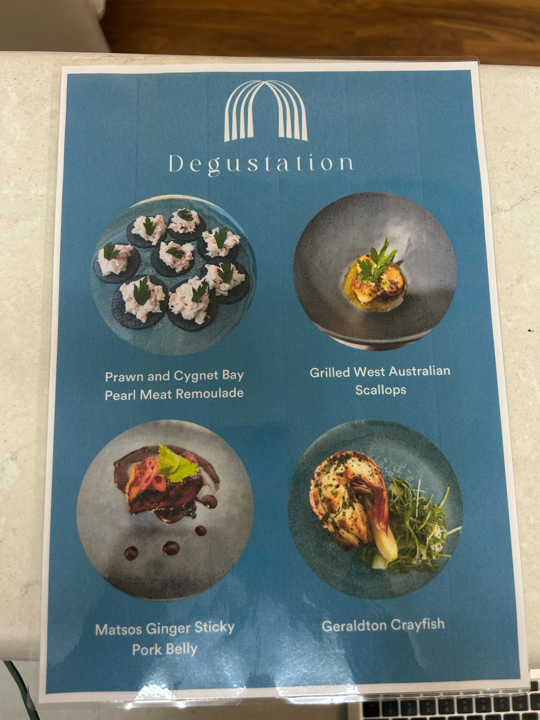
image1

Other Information
- For bookings made onsite, the ticket booth/counter/box office is accessible for people using a wheelchair
- The business accepts the companion card

Guide Dog and Service Animals
- The business provides a secure area with shade and water for service animals
- The business provides a toilet area for service animals
- Bowls, bedding, etc. are provided for service animals
The business provides the following services for services animals:
Comfortable shaded area with blankets to sit in, water and food provided. A litter type of toilet area.

GENERAL

Pre-arrival, arrival and reception
The business has the following in place to support guests during pre-arrival, arrival and reception
- Booking information and websites are compatible with screen readers
- There is a reception/public entryway.
- Seating available at reception
- A lower counter at reception/ticket office
- A clipboard to allow check-in/ticket purchase whilst seated
- Lighting in the reception area is even and glare free
- Information and maps are available in written form
- A familiarisation tour
- In addition, the following further information can assist guests:
There is always comfortable seating and shade available. The tour runs on an efficient schedule and any waiting time is spent on the boat in comfortable seating with lots of food and water available as well as shade.

Cognitive Impairment Support
- Documents are available in plain English for people with cognitive impairment (This may include instructions, guides, menus and general information)
- A space for parents and children on the Autism Spectrum

Car Park and Access amenities
The business has the following Car Park and Access amenities
- A drop off zone
- Designated disabled parking bays
- Level or ramped access from the car park to the entrance
- In addition, the following further information can assist guests:
There are no nearby bus stops to the office. All bus pick ups for the tour are done directly at the guests accomodation.&nbsp;

Entry
The business has the following amenities/systems in place for entry
- A drop off point close to the entrance
- A path of access to the building is slip resistance and even
- A path of access to the building is clear of obstruction
- Self opening entry doors or fitted with a self closer
- Glass doors are fitted with a visual sighting strip
- Door jams/doors are of a contrasting colour to surrounding walls
- Door handles are of a contrasting colour to the door
- Signage is written in a contrasting colour
- The entry door is a minimum of 850mm wide
- The entry door has self opening or a light opening pressure (for manual operations)
- The entrance sill is less than 13mm
- There a clear space of at least 1500mm x 1500mm in front of all doors.
- The entrance door mats have a thickness less than 13mm and a width of 7500mm or greater

Internal Spaces
- Clear and unobstructed routes through and between buildings
- Interior walls are matte or low sheen
- Floors, walls, counters and furniture are of contrasting colours
- Any protruding or overhanging obstructions are at least 2meters above the floor or are protected
- Floor surfaces are hard or short pile carpet
- Seating is available for guests unable to stand for long periods
- Accessible facilities are clearly signed and visible from all areas
- All corridors greater than 900mm
- There is a quiet space for parents and children on the Autism Spectrum

Public areas
The public areas have the following amenities in place
- Even lighting
- Seating

Displays, exhibits, commentary and live performances
For displays, exhibits, commentary and live performances the following amenities are in place
- Seating

External Paths
External paths of travel
- Surfaces are concrete, asphalt, smooth paving or hard packed fine gravel (max aggregate size 13mm)
- Pathways are wider than 900mm
- There 3 successive steps or less on any path or at any doorway

Steps
Steps
- There are steps.
- Top and bottom steps are easily distinguished through colour contrast or the use of TGSIs (Tactile Ground Surface Indicators)
- All steps or staircases have enclosed risers
- The underside of all staircases are enclosed or protected to a height of at least 2 metres
- Handrails fitted to all open sets of steps
- Handrails extend 300mm beyond the top and bottom step
- In addition, the following further information can assist guests:
Small steps to get onto the vessel main seating area and small step ramp to board the sea legs tender vessel.

Public Toilets/Adult change facilities
Public Toilets/Adult change facilities have the following amenities are in place
- There is an accessible toilet for public use
- The door is at least 850mm wide
- There is a minimum of 850mm beside the toilet
- The toilet seat of a contrasting colour to the floor
- The toilet seat is460mm above the floor

TOUR OPERATORS

Tour/Transport Services
The tour/transport services have the following facilities/amenities in place
- Buses/Coaches
- 0 vehicles have wheelchair lifts or ramps
- 0 vehicles have low floors with ramped entry
The maximum wheelchair capacity available in the fleet is:
0

Route Planning
- Route Planning
- There is an accessible toilet on-board for public use
- The door is at least 850mm wide
- There is a minimum of 850mm beside the toilet
- Handrails are fitted
- The toilet seat of a contrasting colour to the floor
- The toilet seat is 460mm above the floor
  - Accessible Toilet Image(s)
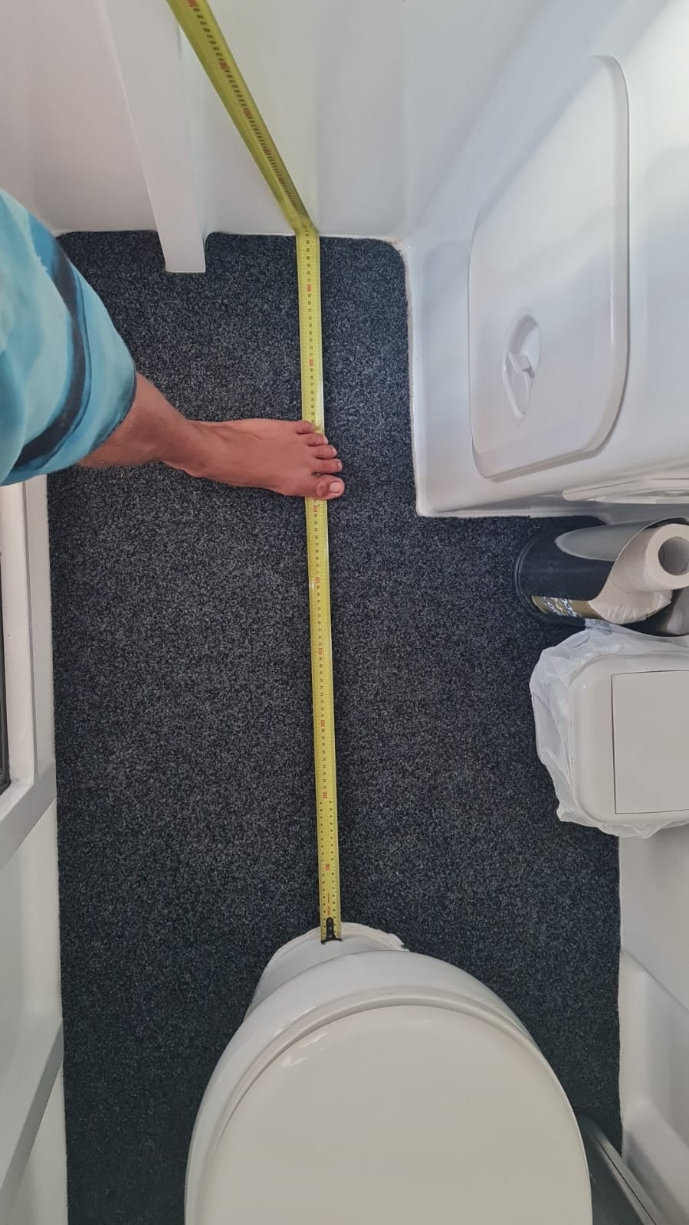
image9

Guides
- Use of clear/simple English
- Correct pronunciation for lip readers
  - Image(s)
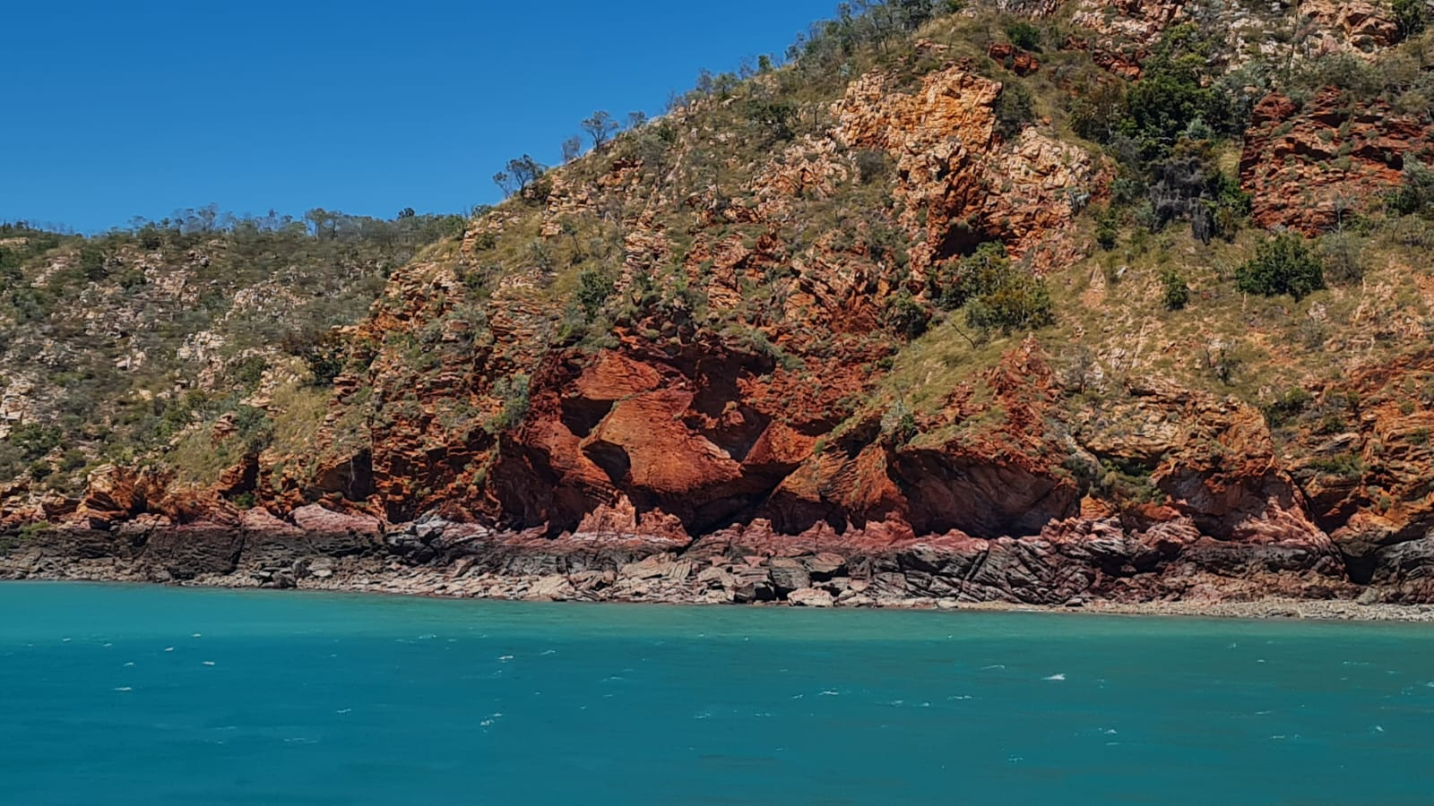
image1
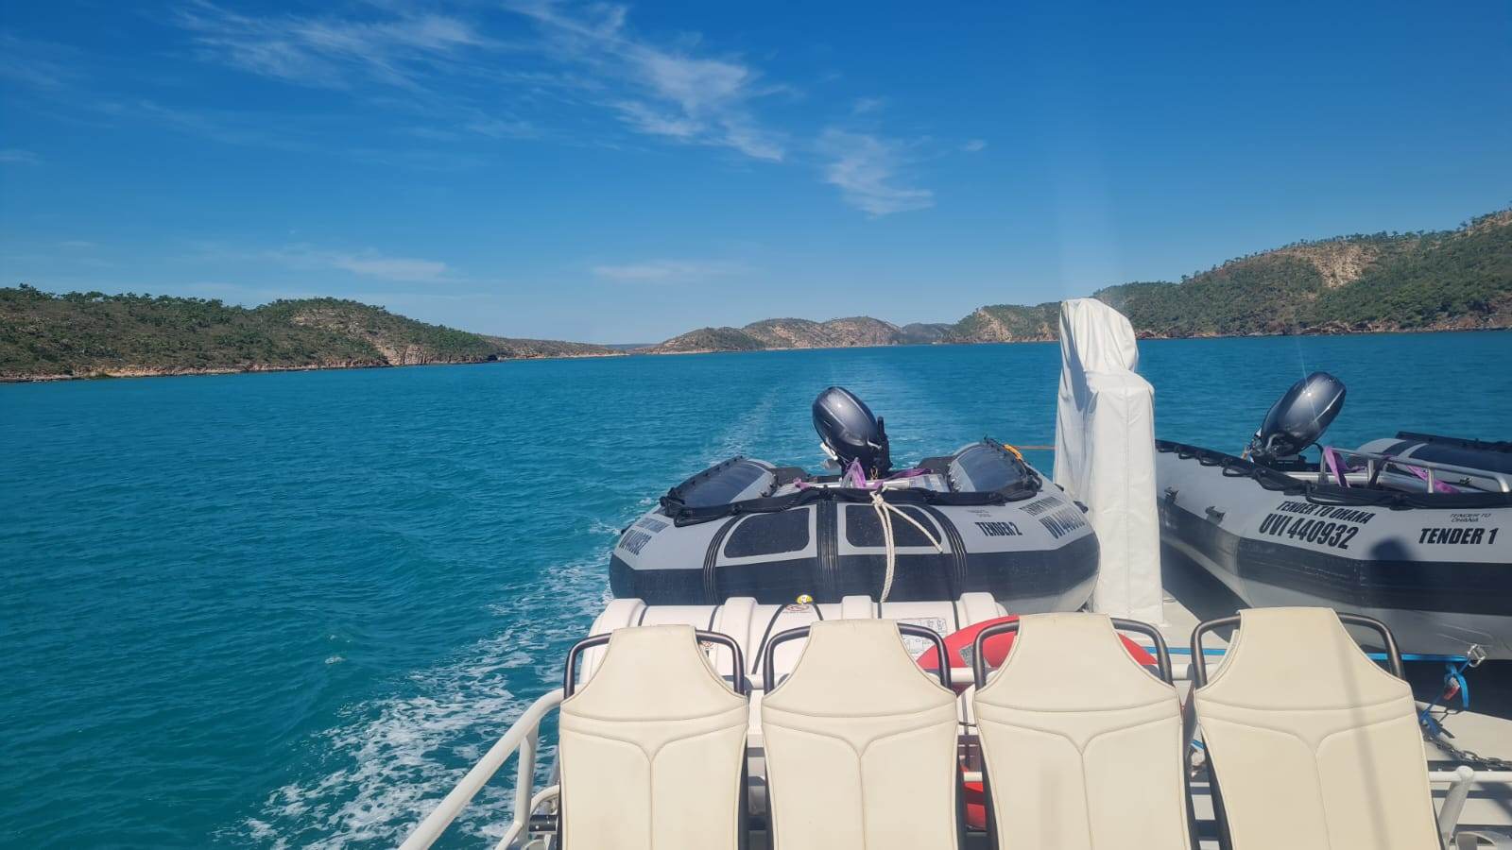
image2
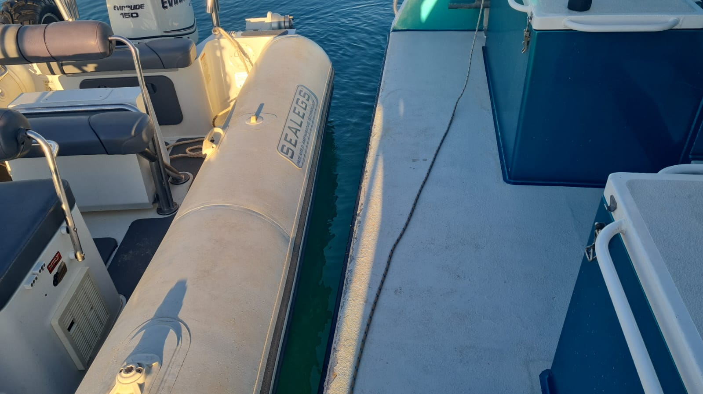
image5
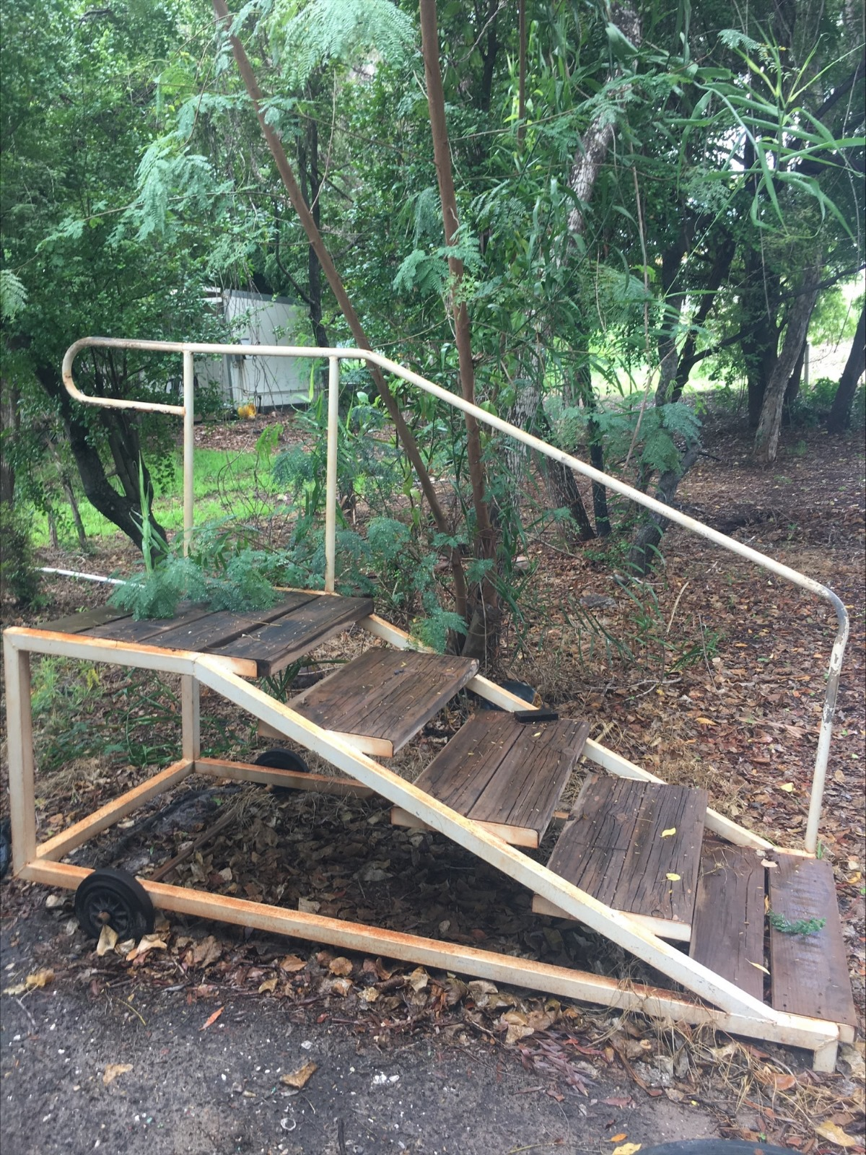
image10
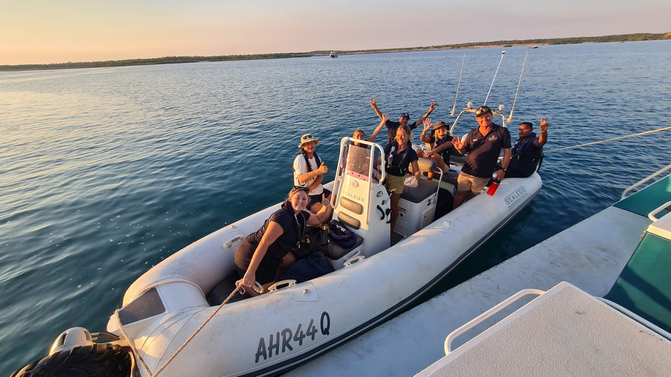
image11
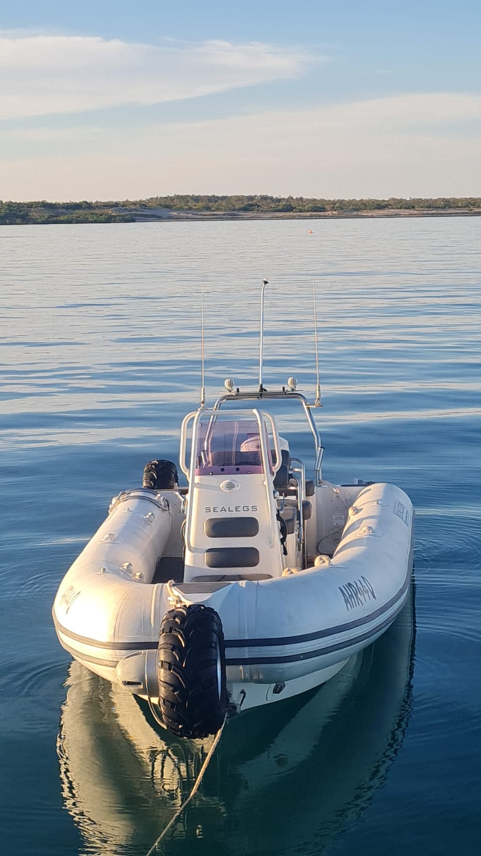
image12
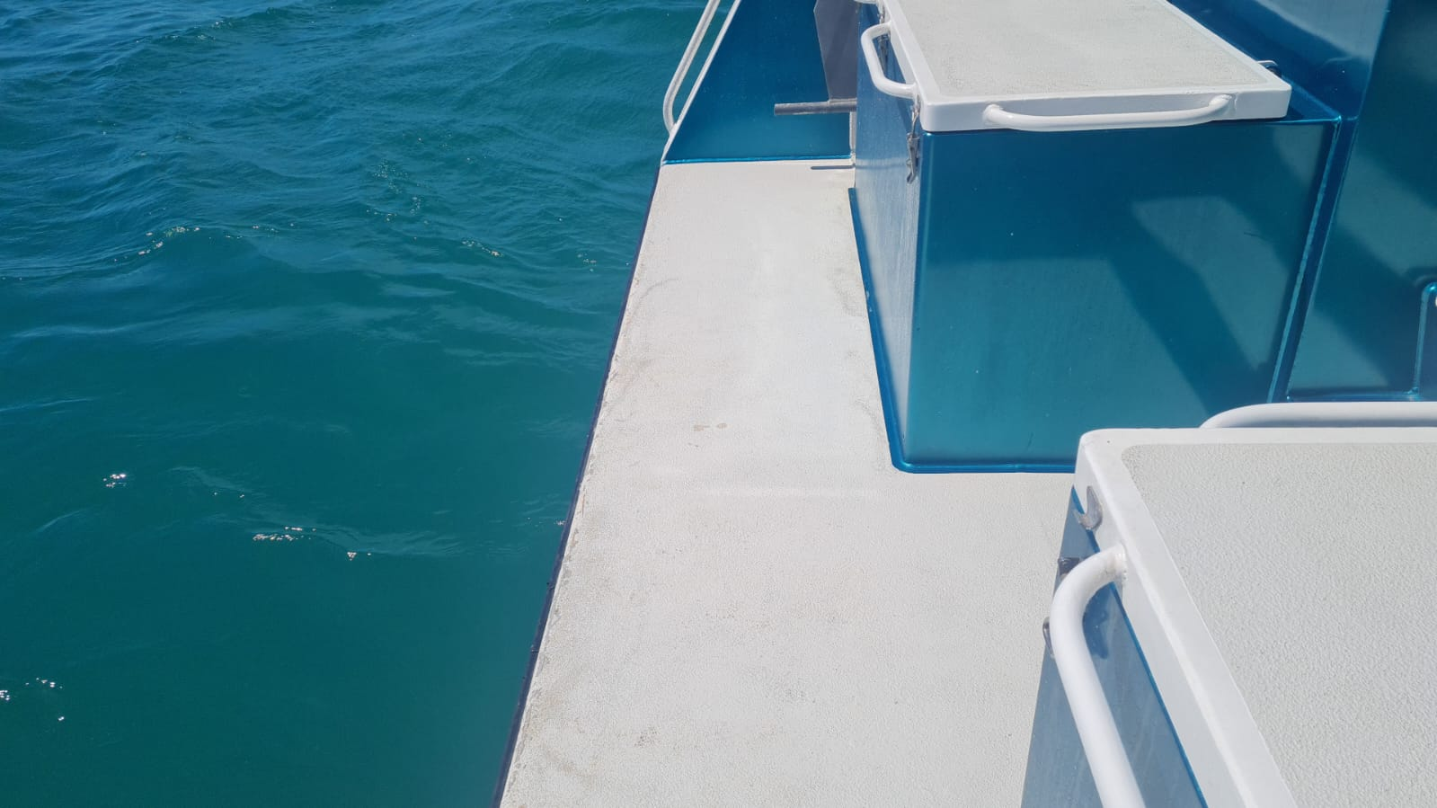
PHOTO-2024-05-01-12-14-44
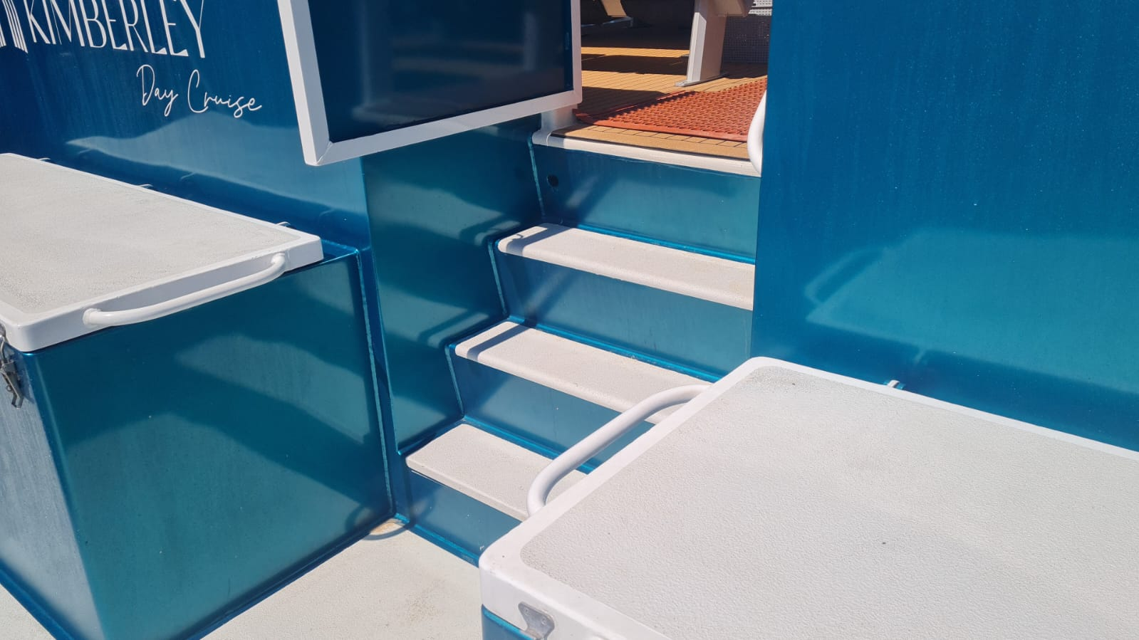
PHOTO-2024-05-01-12-14-58
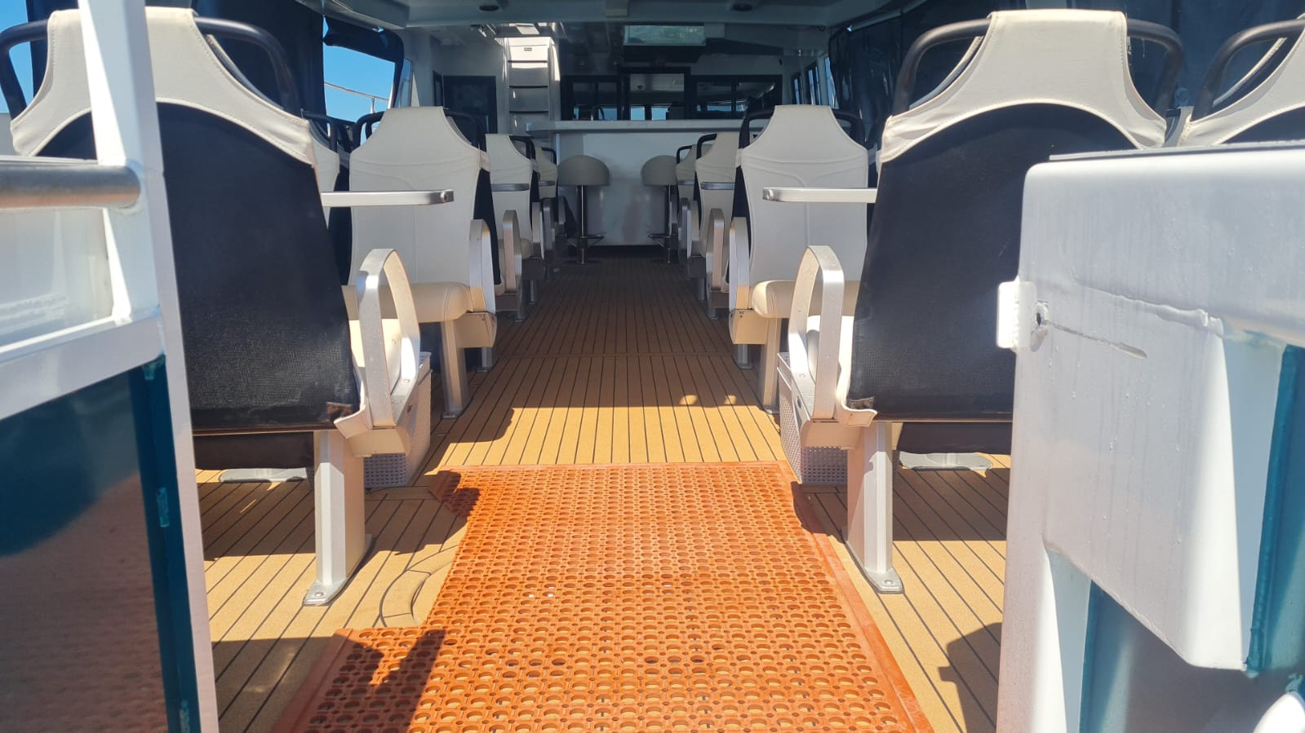
PHOTO-2024-05-01-12-15-37
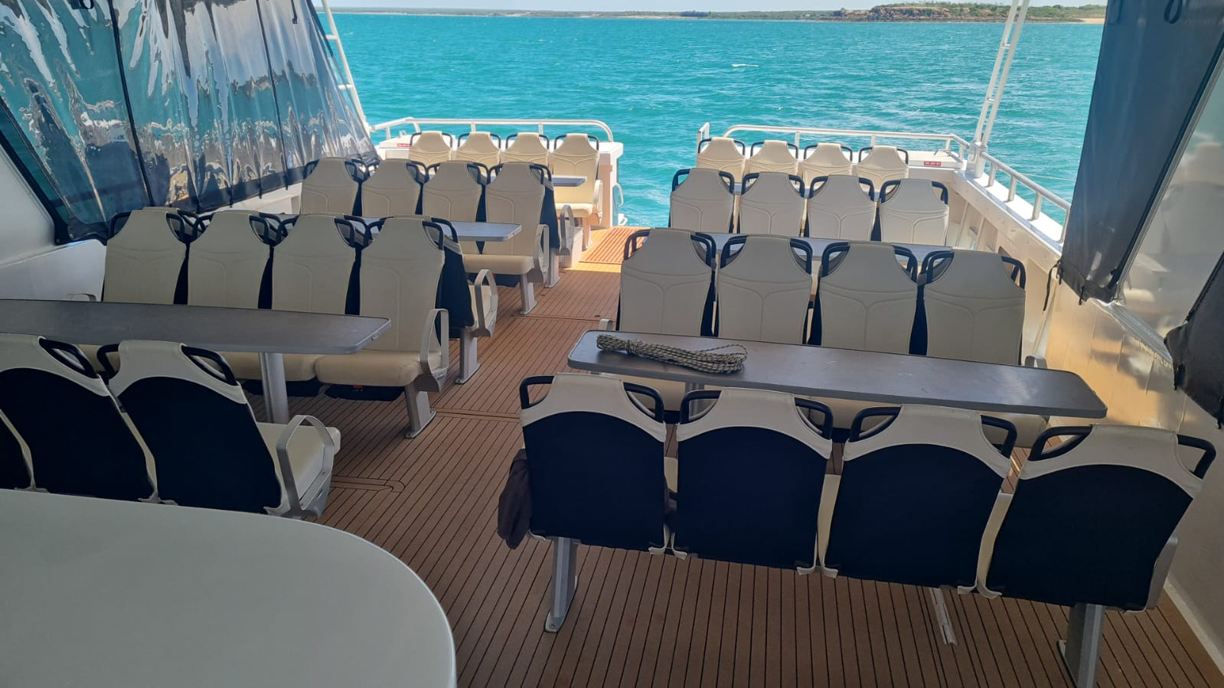
PHOTO-2024-05-01-12-15-43
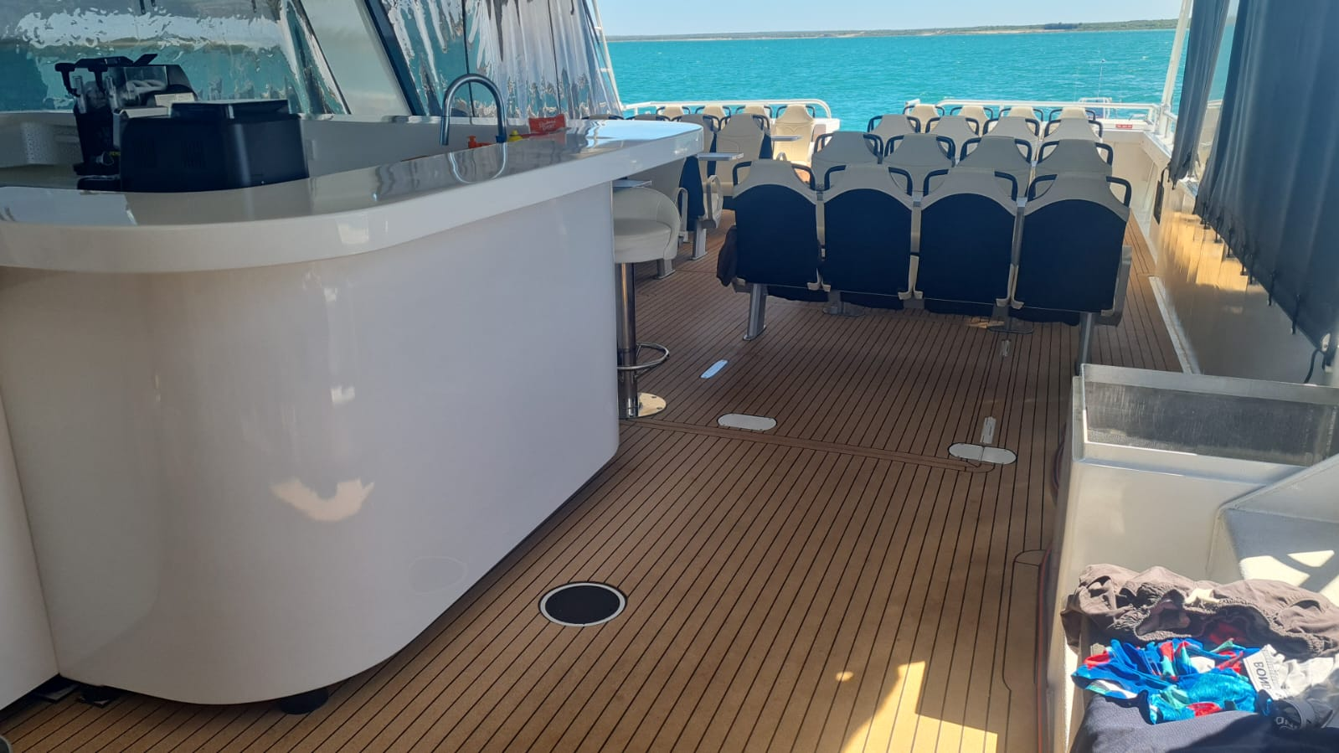
PHOTO-2024-05-01-12-16-09
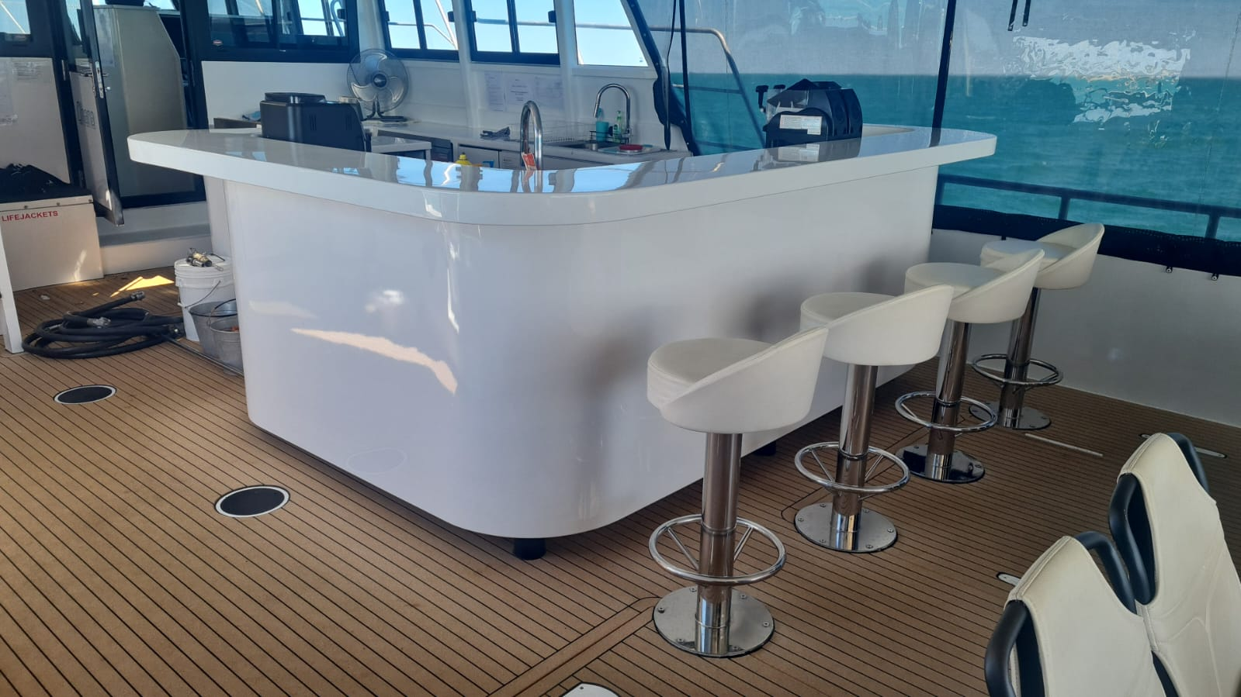
PHOTO-2024-05-01-12-16-25
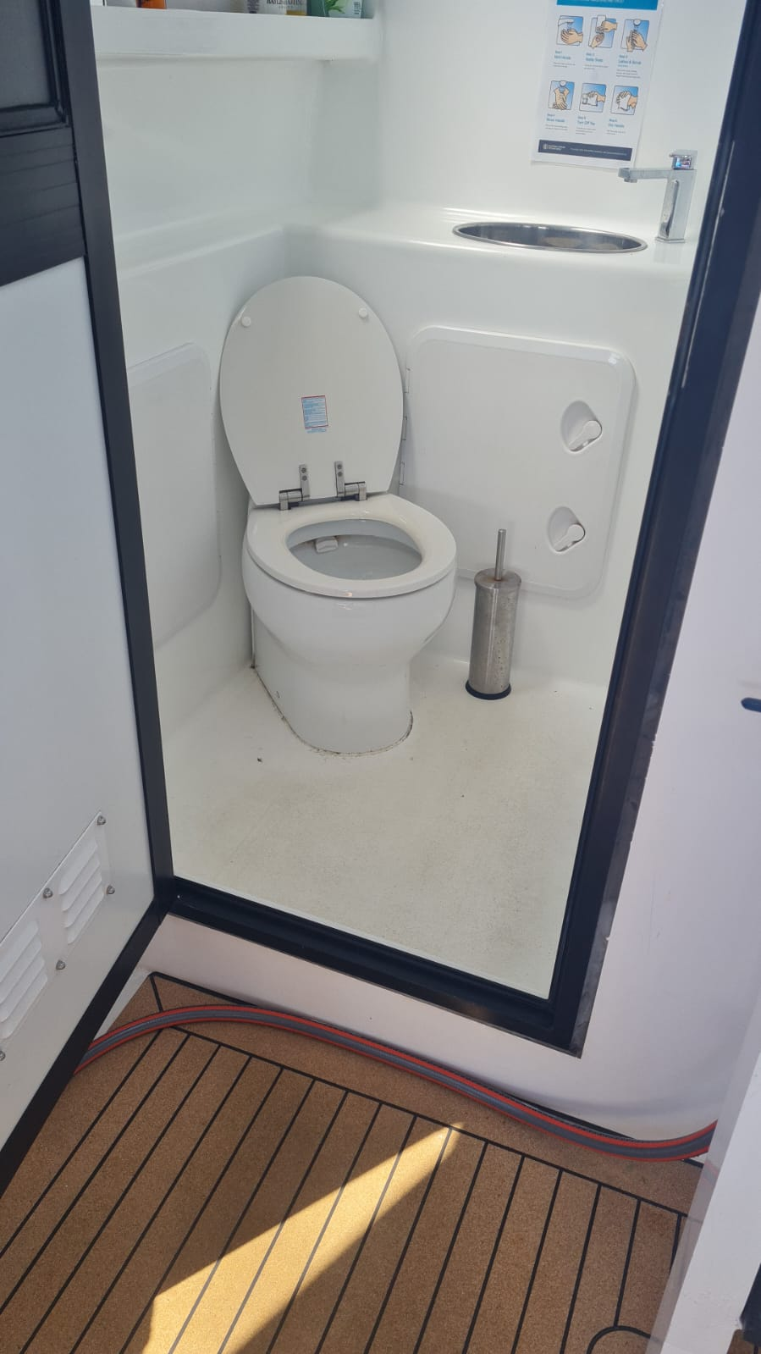
PHOTO-2024-05-01-12-16-52
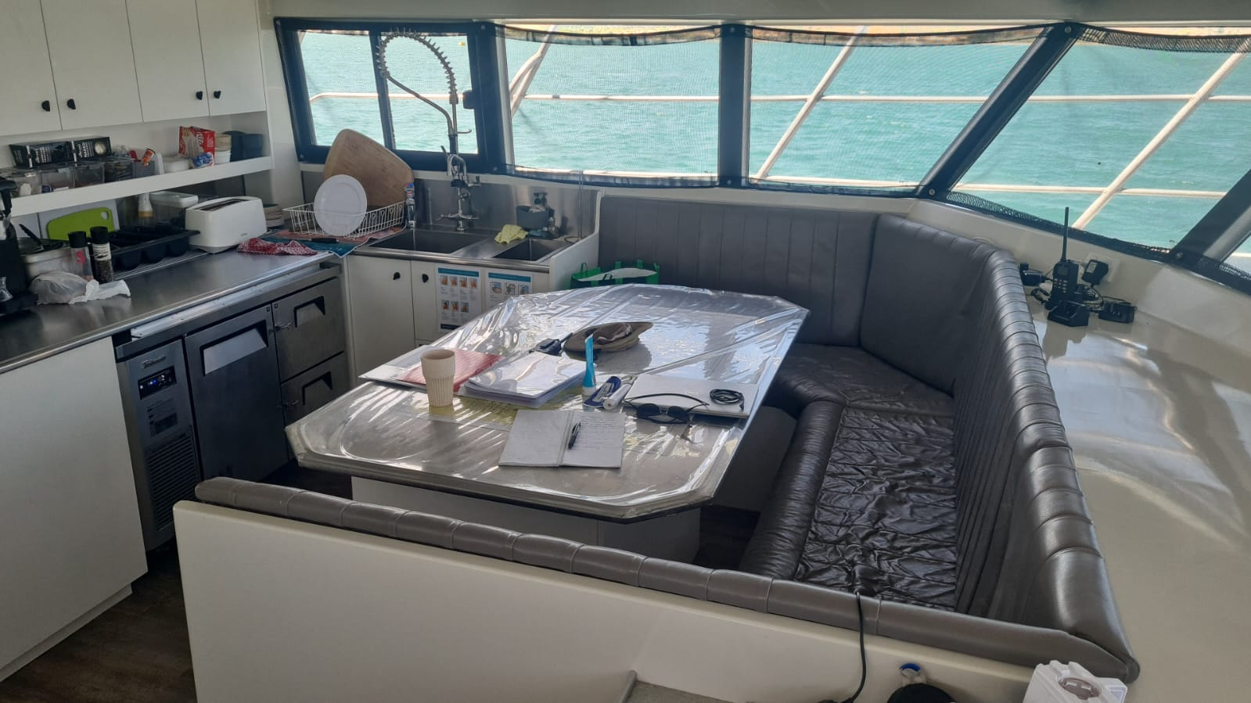
PHOTO-2024-05-01-12-18-03

Report Disclaimer
Please note that this business report, provided as a result of the use of the diagnostic assessment, is for information purposes only.
Australian Tourism Industry Council (ATIC) cannot guarantee the accuracy of respondent’s answers, or that they are fully representative of your business. Therefore, ATIC does not warrant or guarantee any particular outcome in respect of your businesses self-assessment.
This report is intended as guidance only for your business and should not be relied on for future marketing considerations. ATIC recommends that you seek your own independent advice as well as the results from the diagnostic.
Links to external web sites are inserted for convenience and do not constitute endorsement of material at those sites, or any associated organisation, product or service.
ATIC does not:
- Assume any legal liability for the accuracy, completeness, or usefulness of any information from this report or any links provided; or
- Accept responsibility for any loss associated directly or indirectly from the use of this report.

