ATIC Accessibility
To support the accessible community in making informed travel decisions for their individual needs

This report prepared for:
Business name: | WA NT TOURS PTY LTD
Address: | 32 Paitt St
Town: | Willagee
Contact for enquiries: | Pedro Wittwer
Contact Number: | 0893313933
Contact Email: | info@want-tours.com.au
Website: | www.want-tours.com
Date: | 2026-10-26 20:18

ATIC Accessibility
The following pages provides travellers with information on the businesses facilities and amenities which aims to support the traveller to make an informed decision on whether the business is suitable for their individual needs.
OVERVIEW 3
Business Overview 3
Bookings 3
Communications 3
Other Information 4
Guide Dog and Service Animals 4
GENERAL 5
Pre-arrival, arrival and reception 5
Displays, exhibits, commentary and live performances 5
TOUR OPERATORS 6
Tour/Transport Services 6
Route Planning 6
Guides 6
FOOD AND DRINK 8
Report Disclaimer 10

OVERVIEW

Business Overview

The business has the following products/services available
- Tour/Transport

Our business caters for the following disability types:
- Deaf or low hearing
- Limited mobility
- Wheelchairs or mobility scooters
- Food allergies or intolerances
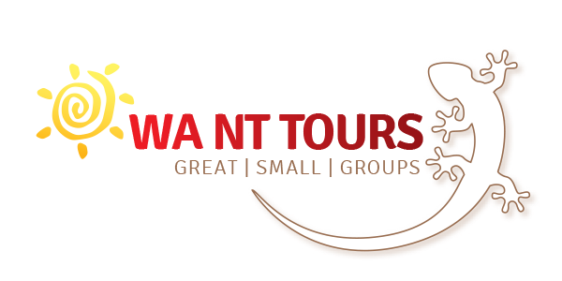

Bookings

The business offers the following methods for bookings and enquiries:
- Phone
- Email
- Webportal

no visitors to our premises, other than that we have only tour buses. Emergency evacuation process on tour buses are explained.

Communications
- Our website meets WCAG 2.0 accessibility standards
- Our business offers the following alternative communication methods
- Plain English

Not specified

Other Information
- The business accepts the companion card

Guide Dog and Service Animals
The business provides the following services for services animals:
Not specified

GENERAL

Pre-arrival, arrival and reception
The business has the following in place to support guests during pre-arrival, arrival and reception
- A familiarisation tour
- In addition, the following further information can assist guests:
there are no long queues or waiting times, people with fatigue related to their disability can relax in the tour bus vehicle

Displays, exhibits, commentary and live performances
For displays, exhibits, commentary and live performances the following amenities are in place
- Seating
The width of the smallest pathway is:
no visitors to our premises, other than that we have only tour buses

no visitors to our premises, other than that we have only tour buses

no visitors to our premises, other than that we have only tour buses

TOUR OPERATORS

Tour/Transport Services
The tour/transport services have the following facilities/amenities in place
- Buses/Coaches
- 0 vehicles have wheelchair lifts or ramps
- 0 vehicles have low floors with ramped entry
The maximum wheelchair capacity available in the fleet is:
0

Route Planning
- Route Planning
- The tour route includes stops with accessible toilet facilities
- Lunch stop venues are accessible
- Overnight Stops
- For overnight stays, wheelchair accessible rooms are available
The total number of wheelchair passengers that can be catered for at overnight stops are:
1

Guides
- Use of clear/simple English
- Correct pronunciation for lip readers
  - Image(s)
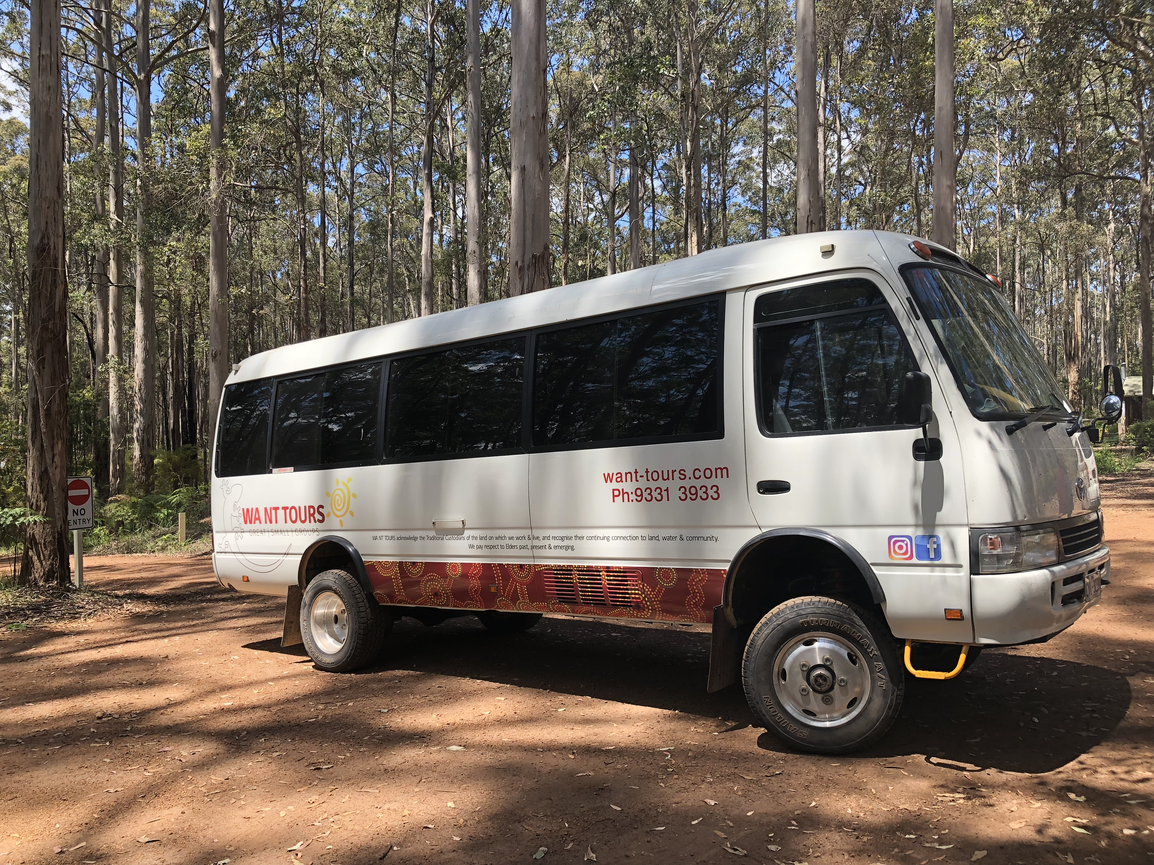
Vehicle in Karri forest
- In addition, the following further information can assist guests:
this is a joke, there are places from Esperance to Kununurra, from morning tea, lunch, afternoon tea, dinner places. We don't have the capacity to list all those places

FOOD AND DRINK
- The smallest doorway is no visitors to our premises, other than that we have only tour buses wide
- In addition, the following further information can assist guests:
no visitors to our premises, other than that we have only tour buses. we do not do food preparation

Report Disclaimer
Please note that this business report, provided as a result of the use of the diagnostic assessment, is for information purposes only.
Australian Tourism Industry Council (ATIC) cannot guarantee the accuracy of respondent’s answers, or that they are fully representative of your business. Therefore, ATIC does not warrant or guarantee any particular outcome in respect of your businesses self-assessment.
This report is intended as guidance only for your business and should not be relied on for future marketing considerations. ATIC recommends that you seek your own independent advice as well as the results from the diagnostic.
Links to external web sites are inserted for convenience and do not constitute endorsement of material at those sites, or any associated organisation, product or service.
ATIC does not:
- Assume any legal liability for the accuracy, completeness, or usefulness of any information from this report or any links provided; or
- Accept responsibility for any loss associated directly or indirectly from the use of this report.

