ATIC Accessibility
To support the accessible community in making informed travel decisions for their individual needs

This report prepared for:
Business name: | Educated by Nature
Address: | 16/23 Gibberd Road
Town: | Balcatta
Contact for enquiries: | Daniel Burton
Contact Number: | 0468 904 070
Contact Email: | admin@educatedbynature.com
Website: | www.educatedbynature.com
Date: | 2026-10-22 14:48

ATIC Accessibility
The following pages provides travellers with information on the businesses facilities and amenities which aims to support the traveller to make an informed decision on whether the business is suitable for their individual needs.
OVERVIEW 3
Business Overview 3
Bookings 3
Emergency Management 3
Communications 4
Guide Dog and Service Animals 4
GENERAL 5
Pre-arrival, arrival and reception 5
External Paths 5
Public Toilets/Adult change facilities 6
ADVENTURE ACTIVITIES 7
Adventure activities 7
Report Disclaimer 9

OVERVIEW

Business Overview

The business has the following products/services available
- Adventure

Our business caters for the following disability types:
- Blind or low vision
- Deaf or low hearing
- Limited mobility
- Food allergies or intolerances
- Cognitive or people on the Autism Spectrum
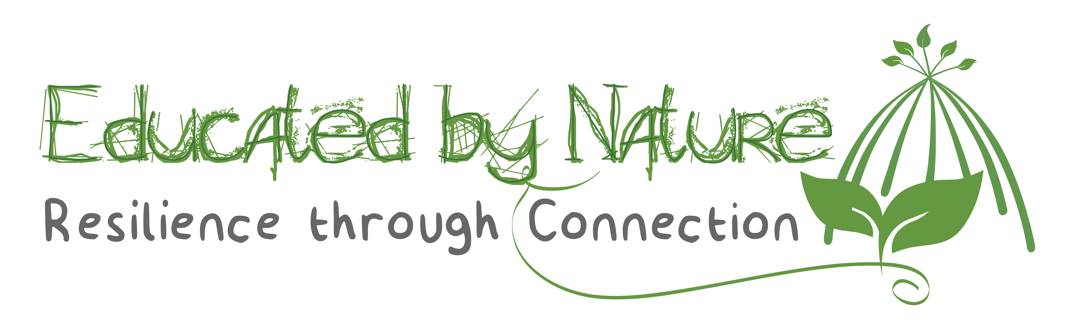

Bookings

The business offers the following methods for bookings and enquiries:
- Phone
- Email
- Webportal

Emergency Management
- Emergency and evacuation procedures are explained on arrival
- In addition, the following further information can assist guests:
Participant details are taken at the time of booking
- In addition, the following further information can assist guests:
Participant details are taken at the time of booking

Communications
- Our business offers the following alternative communication methods
- Plain English

Not specified
- There is easy to read signage and information (e.g. menus and emergency information)

Guide Dog and Service Animals
The business provides the following services for services animals:
Services can be provided on request

GENERAL

Pre-arrival, arrival and reception
The business has the following in place to support guests during pre-arrival, arrival and reception
- Information and maps are available in written form
- In addition, the following further information can assist guests:
We do not have any wait times due to the structure of our programs.
- In addition, the following further information can assist guests:
Please contact us at admin@educatedbynature.com to discuss specific requirements
- In addition, the following further information can assist guests:
Please contact us at admin@educatedbynature.com to discuss specific requirements

External Paths
External paths of travel
- Pathways are wider than 900mm

we use public areas

we use public areas
- In addition, the following further information can assist guests:
Please contact us at admin@educatedbynature.com to discuss specific requirements
- In addition, the following further information can assist guests:
Please contact us at admin@educatedbynature.com to discuss specific requirements

Public Toilets/Adult change facilities
Public Toilets/Adult change facilities have the following amenities are in place
- There is an accessible toilet for public use
- The door is at least 850mm wide
- There is a minimum of 850mm beside the toilet
- Handrails are fitted
- The toilet seat is 460mm above the floor
- The toilet seat of a contrasting colour to the floor
- The toilet seat is460mm above the floor
- In addition, the following further information can assist guests:
Please contact us at admin@educatedbynature.com to discuss specific requirements

ADVENTURE ACTIVITIES

Adventure activities
The adventure activities have the following facilities/amenities in place
- Our adventure activities cater for people with a disability
- In addition, the following further information can assist guests:
Most of our activities are able to be adapted to suit people with disabilities. Please contact us at admin@educatedbynature.com to discuss specific requirements
- In addition, the following further information can assist guests:
Most of our activities are able to be adapted to suit people with disabilities. Please contact us at admin@educatedbynature.com to discuss specific requirements

- In addition, the following further information can assist guests:
Most of our activities are able to be adapted to suit people with disabilities. Please contact us at admin@educatedbynature.com to discuss specific requirements

- In addition, the following further information can assist guests:
Please contact us at admin@educatedbynature.com to discuss specific requirements

Report Disclaimer
Please note that this business report, provided as a result of the use of the diagnostic assessment, is for information purposes only.
Australian Tourism Industry Council (ATIC) cannot guarantee the accuracy of respondent’s answers, or that they are fully representative of your business. Therefore, ATIC does not warrant or guarantee any particular outcome in respect of your businesses self-assessment.
This report is intended as guidance only for your business and should not be relied on for future marketing considerations. ATIC recommends that you seek your own independent advice as well as the results from the diagnostic.
Links to external web sites are inserted for convenience and do not constitute endorsement of material at those sites, or any associated organisation, product or service.
ATIC does not:
- Assume any legal liability for the accuracy, completeness, or usefulness of any information from this report or any links provided; or
- Accept responsibility for any loss associated directly or indirectly from the use of this report.

