ATIC Accessibility
To support the accessible community in making informed travel decisions for their individual needs

This report prepared for:
Business name: | Hotel Vera Ballarat
Address: | 710 Sturt Street
Town: | Ballarat
Contact for enquiries: | Martin Shew
Contact Number: | 0473668821
Contact Email: | hello@hotelballarat.com.au
Website: | www.hotelballarat.com.au
Date: | 2026-10-22 21:19

ATIC Accessibility
The following pages provides travellers with information on the businesses facilities and amenities which aims to support the traveller to make an informed decision on whether the business is suitable for their individual needs.
OVERVIEW 4
Business Overview 4
Bookings 4
Emergency Management 4
Communications 5
Other Information 5
Guide Dog and Service Animals 5
GENERAL 7
Pre-arrival, arrival and reception 7
Cognitive Impairment Support 8
Car Park and Access amenities 8
Entry 8
Internal Spaces 9
Public areas 9
External Paths 9
Ramps 10
Public Toilets/Adult change facilities 10
ACCOMMODATION 11
Bedrooms 11
Room Amenities 11
Bathrooms 12
COMMON AREAS 17
FOOD AND DRINK 18
Dining Spaces 18
Report Disclaimer 23

OVERVIEW

Business Overview

The business has the following products/services available
- Accommodation
- Food and Drink

Our business caters for the following disability types:
- Blind or low vision
- Deaf or low hearing
- Limited mobility
- Wheelchairs or mobility scooters
- Food allergies or intolerances
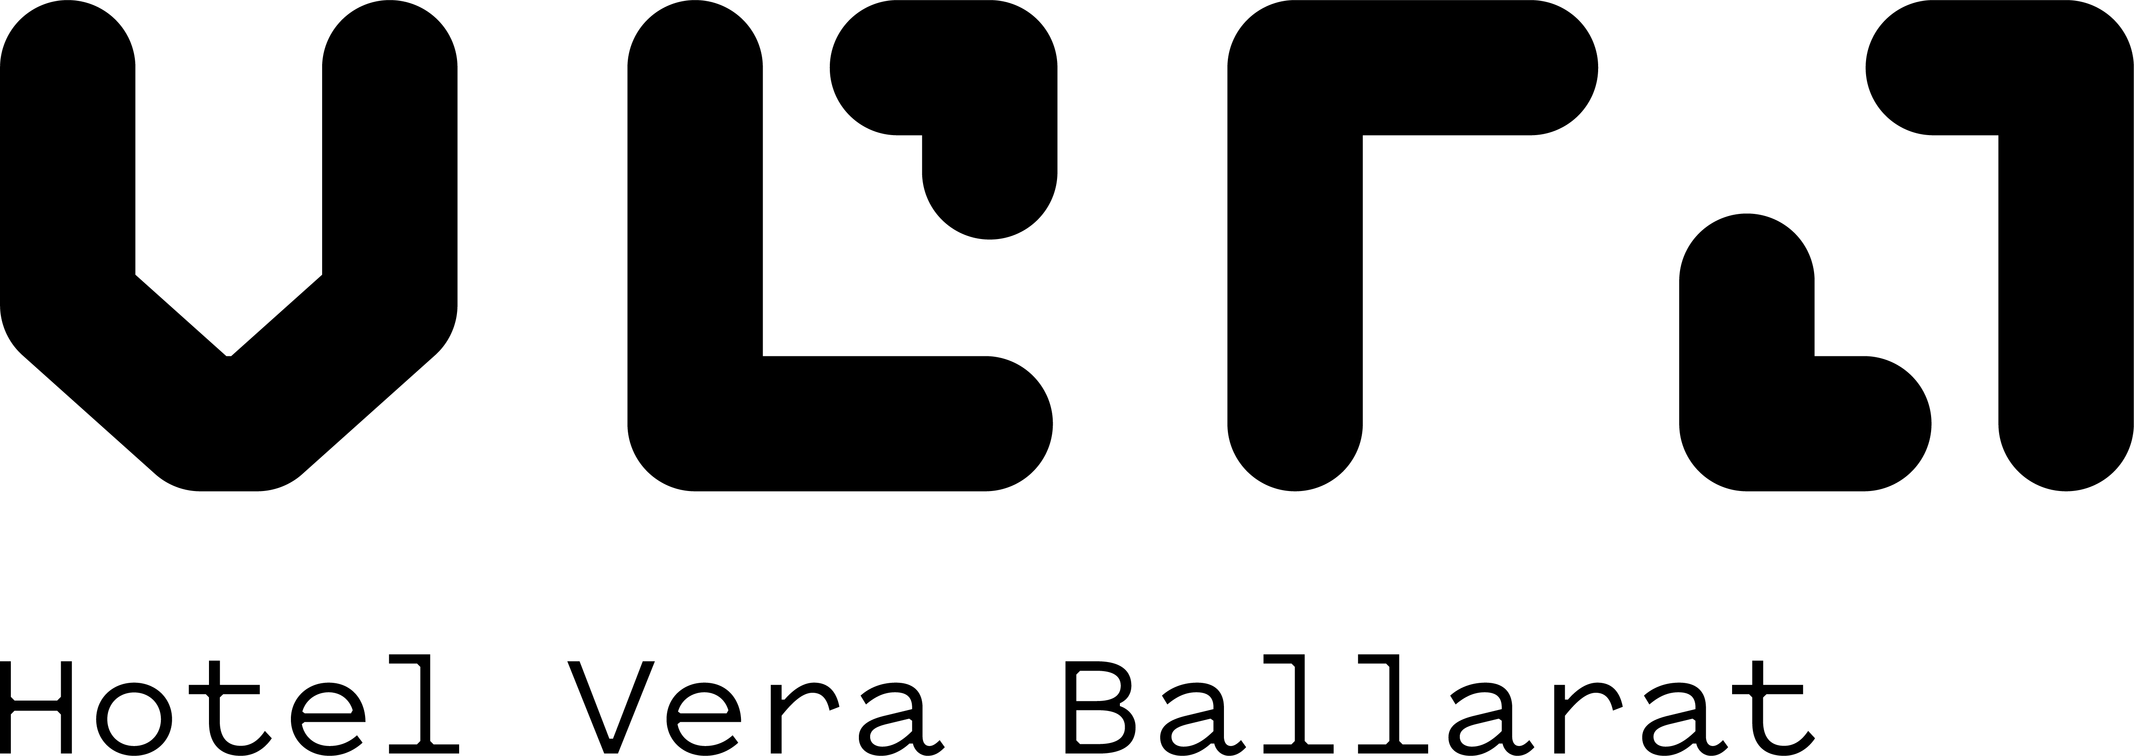

Bookings

The business offers the following methods for bookings and enquiries:
- Phone
- Email
- Webportal

Emergency Management
- The business has an emergency management and evacuation plan for guests with a disability
- Emergency and evacuation procedures are explained on arrival
- Guests with disabilities are noted in the guest log book for emergency and evacuation purposes

Communications
- An accessibility guide is available on the website

https://accreditation.qualitytourismaustralia.com/report/AccessReportPublicHtml2/039f1a46-23b3-4bd9-895a-658bfa71e701
- Our website meets WCAG 2.0 accessibility standards
- Our business offers the following alternative communication methods
- Plain English
- Magnifiers

Nothing to add
- There is easy to read signage and information (e.g. menus and emergency information)

Other Information
- For bookings made onsite, the ticket booth/counter/box office is accessible for people using a wheelchair
- The business accepts the companion card

Guide Dog and Service Animals
- The business provides a secure area with shade and water for service animals
- The business provides a toilet area for service animals
- Bowls, bedding, etc. are provided for service animals
The business provides the following services for services animals:
Service Animal Accommodations at Hotel Vera: At Hotel Vera, we warmly welcome guests accompanied by service animals and are committed to providing a comfortable and accessible environment for both you and your animal companion. Our services and accommodations for guests with service animals include: No Additional Fees: Service animals are welcome at no extra charge. Accessible Rooms: We offer accessible guest rooms designed to provide ample space and comfort for guests and their service animals. Water Bowls and Mats: Complimentary water bowls and mats are available upon request to ensure your service animal’s comfort during your stay. Relief Areas: Designated outdoor areas are available for service animal relief, and our staff can provide directions or escort you to these locations. Welcome Amenities: Upon arrival, service animals receive a welcome treat and information about nearby pet supply stores and veterinary services. Housekeeping Coordination: Our housekeeping team will coordinate with you to arrange cleaning times that are convenient and comfortable for your service animal. Emergency Support: Information about local veterinarians and 24-hour animal emergency services is available at the front desk. Staff Training: Our staff are trained to interact appropriately with service animals and to respect their role in assisting our guests. If you have any specific needs or requests for your service animal, please let us know before or during your stay. We are dedicated to ensuring a welcoming and supportive experience for all our guests.

GENERAL

Pre-arrival, arrival and reception
The business has the following in place to support guests during pre-arrival, arrival and reception
- Booking information and websites are compatible with screen readers
- There is a reception/public entryway.
- Seating available at reception
- A lower counter at reception/ticket office
- A clipboard to allow check-in/ticket purchase whilst seated
- A tablet with text to voice or pen and paper at reception to aid in communication
- Picture Board at reception to aid in communication
- Lighting in the reception area is even and glare free
- Large print information sheets and registration forms
- Information and maps are available in written form
- A step free map/guide
- A familiarisation tour
- Advertising material, web sites and social media contain information relating to phone numbers available for non-voice communication e: Text, SMS, email and fax
- A key to any accessible facilities that are locked
- Keys are available for each guest
- Luggage assistance
- In addition, the following further information can assist guests:
At Hotel Vera, we are committed to ensuring that all guests, including those with disabilities that cause fatigue, have a comfortable and accessible experience. To minimize the impact of long wait times, we offer the following accommodations:

Priority Service: Guests who experience fatigue due to their disability can request priority check-in and assistance at reception to reduce waiting periods.

Seating Availability: Comfortable seating is available in all waiting areas, and staff are trained to offer a seat promptly to guests who may need to rest.

Flexible Arrangements: We are happy to arrange for in-room check-in or concierge services upon request, so guests can relax in their room while formalities are completed.

Assistance on Request: Our team is always available to provide support, including escorting guests to their rooms or facilities to minimize exertion.

If you require any specific accommodations to reduce wait times or support your comfort, please let our staff know in advance or upon arrival. We are dedicated to making your stay as smooth and restful as possible.

Cognitive Impairment Support
- Documents are available in plain English for people with cognitive impairment (This may include instructions, guides, menus and general information)
- Quiet periods or early opening times for people on the Autism Spectrum
- A space for parents and children on the Autism Spectrum
- Access has alternative procedures and clear written instructions with universal access symbols

Car Park and Access amenities
The business has the following Car Park and Access amenities
- A drop off zone
- Designated disabled parking bays
- Level or ramped access from the car park to the entrance
- The accessible entrance is clearly signed from the parking bay

Entry
The business has the following amenities/systems in place for entry
- A drop off point close to the entrance
- A path of access to the building is slip resistance and even
- A path of access to the building is clear of obstruction
- Self opening entry doors or fitted with a self closer
- Glass doors are fitted with a visual sighting strip
- Door jams/doors are of a contrasting colour to surrounding walls
- Signage is written in a Sans Serif font and use upper and lower case letters
- The entry door is a minimum of 850mm wide
- The entry door has self opening or a light opening pressure (for manual operations)
- The entrance sill is less than 13mm
- There a clear space of at least 1500mm x 1500mm in front of all doors.
- The entrance door mats have a thickness less than 13mm and a width of 7500mm or greater

Internal Spaces
- Clear and unobstructed routes through and between buildings
- Interior walls are matte or low sheen
- Floors, walls, counters and furniture are of contrasting colours
- Any protruding or overhanging obstructions are at least 2meters above the floor or are protected
- Menus are available in large print or Braille
- Tableware/glassware contrast with the table surface or table cloth
- Floor surfaces are hard or short pile carpet
- Seating is available for guests unable to stand for long periods
- Accessible facilities are clearly signed and visible from all areas
- All corridors greater than 900mm
- There is a quiet space for parents and children on the Autism Spectrum

Public areas
The public areas have the following amenities in place
- Even lighting
- Seating

External Paths
External paths of travel
- Surfaces are concrete, asphalt, smooth paving or hard packed fine gravel (max aggregate size 13mm)
- Paths or slopes longer than 15 metres have resting places or seats
- Pathways are wider than 900mm
- There 3 successive steps or less on any path or at any doorway
- Any paths having steps are clearly identified as non-wheelchair accessible
- Step free routes clearly signed
- In addition, the following further information can assist guests:
We have two accessible entry points to the hotel and restaurant.

Ramps
Ramps have the following amenities are in place
- There are ramps.
- All fixed ramps are 1:14 or less
- Hand rails are fitted
- Long ramps (more than 10m) are 1:20 or less
- Ramps have a raised edge of at least 100mm

Public Toilets/Adult change facilities
Public Toilets/Adult change facilities have the following amenities are in place
- There is an accessible toilet for public use
- The door is at least 850mm wide
- There is a minimum of 850mm beside the toilet
- Handrails are fitted
- The toilet seat is 460mm above the floor
- The toilet seat of a contrasting colour to the floor
- The toilet seat is460mm above the floor

ACCOMMODATION

Bedrooms
The bedrooms have the following facilities/amenities in place
- There are 1 rooms available to guests who use a wheelchair
- Bedroom furniture can be re-arranged on request
  - Layout of room Image(s)
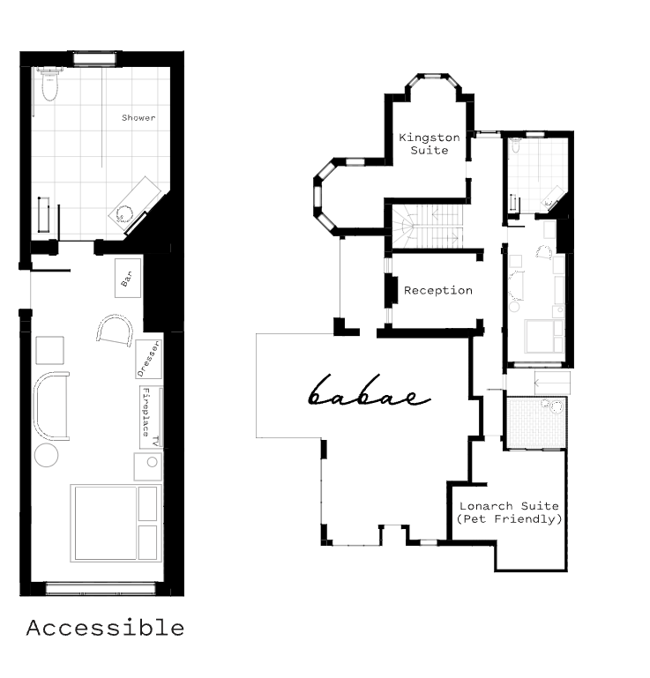
Screenshot 2025-08-26 at 8.41.34 am

Room Amenities
- Lower hanging rails are in wardrobes
- Visual alarm is fitted to the room
- Televisions are equipped with closed captioning capability
- There is contrast between the walls, skirtings, floor and furniture
- There is a clear path through the room
- The edges of all furniture and fixtures are rounded
- Wardrobe handles are a contrasting colour to the doors and draws
- Housekeeping procedures instruct staff not to reposition furniture that has been moved
- Doors open fully against the adjoining wall
- There is a clear opening at least 850mm wide
- There luggage racks for at least two suitcases
- There at least one chair with rigid arms
- Wardrobe and drawer handles are easy to grip
- The bedside lamp switch is easy to reach from the bed
- There is at least 850mm clear space beside the bed
- The bed height is no higher than 680mm from the floor
- There is at least 130mm clearance under the bed
- The business offers a range of non-allergenic bedding
- Non-allergenic cleaning products are used
- In addition, the following further information can assist guests:
We have automatic door opener
Wheelchair height compliant basins
Handheld portable light switches so lights can be easily turned off

Bathrooms
The bathrooms have the following facilities/amenities in place
- All heating appliances and hot water pipes are protected or insulated
- All shower, bath and basin taps are clearly differentiated between hot and cold
- Fixtures and fittings have rounded edges
- The hot water is thermostatically controlled to 41 degrees
- The door is at least 850mm wide
- There is a minimum of 850mm beside the toilet
- Handrails are fitted
- There is a minimum of 1400mm of clear space in front of the toilet
- The toilet seat is 460mm above the floor
- A range of non-allergenic toiletries are available
- There is a roll-in shower with fold down fixed seat or a shower chair
- There is a portable shower head on flexible hose
  - Bathroom Image(s)
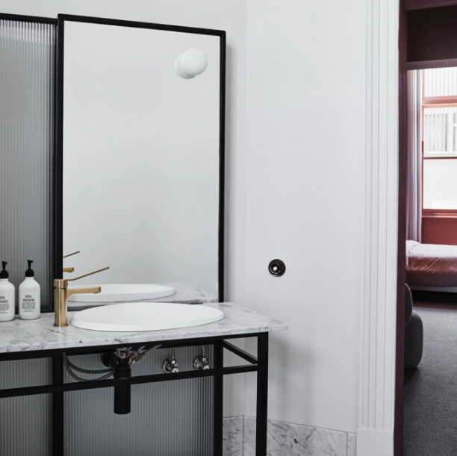
Bathroom
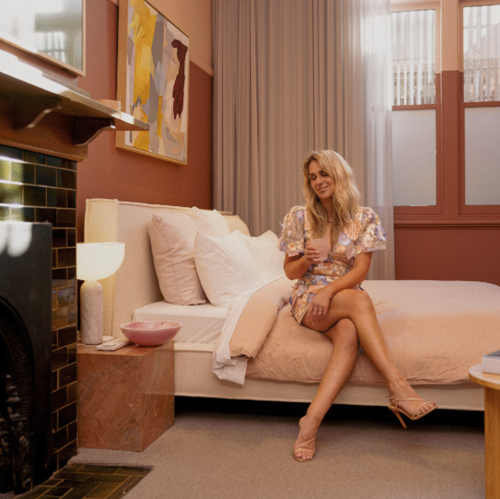
Bed
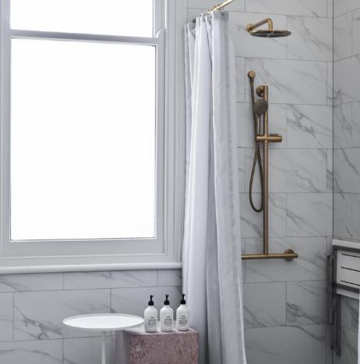
Shower
Layout
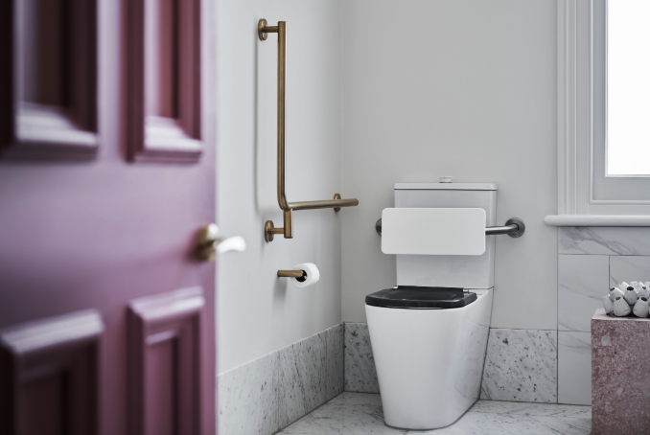
Toilet
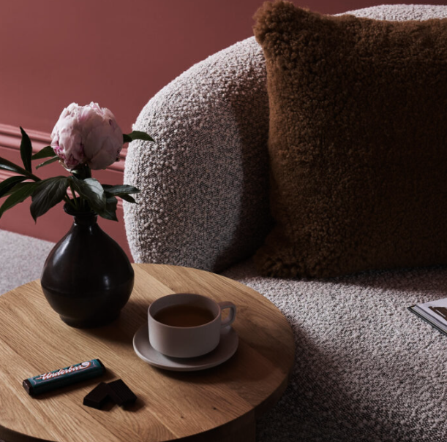
Seating
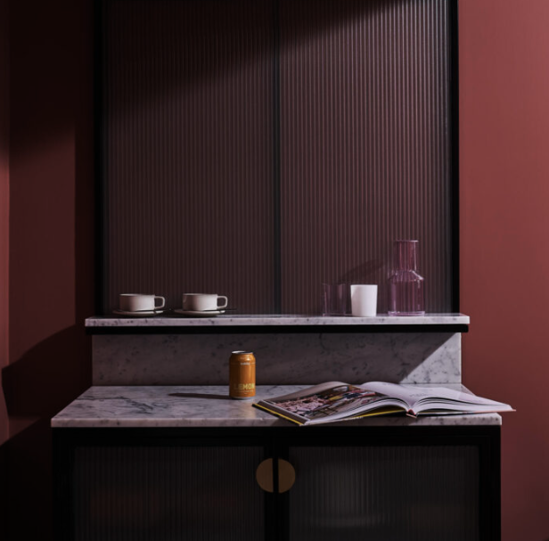
Minibar
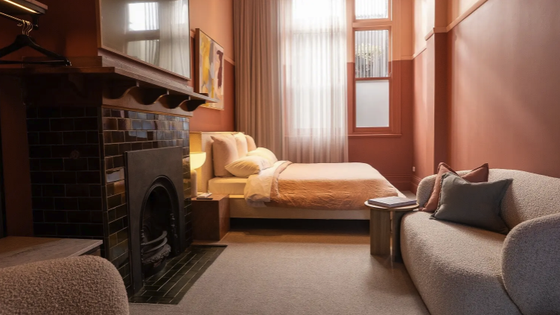
Room
- In addition, the following further information can assist guests:
Refer to: https://www.visitballarat.com.au/stories/5-accessible-places-to-stay-in-ballarat

The Tourello Suite is one of just seven personalised rooms at the boutique Hotel Vera Ballarat. Sydney artist Tonee Messiah's oil on canvasLeft Side Living perfectly complements the space's sunset shade, instilling a sense of romance and respite. The room features a luxe king-size bed, Bed Threads linen, Salus body products and Tekla organic cotton bath robes.

Accessibility features include an automatic door which is opened with a key access card, lever handles on tapware, shower seat, grab handles on the shower and toilet, plus toilet backrest.

https://www.visitballarat.com.au/stories/10-accessible-ways-to-experience-ballarat
Ryan Smith from The Access Agency says:
You might think that due to the décor,Hotel Vera is all about style. You’d be right, but it’s also about service (and access).

The Tourello Suite is the beautifully-appointed accessible room. The old circular servants' switch sits across from the push button for the power-opening door – tradition next to stylish innovation, which is kind of a metaphor for this property.

The bathroom really is a masterclass in how style and access can not only co-exist but compliment one another. There’s even a light that softly radiates as the sensors find you in the bathroom at night.

Elsewhere, there’s a wide hallway connecting the ground floor rooms, a stairway with handrails and tactile indicators for visitors who are blind or low vision.

If you’re looking for a luxury, accessible stay in Ballarat, you’d be hard pressed to beat Vera.

COMMON AREAS

FOOD AND DRINK

Dining Spaces
The dining spaces have the following facilities/amenities in place
- The entrance has level access
- The doorway is at least 850mm wide
- There is level access through the dining area
- Chairs are moveable to allow for wheelchairs to be seated at the tables
- All glass doors and full height windows have contrast markings
- There are areas of full lighting
- There are large print menus
- There are Plain English menus
- There is an accessible toilet

Our business caters for the following dietary requirements
- Gluten free (celiac)
- Low fat and fibre with no gastric content
- Low potassium
- Low sodium
- Nut free
- Additive free
- Organic
- Vegetarian
- Kosher
- Halal
- In addition, the following further information can assist guests:
Procedures to Avoid Cross-Contamination of Food Products

Our restaurant is committed to food safety and takes the following steps to prevent cross-contamination:

Separate Preparation Areas: We use designated areas and equipment for preparing different types of food, such as raw meats, seafood, and ready-to-eat items.

Clean and Sanitize: All surfaces, utensils, and equipment are thoroughly cleaned and sanitized between uses and after handling allergens or raw foods.

Hand Hygiene: Staff wash their hands frequently, especially after handling raw ingredients, allergens, or switching between tasks.

Color-Coded Equipment: We use color-coded cutting boards and utensils to keep foods separate and reduce the risk of cross-contact.

Proper Storage: Foods are stored in sealed containers and kept separate in refrigerators and pantries to prevent drips or spills from contaminating other items.

Staff Training: All team members receive regular training on food safety, allergen management, and cross-contamination prevention.

Allergen Awareness: We take extra care when preparing meals for guests with allergies or dietary restrictions, including using separate utensils and cooking surfaces when needed.

If you have specific dietary needs or concerns, please let our staff know so we can take every precaution to ensure your meal is safe.

- There is a sample menu available online
Sample menu is available here -
https://babaeballarat.com.au/menu/
  - Food and Beverage Image(s)
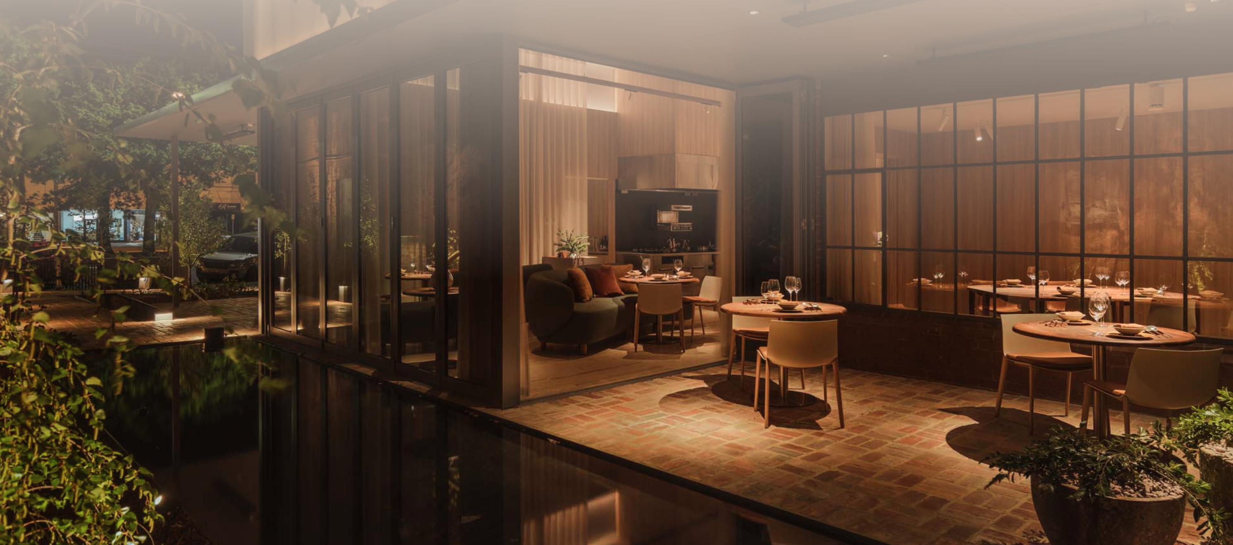
General restauarnt overview
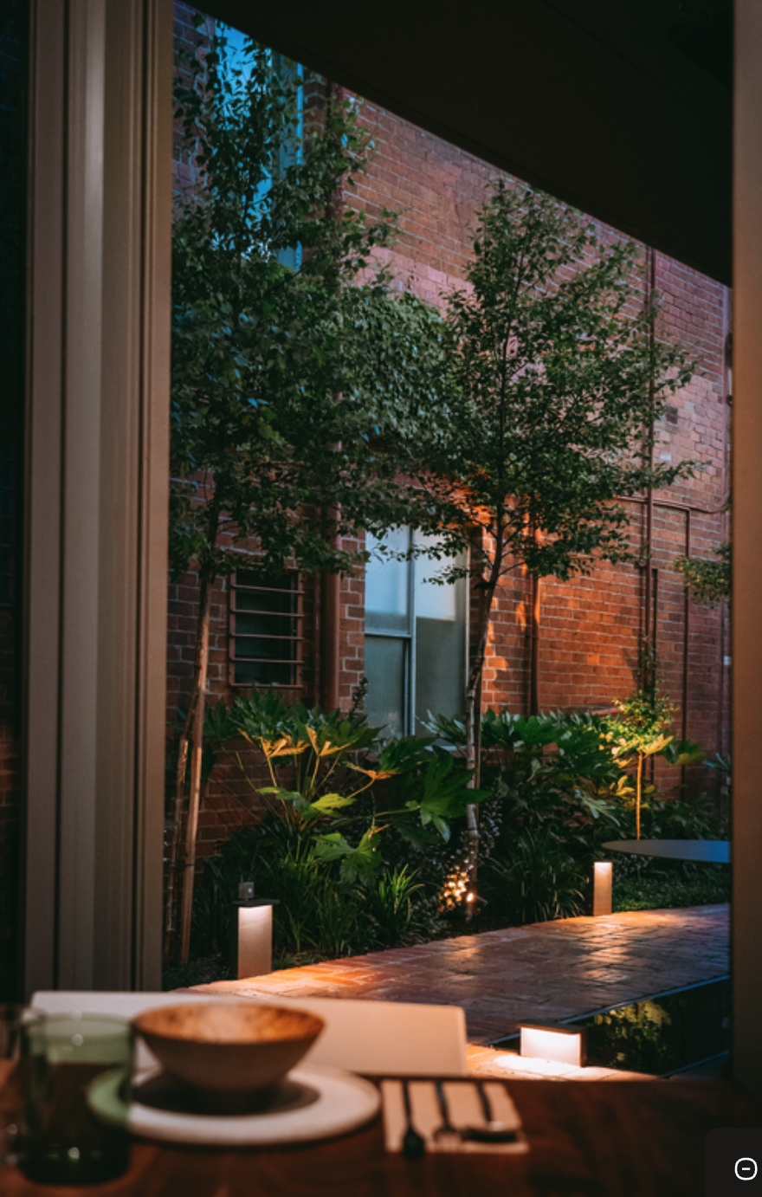
Entrance and table setting
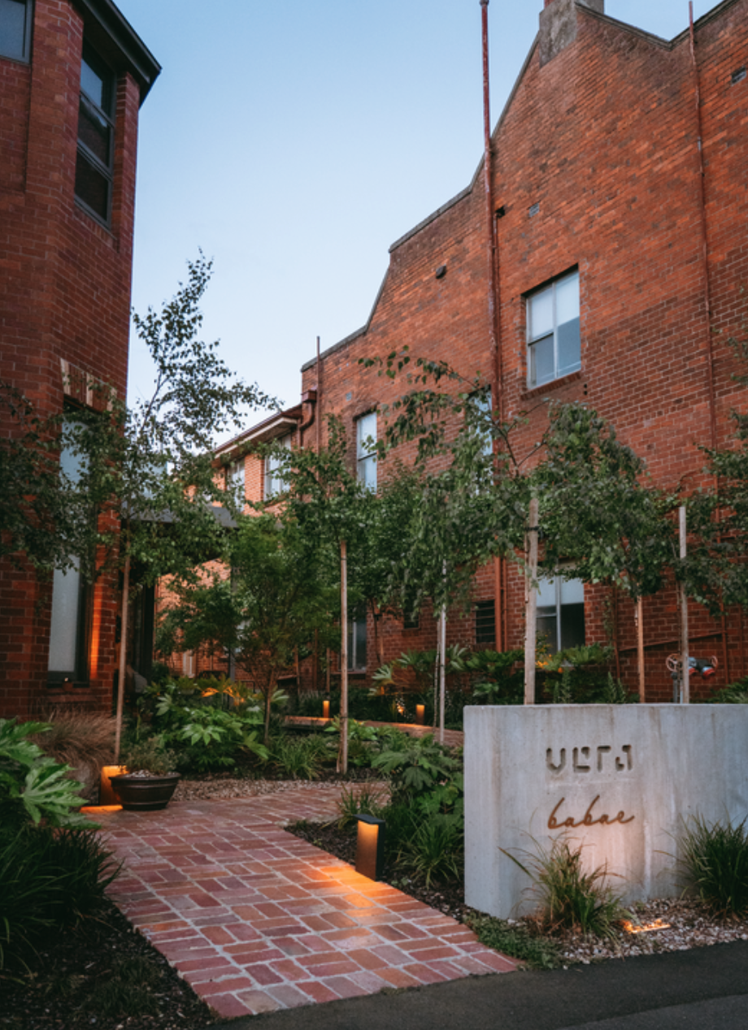
Acessible path entrance
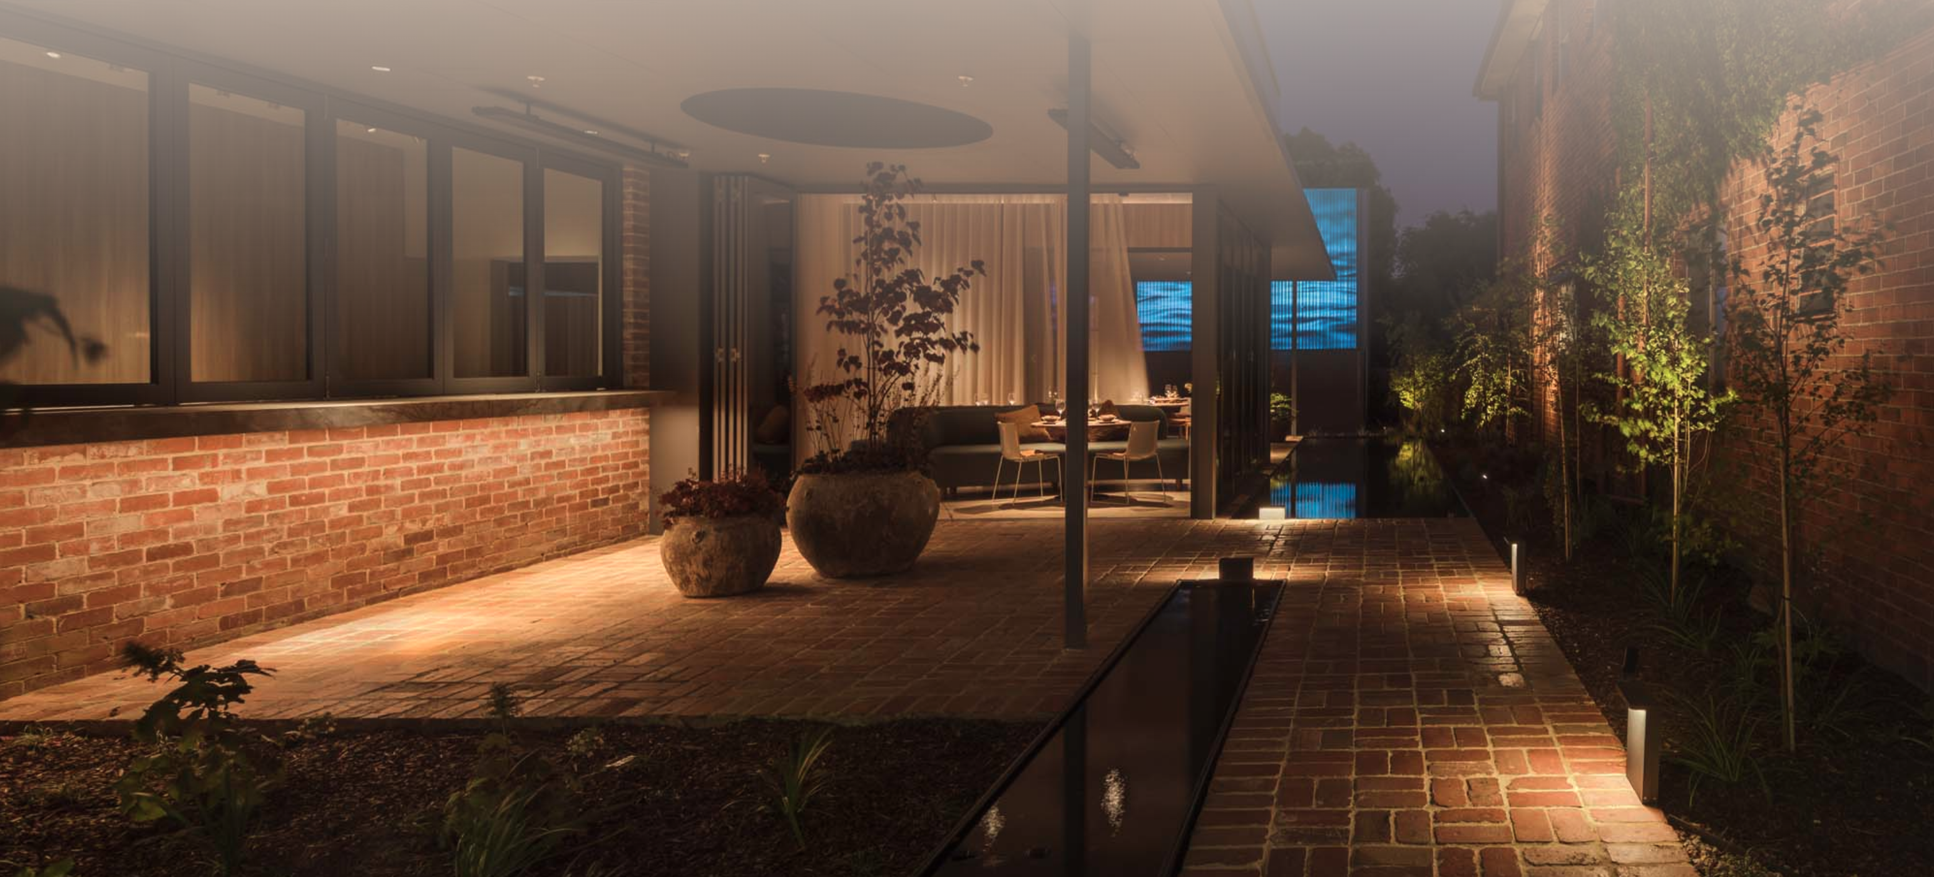
Bar Servery and restaurant entrance
- In addition, the following further information can assist guests:
We have two accessible entrance points into the restaurant.
We have two accessible toilets.
All guests are personally greeted at the door and ushered to their table ensuring clearance and dignity is maintained at all times.
We are a chef's hatted restaurant so all guests are looked after with the utmost care

Report Disclaimer
Please note that this business report, provided as a result of the use of the diagnostic assessment, is for information purposes only.
Australian Tourism Industry Council (ATIC) cannot guarantee the accuracy of respondent’s answers, or that they are fully representative of your business. Therefore, ATIC does not warrant or guarantee any particular outcome in respect of your businesses self-assessment.
This report is intended as guidance only for your business and should not be relied on for future marketing considerations. ATIC recommends that you seek your own independent advice as well as the results from the diagnostic.
Links to external web sites are inserted for convenience and do not constitute endorsement of material at those sites, or any associated organisation, product or service.
ATIC does not:
- Assume any legal liability for the accuracy, completeness, or usefulness of any information from this report or any links provided; or
- Accept responsibility for any loss associated directly or indirectly from the use of this report.

