ATIC Accessibility
To support the accessible community in making informed travel decisions for their individual needs

This report prepared for:
Business name: | Museums Victoria
Address: | 11 Nicholson Street
Town: | Carlton
Contact for enquiries: | Sara Sunners-Gormley
Contact Number:
Contact Email: | yfinch@museum.vic.gov.au
Website: | https://museumsvictoria.com.au/melbournemuseum
Date: | 2026-10-04 08:58

ATIC Accessibility
The following pages provides travellers with information on the businesses facilities and amenities which aims to support the traveller to make an informed decision on whether the business is suitable for their individual needs.
OVERVIEW 4
Business Overview 4
Bookings 4
Emergency Management 5
Communications 5
Other Information 5
Guide Dog and Service Animals 5
GENERAL 6
Pre-arrival, arrival and reception 6
Cognitive Impairment Support 6
Car Park and Access amenities 6
Entry 7
Lifts 7
Internal Spaces 7
Public areas 8
Displays, exhibits, commentary and live performances 8
External Paths 8
Steps 9
Ramps 9
Public Toilets/Adult change facilities 9
ATTRACTIONS 10
Attractions Basics 10
COMMON AREAS 12
Play Spaces 12
Parks and gardens 13
FOOD AND DRINK 15
Dining Spaces 15
EVENTS 17
Events 17
Report Disclaimer 19

OVERVIEW

Business Overview

The business has the following products/services available
- Attraction
- Food and Drink
- Event

Our business caters for the following disability types:
- Blind or low vision
- Deaf or low hearing
- Limited mobility
- Wheelchairs or mobility scooters
- Food allergies or intolerances
- Cognitive or people on the Autism Spectrum



Bookings

The business offers the following methods for bookings and enquiries:
- Phone
- Email
- Webportal
- Our website supports Screen Readers
- Our forms have high contract boxes and submit boxes
- Staff have undergone disability awareness and training

Emergency Management
- The business has an emergency management and evacuation plan for guests with a disability

Communications
- An accessibility guide is available on the website

https://museumsvictoria.com.au/melbournemuseum/plan-your-visit/accessibility/
- Our website meets WCAG 2.0 accessibility standards
- Our business offers the following alternative communication methods
- Plain English

Not specified
- There is easy to read signage and information (e.g. menus and emergency information)

Other Information
- For bookings made onsite, the ticket booth/counter/box office is accessible for people using a wheelchair
- The business accepts the companion card

Guide Dog and Service Animals
- The business provides a secure area with shade and water for service animals
The business provides the following services for services animals:
We provide access to people with services animals to our venues.

GENERAL

Pre-arrival, arrival and reception
The business has the following in place to support guests during pre-arrival, arrival and reception
- Booking information and websites are compatible with screen readers
- There is a reception/public entryway.
- Seating available at reception
- A tablet with text to voice or pen and paper at reception to aid in communication
- Lighting in the reception area is even and glare free

Staff communicate with each person and makes the booking for them as part of our service.
- Information and maps are available in written form
- In addition, the following further information can assist guests:
Staff monitor waiting lines and assist visitors where needed. This may be moving them to be assisted quicker or offering a place to sit.

Cognitive Impairment Support
- Documents are available in plain English for people with cognitive impairment (This may include instructions, guides, menus and general information)
- Quiet periods or early opening times for people on the Autism Spectrum
- A space for parents and children on the Autism Spectrum

Car Park and Access amenities
The business has the following Car Park and Access amenities
- Designated disabled parking bays
- Level or ramped access from the car park to the entrance
- The accessible entrance is clearly signed from the parking bay
- The public transport services available are:

Our website has a section for Getting Here which details all modes of transport
- Kerb ramps are in place where a pavement or walkway needs to be crossed
- An intercom system is available at the entrance of car park
- Instructions on how to use the system are in Plan English and accompanied by Universal design standard pictures

Entry
The business has the following amenities/systems in place for entry
- A drop off point close to the entrance
- A path of access to the building is slip resistance and even
- A path of access to the building is clear of obstruction
- Self opening entry doors or fitted with a self closer
- Glass doors are fitted with a visual sighting strip
- Door handles are of a contrasting colour to the door
- Signage is written in a contrasting colour
- Signage is written in a Sans Serif font and use upper and lower case letters
- The entry door is a minimum of 850mm wide
- The entry door has self opening or a light opening pressure (for manual operations)
- The entrance sill is less than 13mm
- There a clear space of at least 1500mm x 1500mm in front of all doors.
- The entrance door mats have a thickness less than 13mm and a width of 7500mm or greater

Lifts
- Premises has lifts

Internal Spaces
- Clear and unobstructed routes through and between buildings
- Interior walls are matte or low sheen
- Floors, walls, counters and furniture are of contrasting colours
- Any protruding or overhanging obstructions are at least 2meters above the floor or are protected
- Tableware/glassware contrast with the table surface or table cloth
- Floor surfaces are hard or short pile carpet
- Seating is available for guests unable to stand for long periods
- Accessible facilities are clearly signed and visible from all areas
- All corridors greater than 900mm
- There is a quiet space for parents and children on the Autism Spectrum

Public areas
The public areas have the following amenities in place
- Hearing loops
- Hearing loop symbols are displayed
- Even lighting
- Seating
- In addition, the following further information can assist guests:
There are hearing loops in a number of spaces at Melbourne Museum. Hearing Loops are located in:

Ground Floor, First Peoples - Creation Cinema
Lower Floor, Theatre

Displays, exhibits, commentary and live performances
For displays, exhibits, commentary and live performances the following amenities are in place
- Seating
- Wheelchair accessible spaces/seating
- In addition, the following further information can assist guests:
The location of the show or presentation will determine if hearing loop is available.

External Paths
External paths of travel
- Surfaces are concrete, asphalt, smooth paving or hard packed fine gravel (max aggregate size 13mm)
- Paths or slopes longer than 15 metres have resting places or seats
- Pathways are wider than 900mm
- There 3 successive steps or less on any path or at any doorway
- Any paths having steps are clearly identified as non-wheelchair accessible
- Step free routes clearly signed

Steps
Steps
- There are steps.
- Top and bottom steps are easily distinguished through colour contrast or the use of TGSIs (Tactile Ground Surface Indicators)
- All steps or staircases have enclosed risers
- The underside of all staircases are enclosed or protected to a height of at least 2 metres
- Handrails fitted to all open sets of steps
- Handrails extend 300mm beyond the top and bottom step
- Where steps are present are there three steps or less

Ramps
Ramps have the following amenities are in place
- There are ramps.
- All fixed ramps are 1:14 or less
- Hand rails are fitted
- Long ramps (more than 10m) are 1:20 or less
- Temporary ramps are available
- Temporary ramps are in place for the duration of the guests stay
- Ramps have a raised edge of at least 100mm

Public Toilets/Adult change facilities
Public Toilets/Adult change facilities have the following amenities are in place
- There is an accessible toilet for public use
- The door is at least 850mm wide
- There is a minimum of 850mm beside the toilet
- Handrails are fitted
- The toilet seat is 460mm above the floor
- The toilet seat of a contrasting colour to the floor
- The toilet seat is460mm above the floor
- There is a registered changing places facility
- In addition, the following further information can assist guests:
There is a Changing Place facility at Melbourne Museum but not at Immigration Museum or Scienceworks.

ATTRACTIONS

Attractions Basics
- A park map is available here:

https://museumsvictoria.com.au/melbournemuseum/plan-your-visit/visitor-map/
  - Image(s)
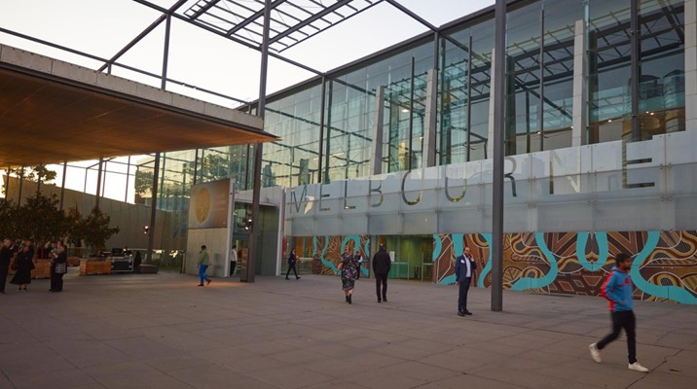
gettinghereandparking_image
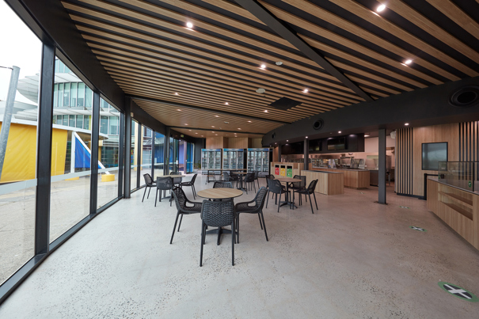
hd196702-a-138-co
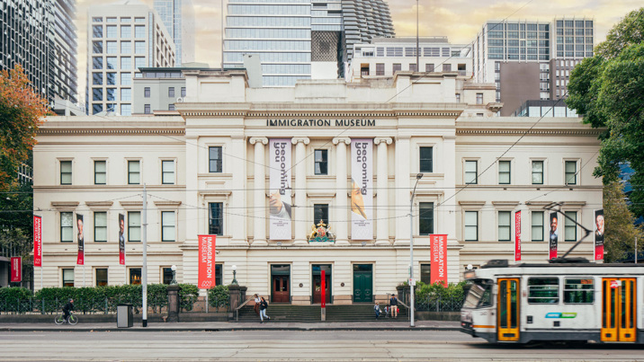
immigration-museum-entrance-000419431_o5-1
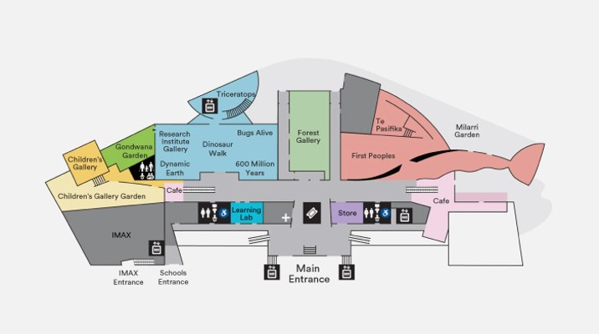
pyv_map_mm
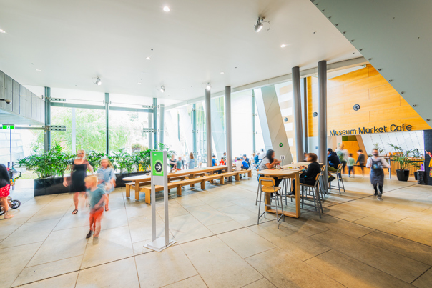
stewiedonn-lr-museummarketcafe-4
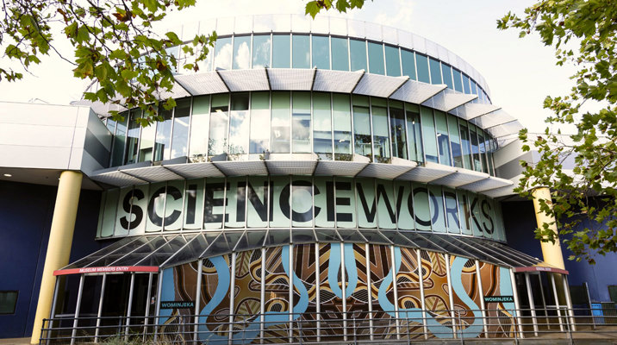
sw-getting-here

COMMON AREAS

Play Spaces
- Level access is provided to play spaces
- Ramps provided are at least 25% of elevated sections of the play space
- The surface of the play space is of a composite or rubberized material
- There wheelchair accessible activities
- The play space contains cognitive play panels
- The play space contains tactile play panels or activities
- The space contain colour contrasting elements
- Seating is provided in or around the play space
  - Image(s)
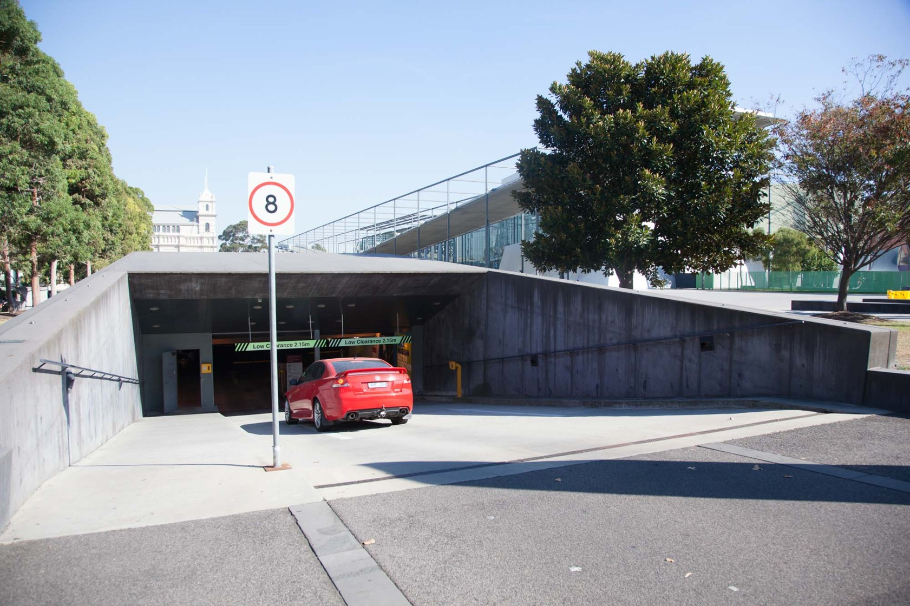
MM Carpark entry
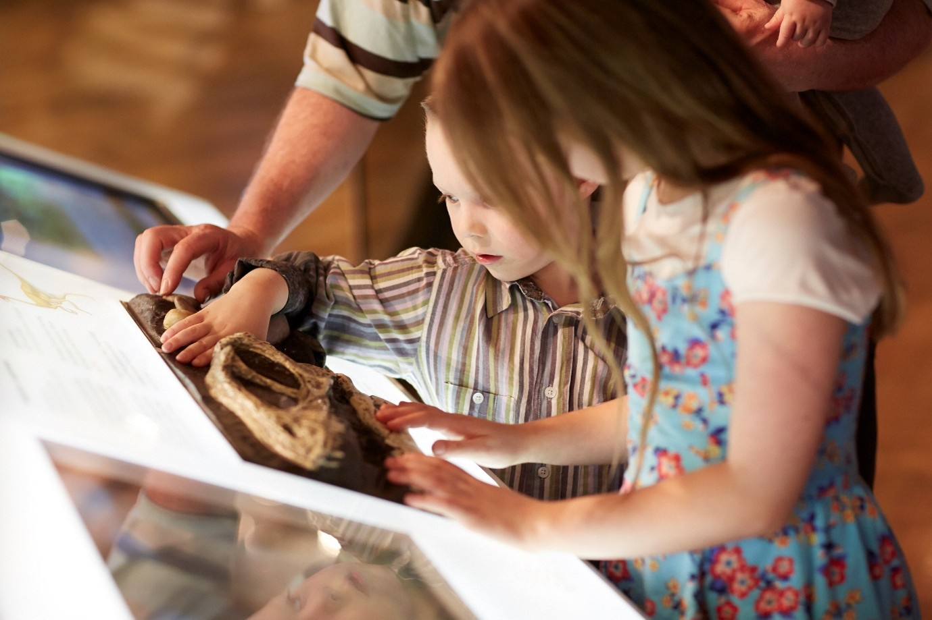
MM Dinosaurs touch area
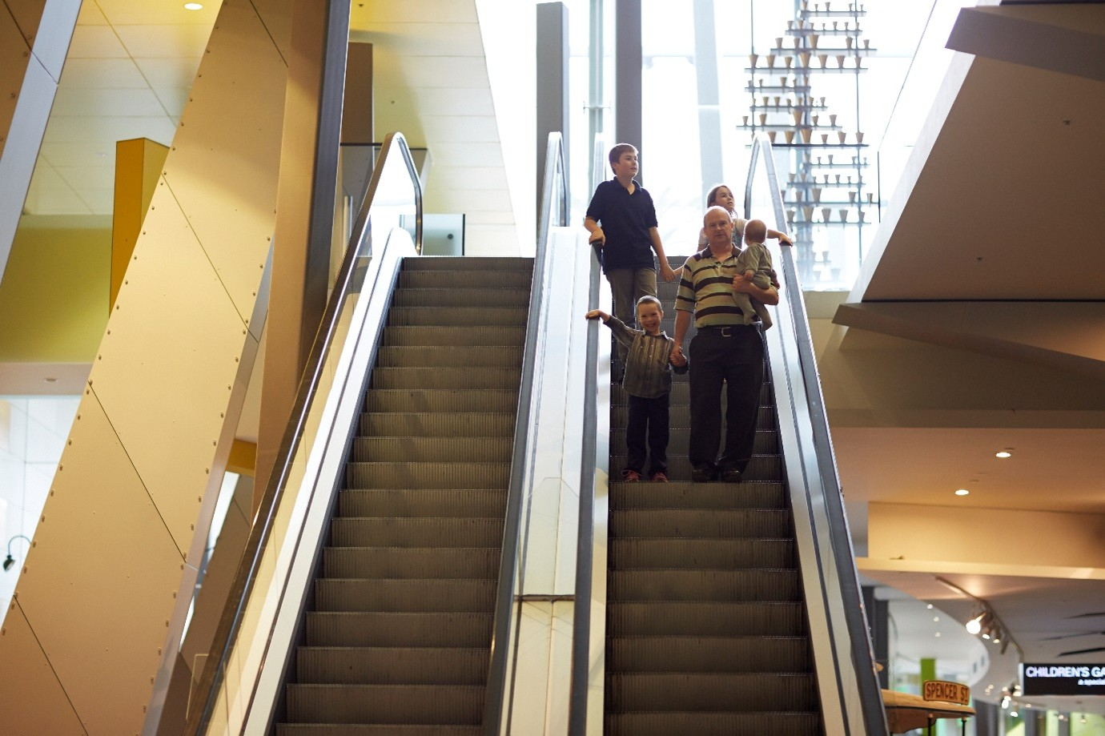
MM Escalators
- In addition, the following further information can assist guests:
The Children's Gallery includes an indoor play space plus outdoor area.

Parks and gardens
- The following parks and gardens amenities are available
  - Parks and Gardens Access/Entry Image(s)
immigration-museum-entrance-000419431_o5-1
sw-getting-here
gettinghereandparking_image
- Handrails and stairs are built as per state/territory building code.
- A handrail is available and at 865-965mm in height.
  - Parks and Gardens Stair entry and exit Image(s)
MM Escalators

FOOD AND DRINK

Dining Spaces
The dining spaces have the following facilities/amenities in place
- The entrance has level access
- The doorway is at least 850mm wide
- There is level access through the dining area
- Chairs are moveable to allow for wheelchairs to be seated at the tables
- All glass doors and full height windows have contrast markings
- There are areas of full lighting
- There are Plain English menus
- There is an accessible toilet

Our business caters for the following dietary requirements
- Sugar free (diabetic)
- Gluten free (celiac)
- Lactose free (dairy free)
- Low potassium
- Low sodium
- Nut free
- Additive free
- Vegetarian
- Vegan
- Kosher
- Halal
- In addition, the following further information can assist guests:
The Cafe operators are aware of the health and safety requirements and have procedures in place.
- There is a sample menu available online
Sample menu is available here -
https://museumsvictoria.com.au/melbournemuseum/plan-your-visit/dining/
  - Food and Beverage Image(s)
stewiedonn-lr-museummarketcafe-4
hd196702-a-138-co

EVENTS

Events
Events have the following facilities/amenities in place
- There is step free access throughout the venue
- All ancillary areas are step free e.g. breakout rooms, dining areas, outside areas and exhibition spaces
- A low height lectern is available
- Accessible toilets are available at the venue
- There is clear signage throughout the venue including accessible routes and accessible facilities
- Wheelchair designated seating is provided
- We cater for a range of seating and viewing options
- We cater for varying group sizes
- There is good circulation space with the number of people expected to allow people with a disability to move around freely
- Food and water is available for guide and service animals
- Accessible car parking is available
- There are designated drop-off points
- There is accessible public transport to the venue
- Quiet rooms, marquees or spaces are available
- In addition, the following further information can assist guests:
Melbourne Museum hosts a wide variety of public programs and events year-round. Venue information for guests is available as per usual daytime activities, with additional program or event specific information available on each What's On page or in consultation with the Bookings team.

Report Disclaimer
Please note that this business report, provided as a result of the use of the diagnostic assessment, is for information purposes only.
Australian Tourism Industry Council (ATIC) cannot guarantee the accuracy of respondent’s answers, or that they are fully representative of your business. Therefore, ATIC does not warrant or guarantee any particular outcome in respect of your businesses self-assessment.
This report is intended as guidance only for your business and should not be relied on for future marketing considerations. ATIC recommends that you seek your own independent advice as well as the results from the diagnostic.
Links to external web sites are inserted for convenience and do not constitute endorsement of material at those sites, or any associated organisation, product or service.
ATIC does not:
- Assume any legal liability for the accuracy, completeness, or usefulness of any information from this report or any links provided; or
- Accept responsibility for any loss associated directly or indirectly from the use of this report.

