ATIC Accessibility
To support the accessible community in making informed travel decisions for their individual needs

This report prepared for:
Business name: | Starscape Australia
Address: | 684 Curragh Road
Town: | Abercrombie River
Contact for enquiries: | Naman Juneja
Contact Number: | 0490716774
Contact Email: | starscapeaustralia@gmail.com
Website: | www.starscapeaustralia.com
Date: | 2026-09-21 11:45

ATIC Accessibility
The following pages provides travellers with information on the businesses facilities and amenities which aims to support the traveller to make an informed decision on whether the business is suitable for their individual needs.
OVERVIEW 3
Business Overview 3
Bookings 3
Emergency Management 3
Communications 4
GENERAL 5
Pre-arrival, arrival and reception 5
Cognitive Impairment Support 5
External Paths 5
Steps 5
ACCOMMODATION 6
Room Amenities 6
Bathrooms 6
COMMON AREAS 8
Report Disclaimer 10

OVERVIEW

Business Overview

The business has the following products/services available
- Accommodation

Our business caters for the following disability types:
- Food allergies or intolerances
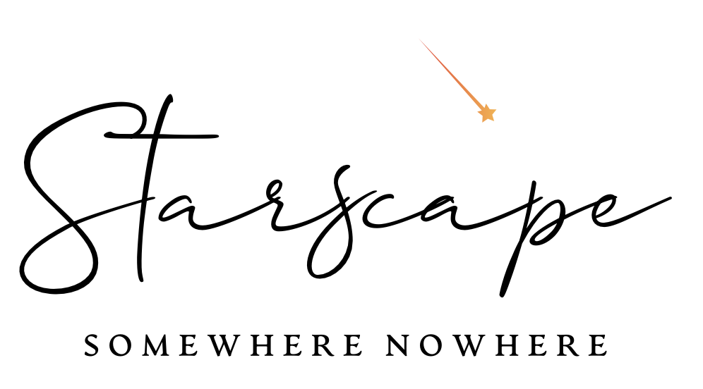

Bookings

The business offers the following methods for bookings and enquiries:
- Phone
- Email
- Webportal
- Our website supports Screen Readers
- Our forms have high contract boxes and submit boxes

Emergency Management
- Emergency and evacuation procedures are explained on arrival
- Exit access is free and clear at all times
We ensure exit access is free and clear at all times by:
The exit is always clear and not obstructed by anything
- Exits and access to exists are greater than 900mm
- Exit doors are able to be opened by all occupants
- The evacuation point is clearly marked by a sign
- In addition, the following further information can assist guests:
N/A
- In addition, the following further information can assist guests:
N/A

Communications
- Our website meets WCAG 2.0 accessibility standards
The business provides the following services for services animals:
N/A

GENERAL

Pre-arrival, arrival and reception
The business has the following in place to support guests during pre-arrival, arrival and reception
- Booking information and websites are compatible with screen readers
- Keys are available for each guest
- In addition, the following further information can assist guests:
N/A
- In addition, the following further information can assist guests:
Our website has a WAVE Accessibility IMpact (AIM)score of 8 out of 10
Siteimprove score of 82 out of 100
Voice Over Text works on our website

Cognitive Impairment Support
- Documents are available in plain English for people with cognitive impairment (This may include instructions, guides, menus and general information)

External Paths
External paths of travel
The width of the smallest pathway is:
Not applicable. It's a farm setting.
- There 3 successive steps or less on any path or at any doorway

Steps
Steps
- There are steps.

ACCOMMODATION

Room Amenities
- There is contrast between the walls, skirtings, floor and furniture
- There is a clear path through the room
- The edges of all furniture and fixtures are rounded
- Wardrobe handles are a contrasting colour to the doors and draws
- Doors open fully against the adjoining wall
- There is a clear opening at least 850mm wide
- The bedside lamp switch is easy to reach from the bed
- The bed height is no higher than 680mm from the floor
- There is at least 130mm clearance under the bed
- The business offers a range of non-allergenic bedding
- Non-allergenic cleaning products are used

Bathrooms
The bathrooms have the following facilities/amenities in place
- All heating appliances and hot water pipes are protected or insulated
- All shower, bath and basin taps are clearly differentiated between hot and cold
- Fixtures and fittings have rounded edges
- The hot water is thermostatically controlled to 41 degrees
- The door is at least 850mm wide
- The width beside the toilet is N/A.
- There is a minimum of 1400mm of clear space in front of the toilet
- The toilet seat is a contrasting colour to the floor
- The toilet seat is 460mm above the floor
  - Bathroom Image(s)
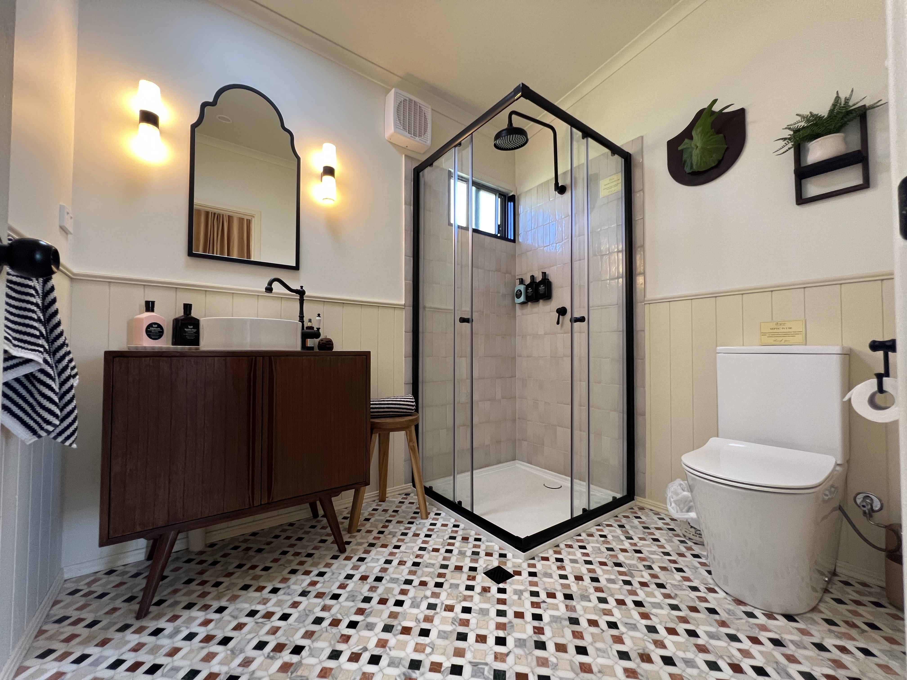
Bathroom Full Photo - Starscape
- In addition, the following further information can assist guests:
N/A

COMMON AREAS

Report Disclaimer
Please note that this business report, provided as a result of the use of the diagnostic assessment, is for information purposes only.
Australian Tourism Industry Council (ATIC) cannot guarantee the accuracy of respondent’s answers, or that they are fully representative of your business. Therefore, ATIC does not warrant or guarantee any particular outcome in respect of your businesses self-assessment.
This report is intended as guidance only for your business and should not be relied on for future marketing considerations. ATIC recommends that you seek your own independent advice as well as the results from the diagnostic.
Links to external web sites are inserted for convenience and do not constitute endorsement of material at those sites, or any associated organisation, product or service.
ATIC does not:
- Assume any legal liability for the accuracy, completeness, or usefulness of any information from this report or any links provided; or
- Accept responsibility for any loss associated directly or indirectly from the use of this report.

